Load Test Report

## Load Details

stack: S1

stack_url: https://jupiter.uptycs.net/

sprint: 139

build: 139000

load_type: SingleCustomer

load_time: 10 hrs

load_start_time_ist: 2023-08-12 23:08

load_end_time_ist: 2023-08-13 09:08

## Disk Usages

### KAFKA disk space usage

|  |  |  |  |  |
| --- | --- | --- | --- | --- |
| Node | KAFKA total space configured(TB) | KAFKA disk used % before load | KAFKA disk used % after load | KAFKA used space during load (GB) |

### HDFS disk space usage

|  |  |  |  |  |
| --- | --- | --- | --- | --- |
| Node | HDFS total space configured(TB) | HDFS disk used % before load | HDFS disk used % after load | HDFS used space during load (GB) |

### PG disk space usage

|  |  |  |
| --- | --- | --- |
| partition | master configdb node | standby configdb node |
| /pg | 2.9G | 5.0G |
| /data | 28G | 29G |

### Kafka topics

|  |
| --- |
| 139000 |
| Summary : No new topics added |
| New Topics : |
| Old Topics : __consumer_offsets __debezium-heartbeat.cdc __debezium-heartbeat.statedb agentghquery agentkubequery agentlesslog agentlesslogdecorator agentoktaquery agentosquery alert alert_replay api asset-capability assetgroup1 audit auto-exception az_events_blob bulk_replay cdc.public.alerts cdc.public.asset_cloud_infos cdc.public.asset_tags cdc.public.assets cdc.public.cloud_accounts cdc.public.customer_database cdc.public.customers cdc.public.incidents cdc.public.object_groups cdc.public.user_object_groups cdc.public.users cloudconnectorsink cloudqueryVuln cloudqueryevents cloudqueryinventory cloudtrail_objects compliance compliance_summary containers cqazevents cqcloudtrail cqcloudtrail_data_sink cqcloudtrail_ro_sink debezium_configs debezium_offsets debezium_statedb_configs debezium_statedb_offsets debezium_statedb_status_storage debezium_status_storage decorators detection ephermalresources epsink event event_cloud event_replay gcp_cloudlog_objects managedavtables notifications op osquery_cli_tags prestoquerylogs querypack realtimequery registryevent reportschedule1 scan_summary sidequerydecorator slackuser1 state statedb.public.containers_current statedb.public.kubernetes_nodes_current statedb.public.kubernetes_pods_containers_current statedb.public.kubernetes_pods_current statedb.public.vulnerabilities_scanned_images tag1 threat_indicators unified_dashboard uptycs-cloud-remediation vulnerabilities vulntickets |

## Charts

### Live assets

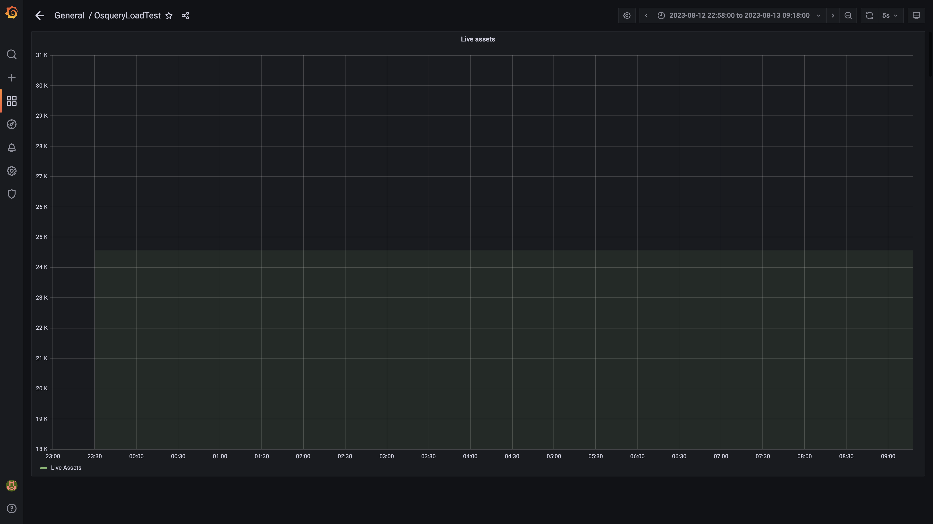

### Panel 142 not loaded in given time

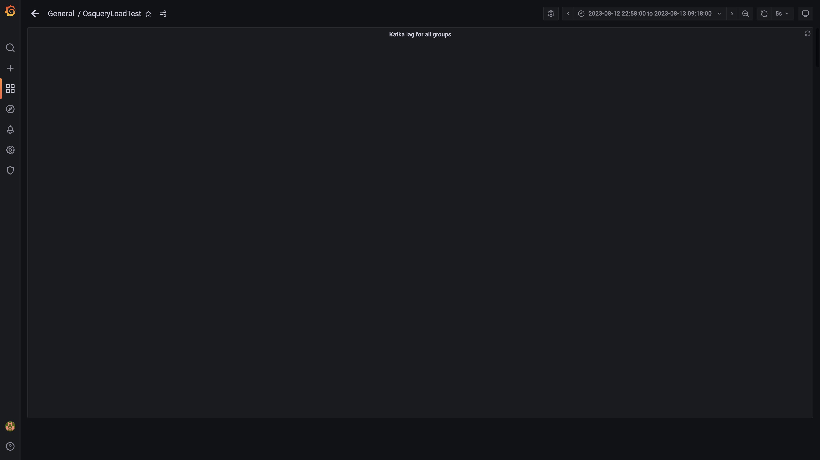

### Panel 16 not loaded in given time

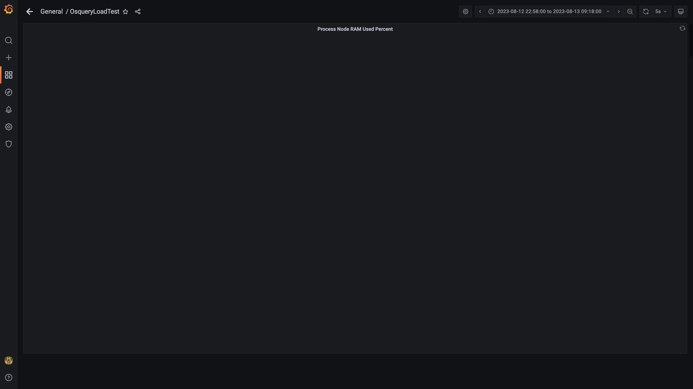

### Panel 12 not loaded in given time

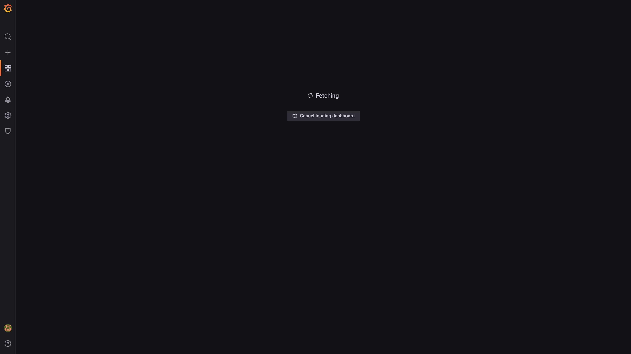

### Panel 14 not loaded in given time

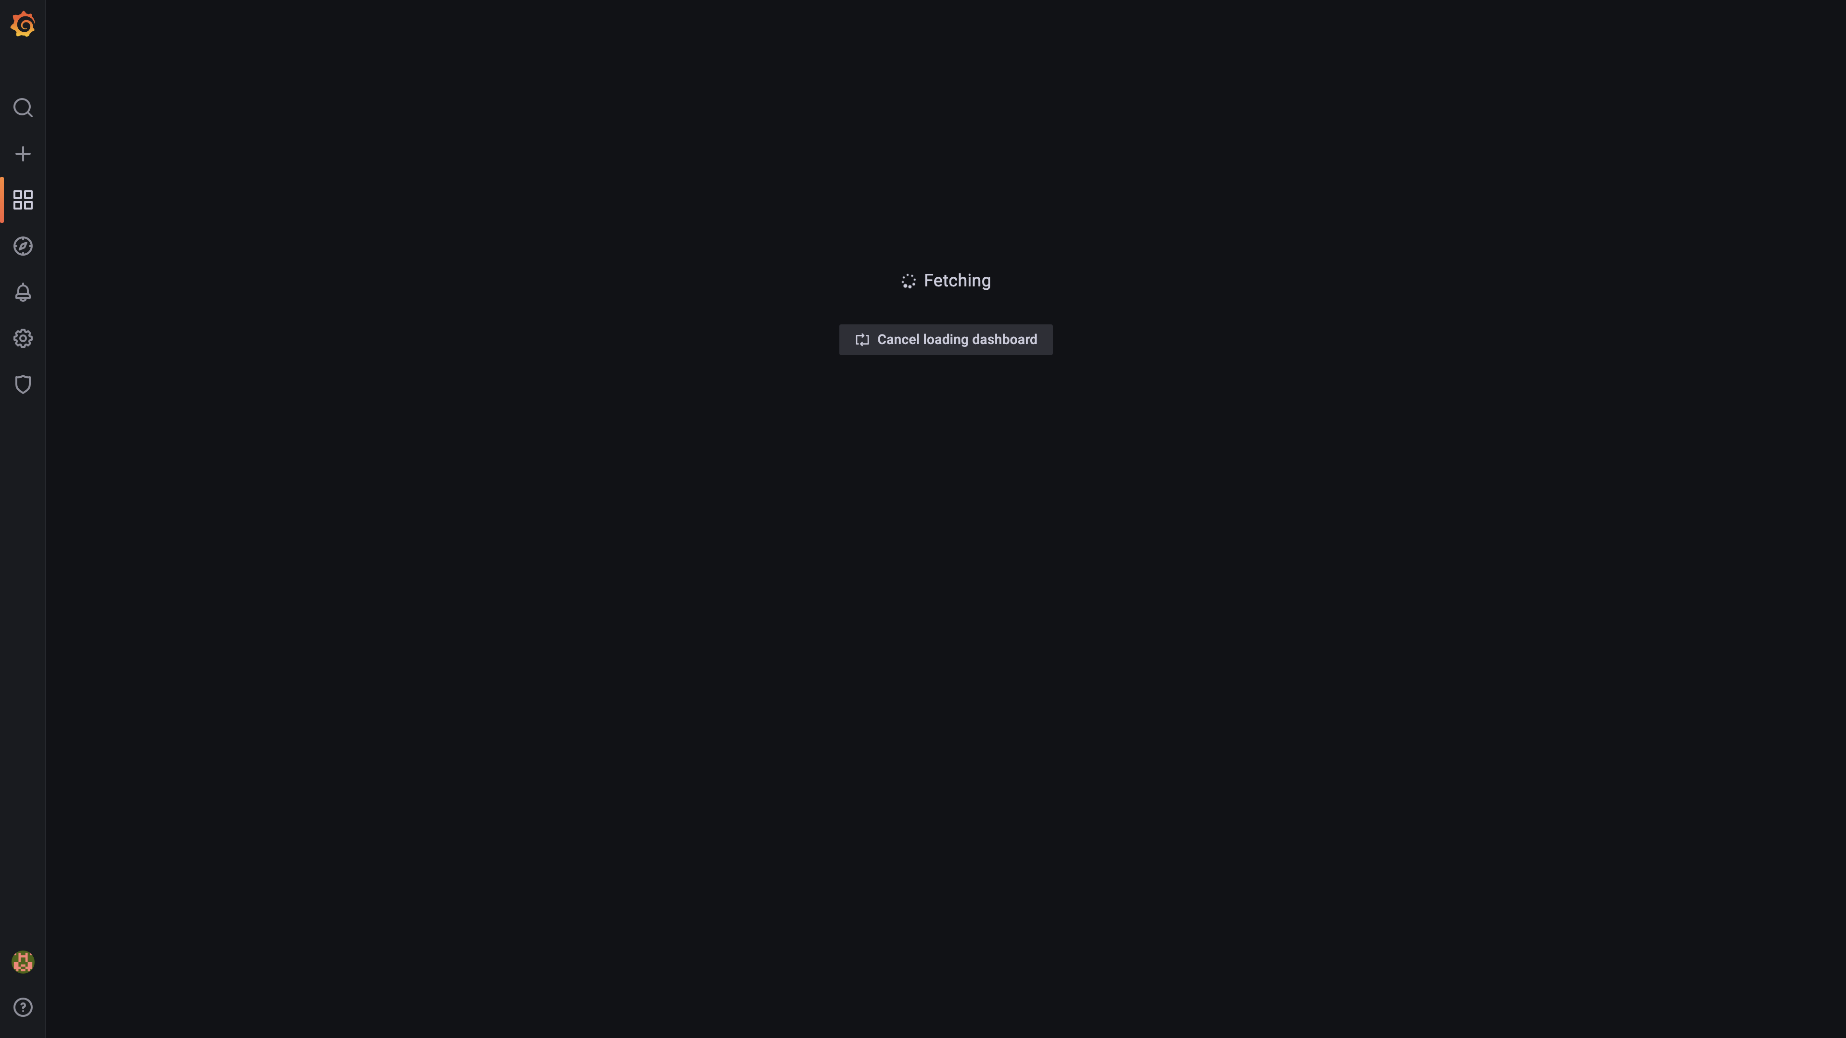

### Memory consumed by eventsdbingestion

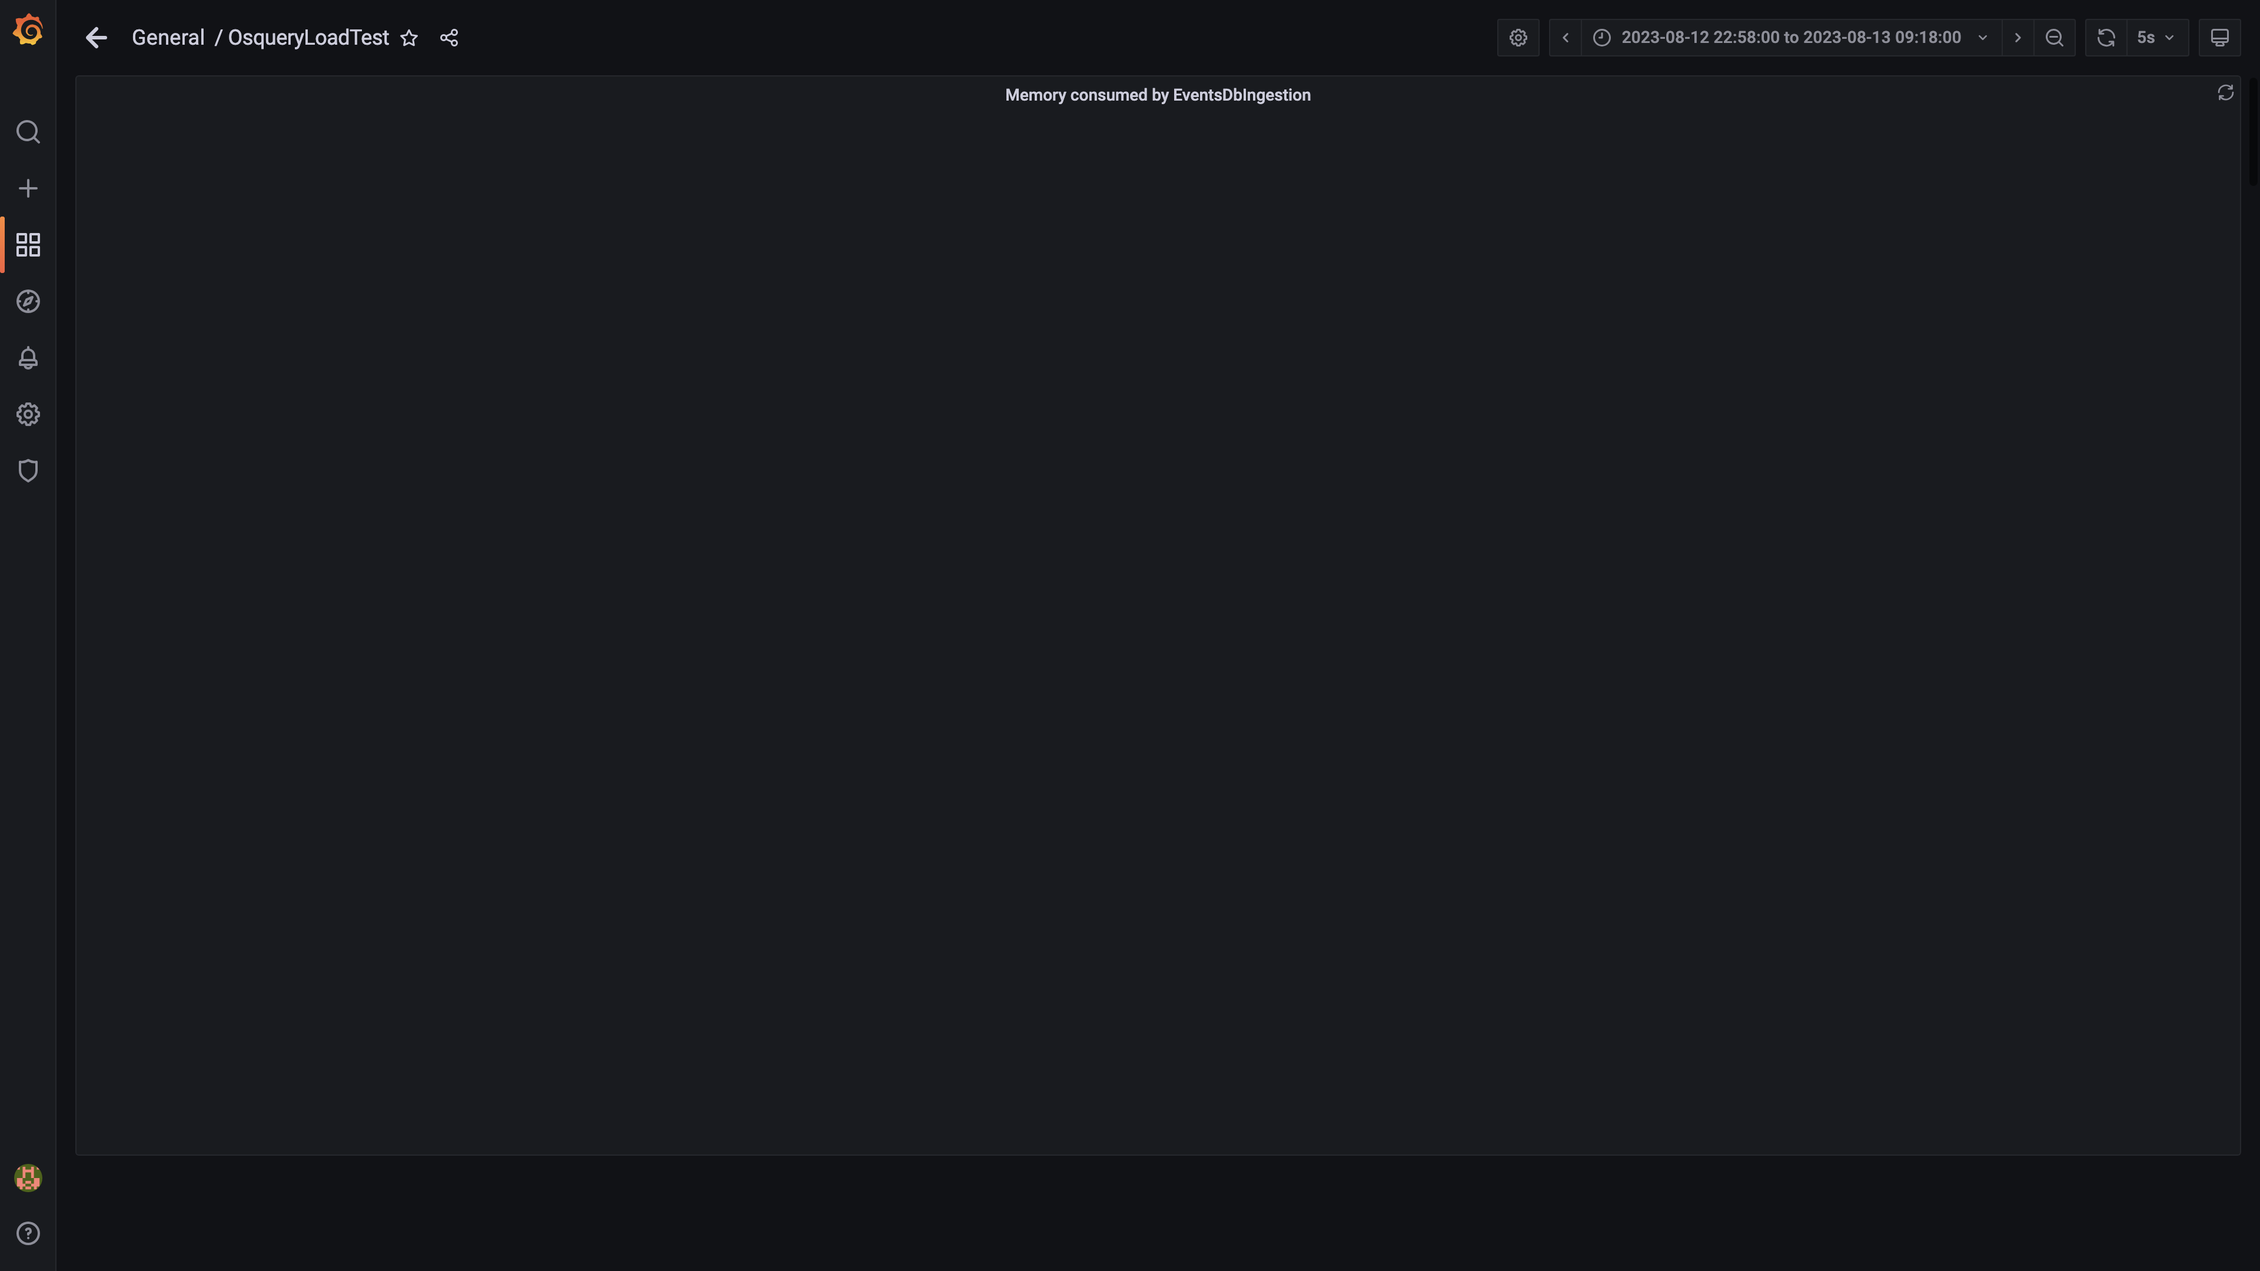

### Kafka disk used percentage

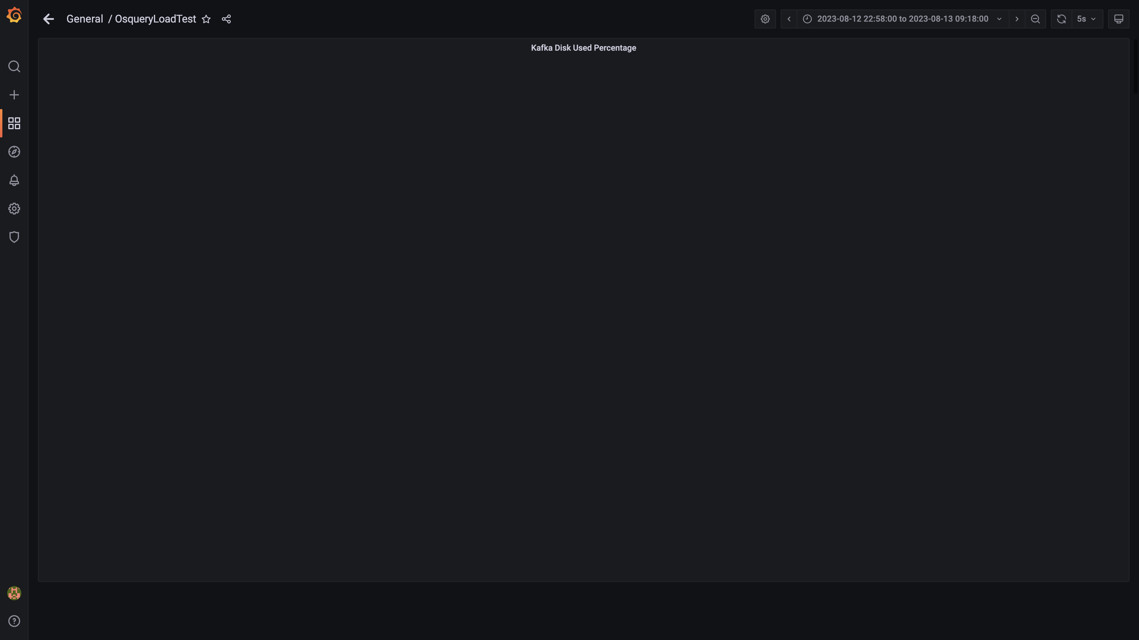

### Panel 22 not loaded in given time

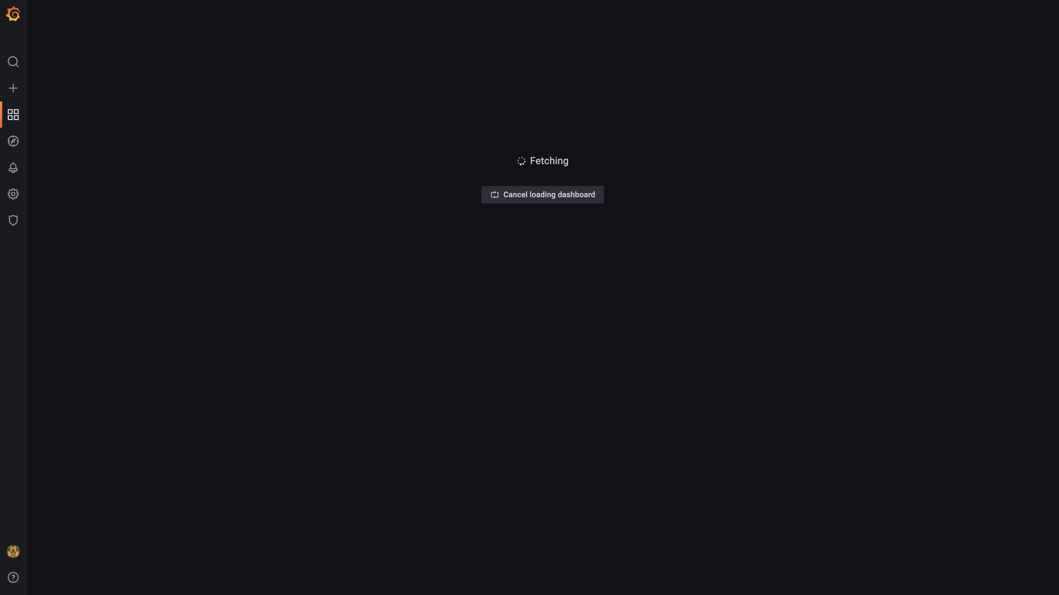

### Panel 34 not loaded in given time

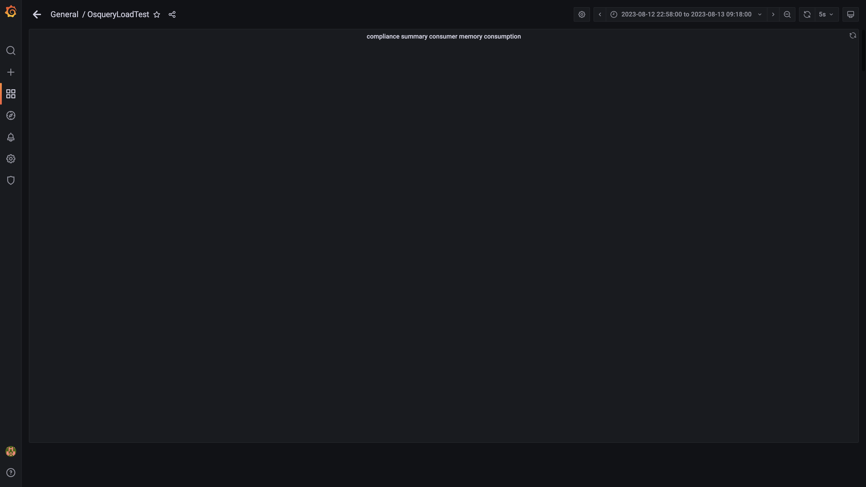

### Panel 18 not loaded in given time

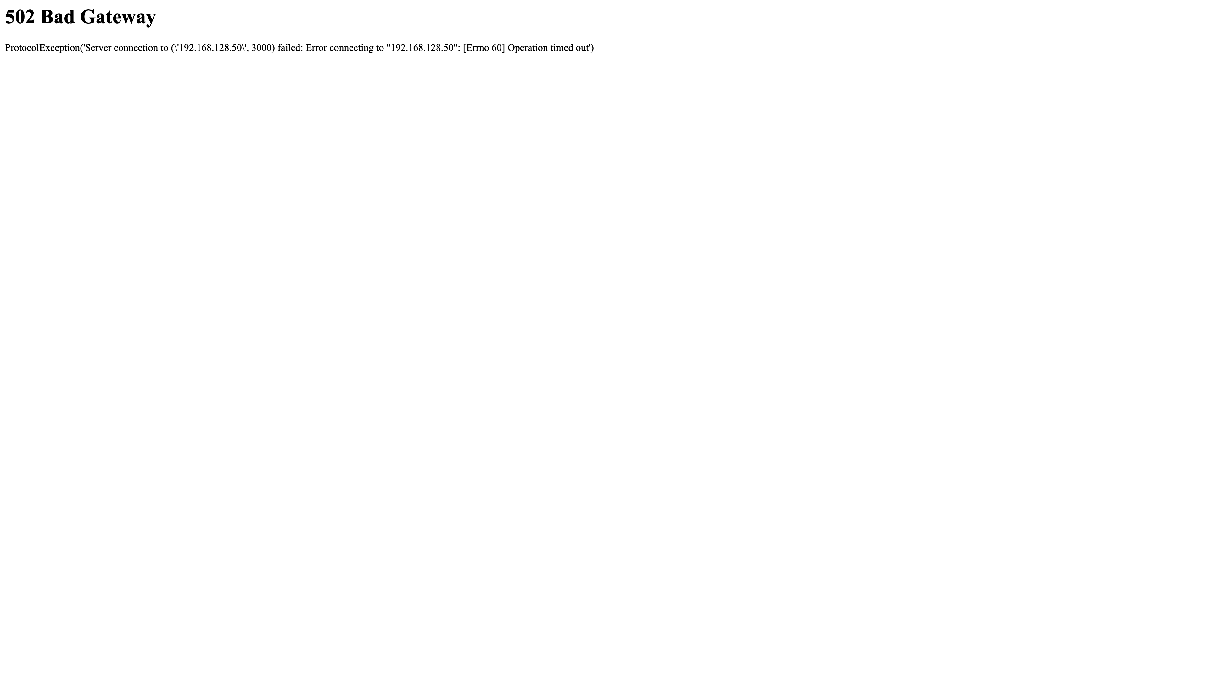

### Kafka memory used percentage

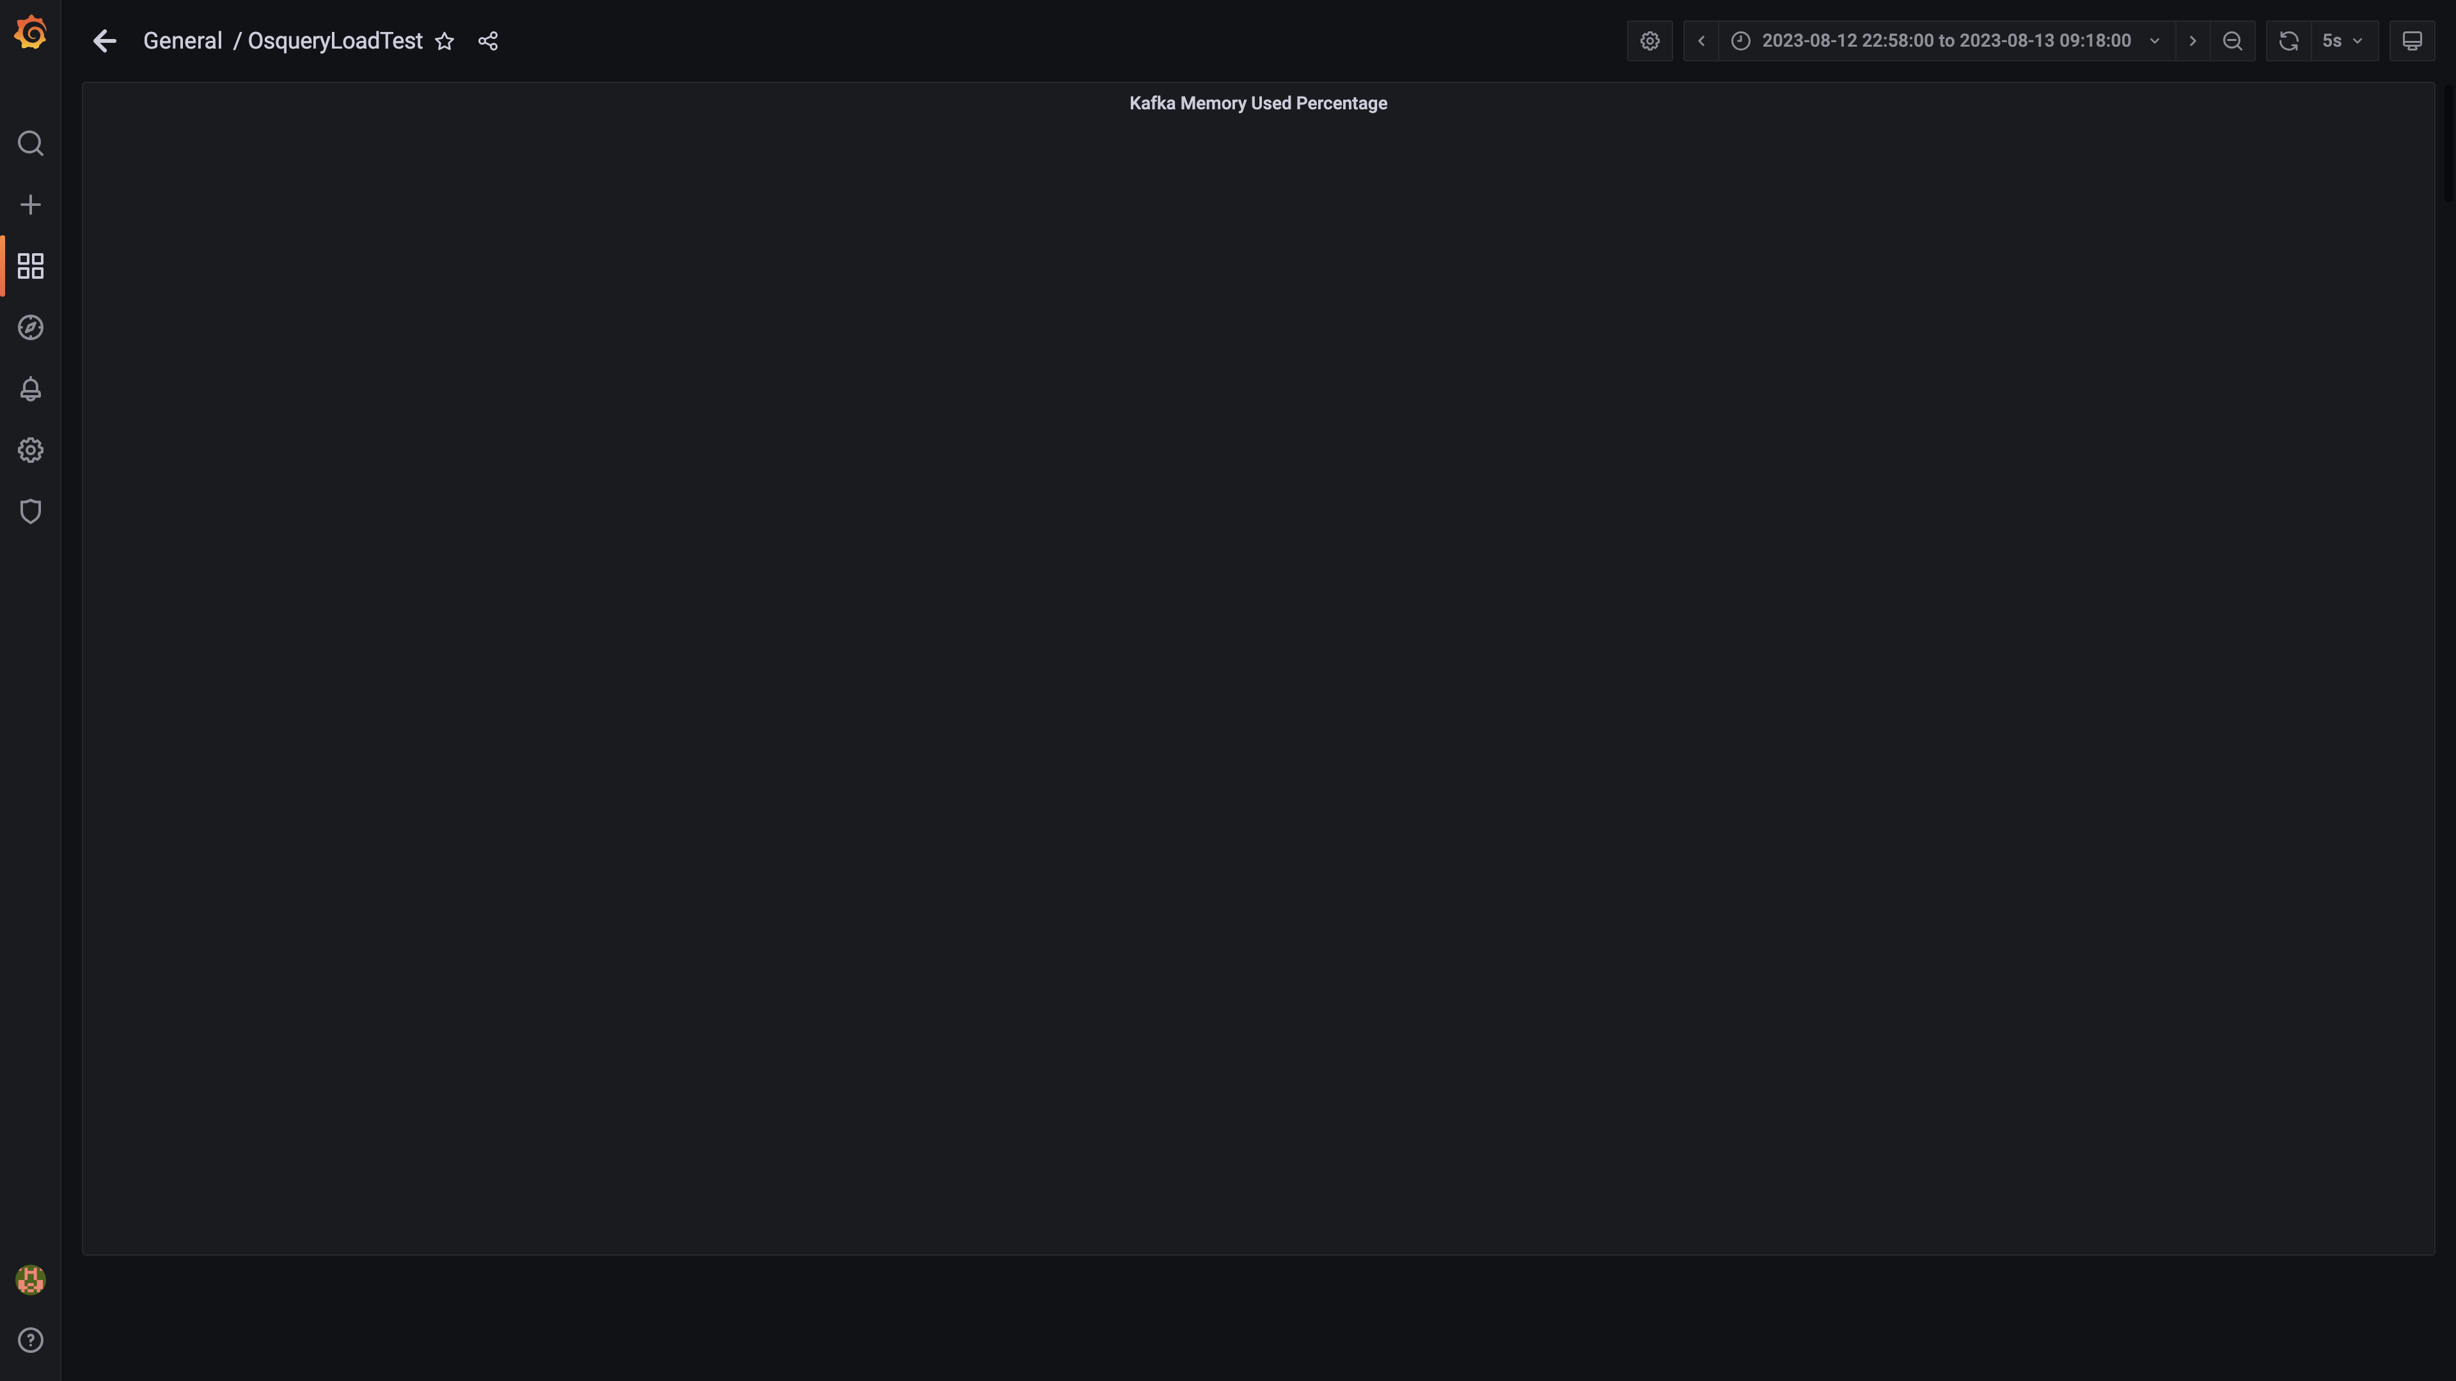

### Memory consumed by trino

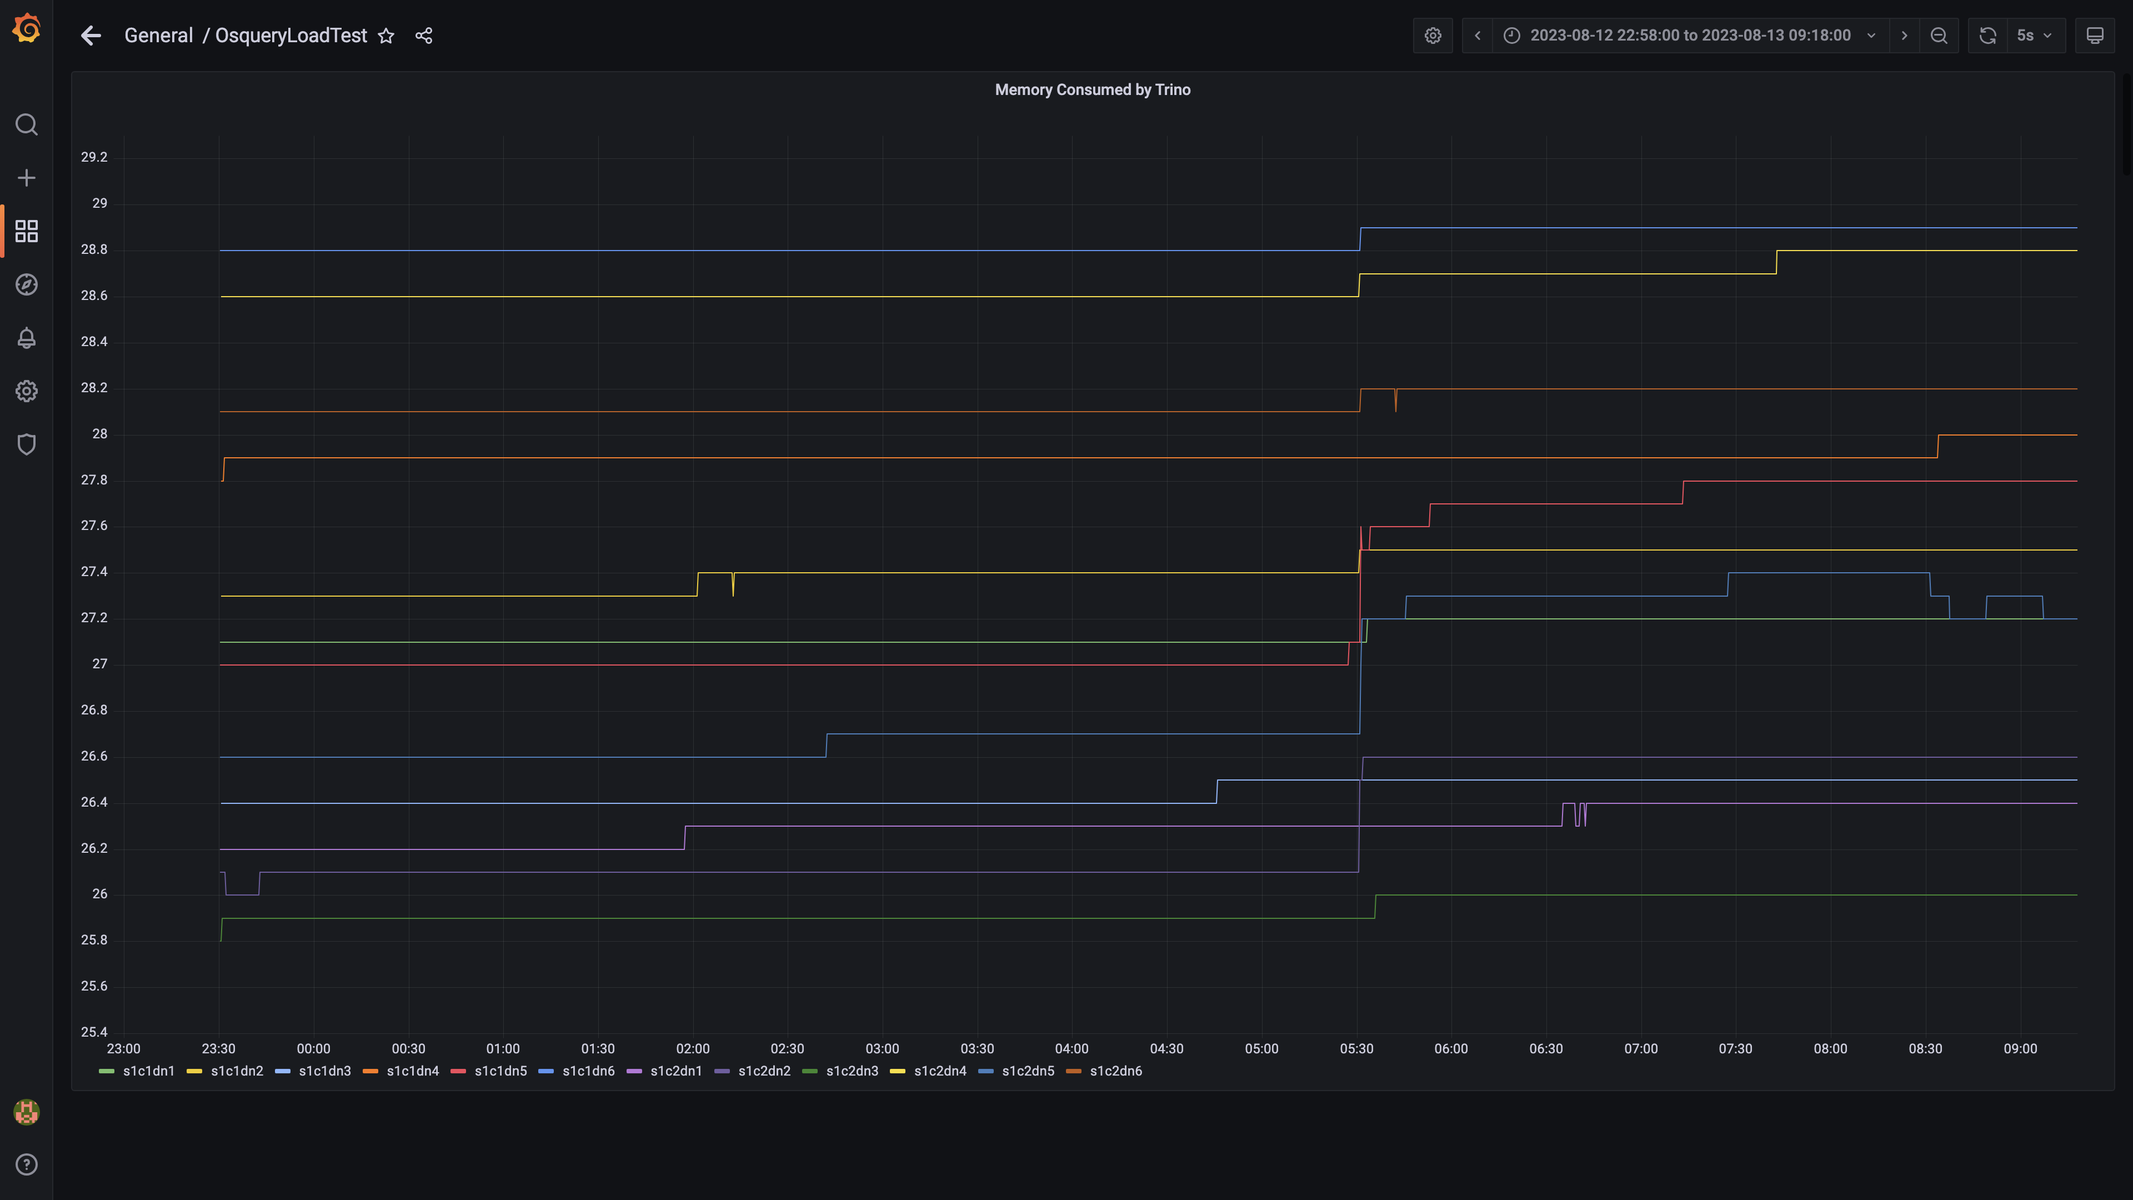

### Panel 28 not loaded in given time

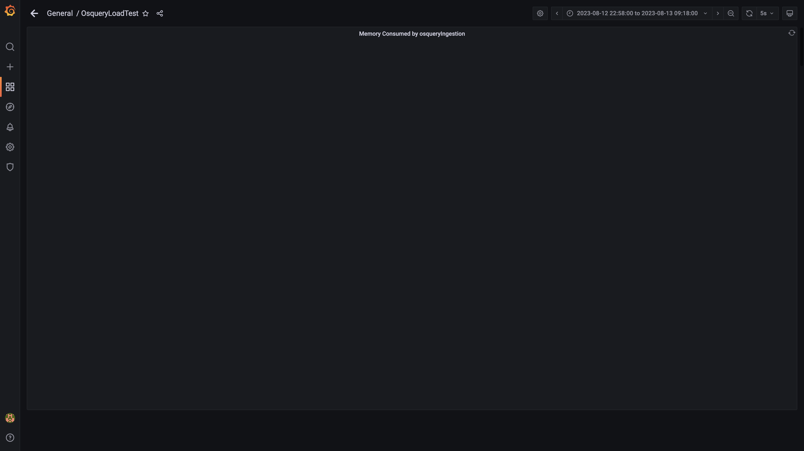

### Panel 6 not loaded in given time

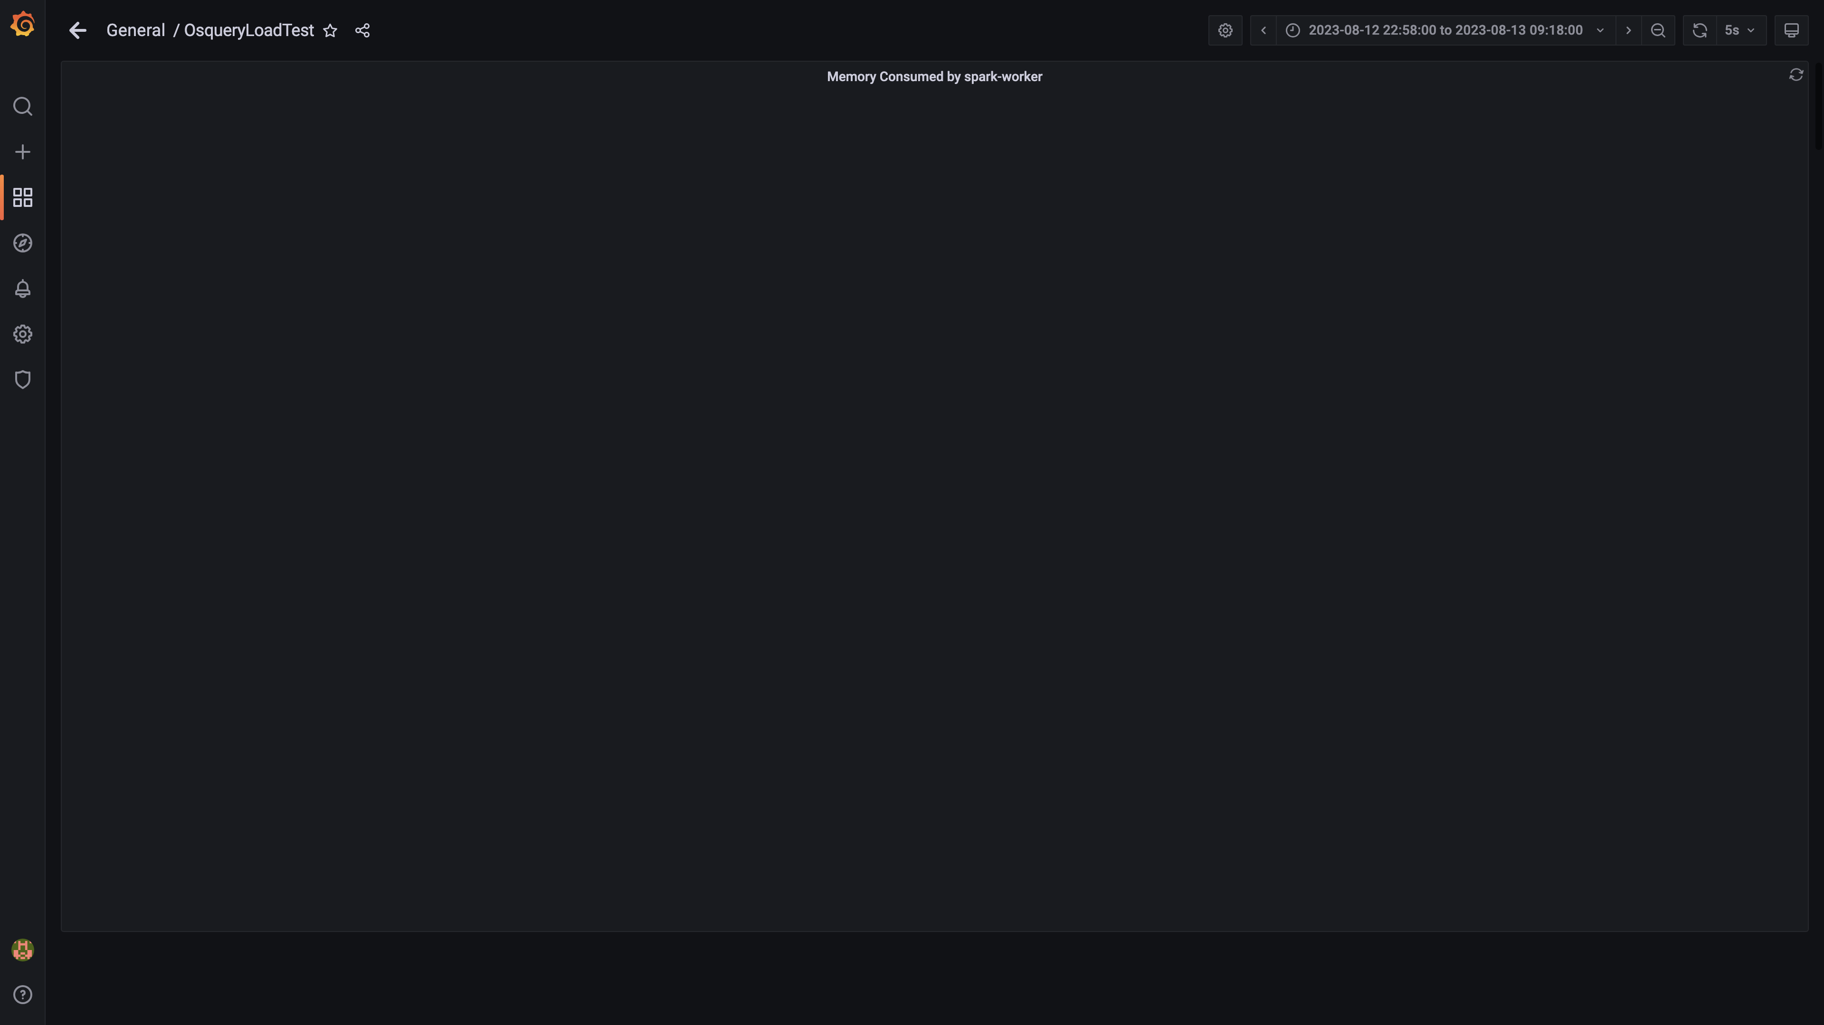

### Panel 24 not loaded in given time

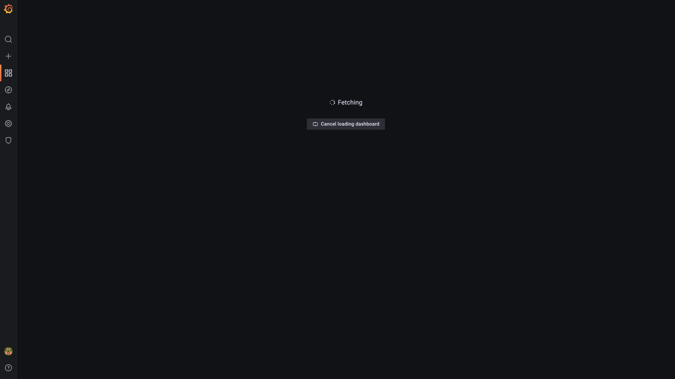

### Memory consumed by configdb

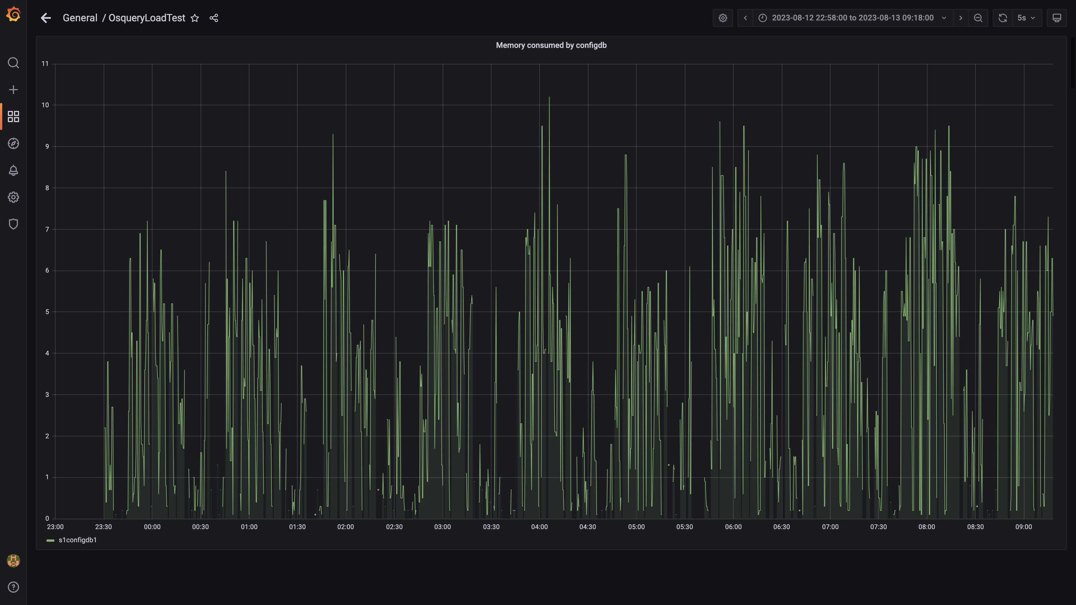

### Panel 20 not loaded in given time

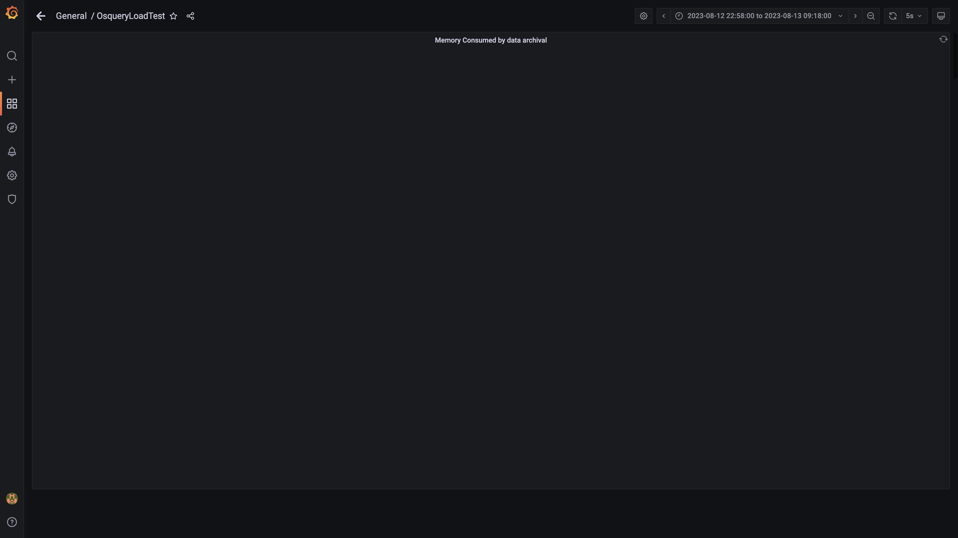

### Airflow memory usage

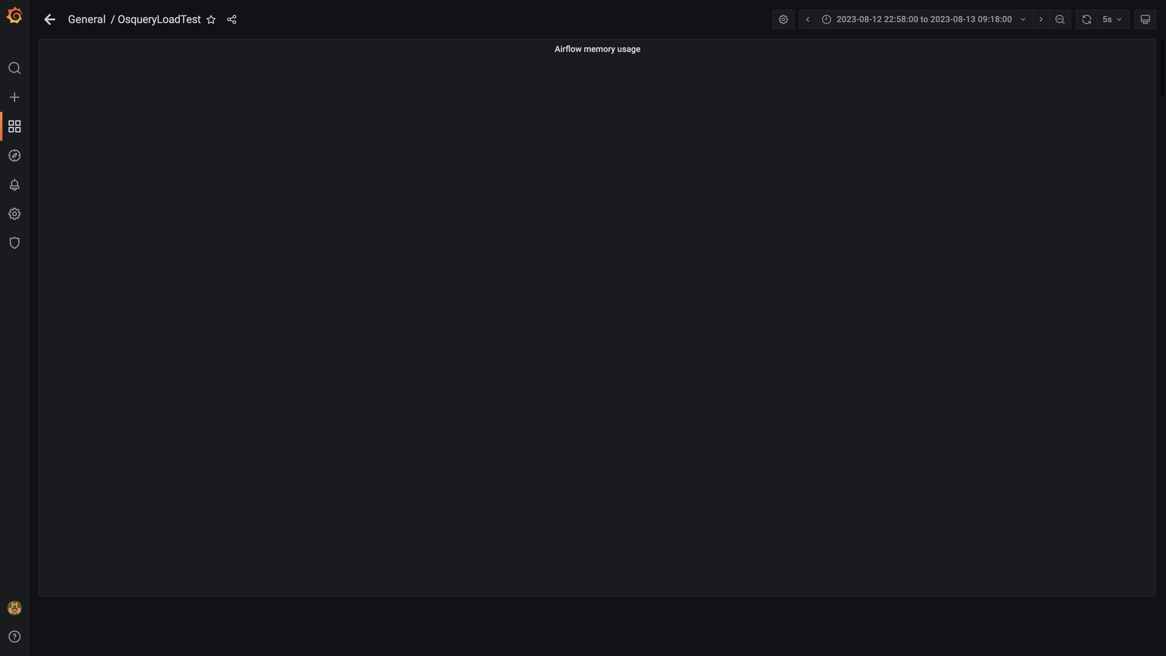

### Postgres node cpu busy percent

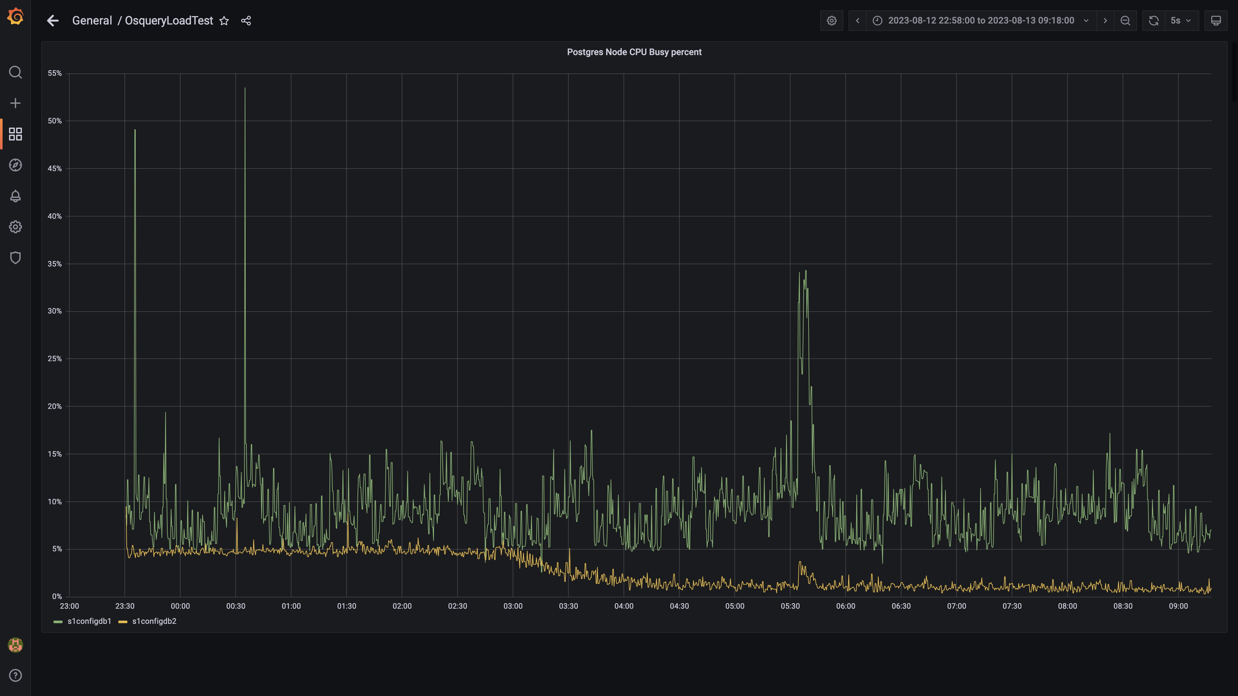

### Panel 54 not loaded in given time

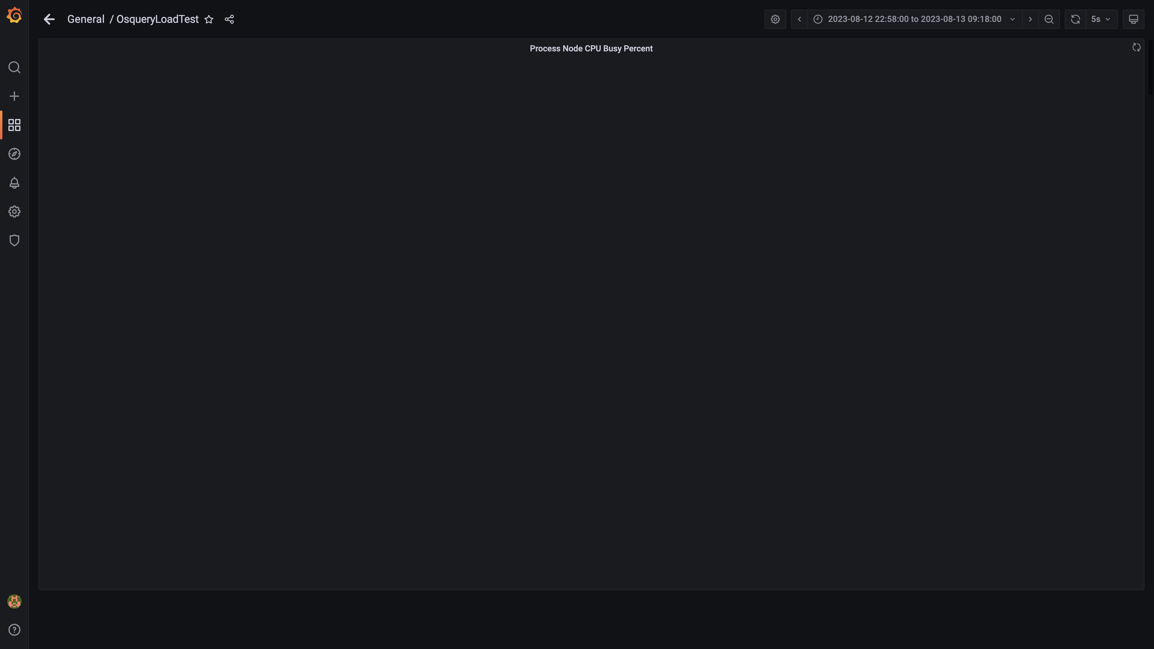

### Panel 52 not loaded in given time

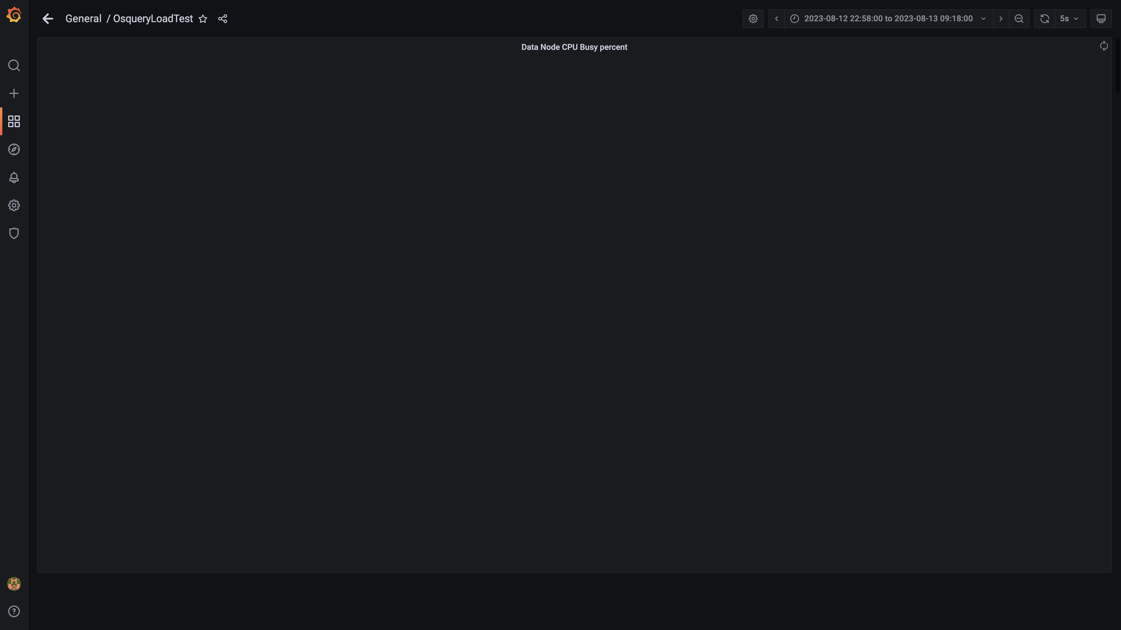

### Panel 76 not loaded in given time

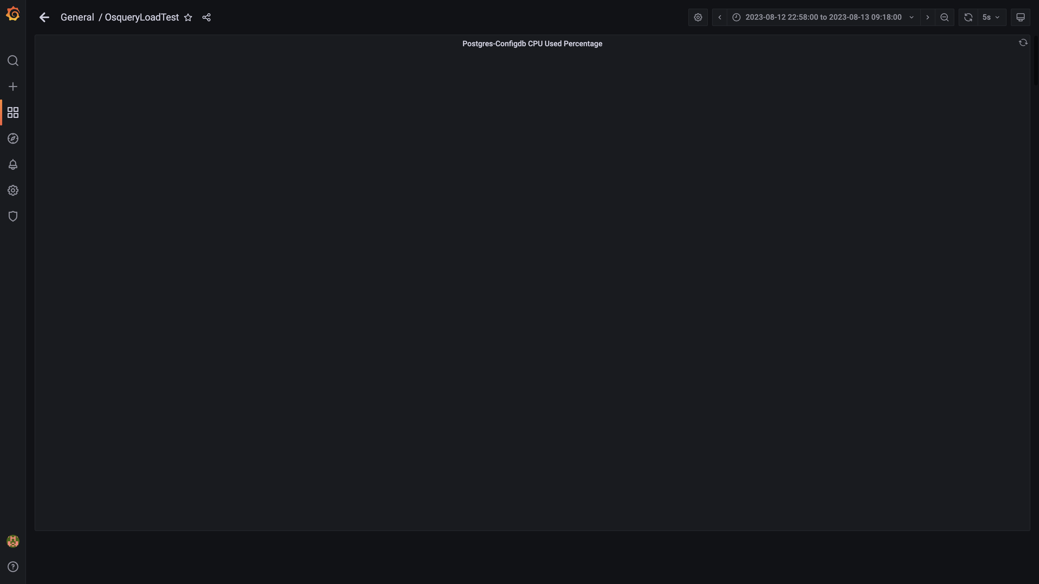

### Panel 72 not loaded in given time

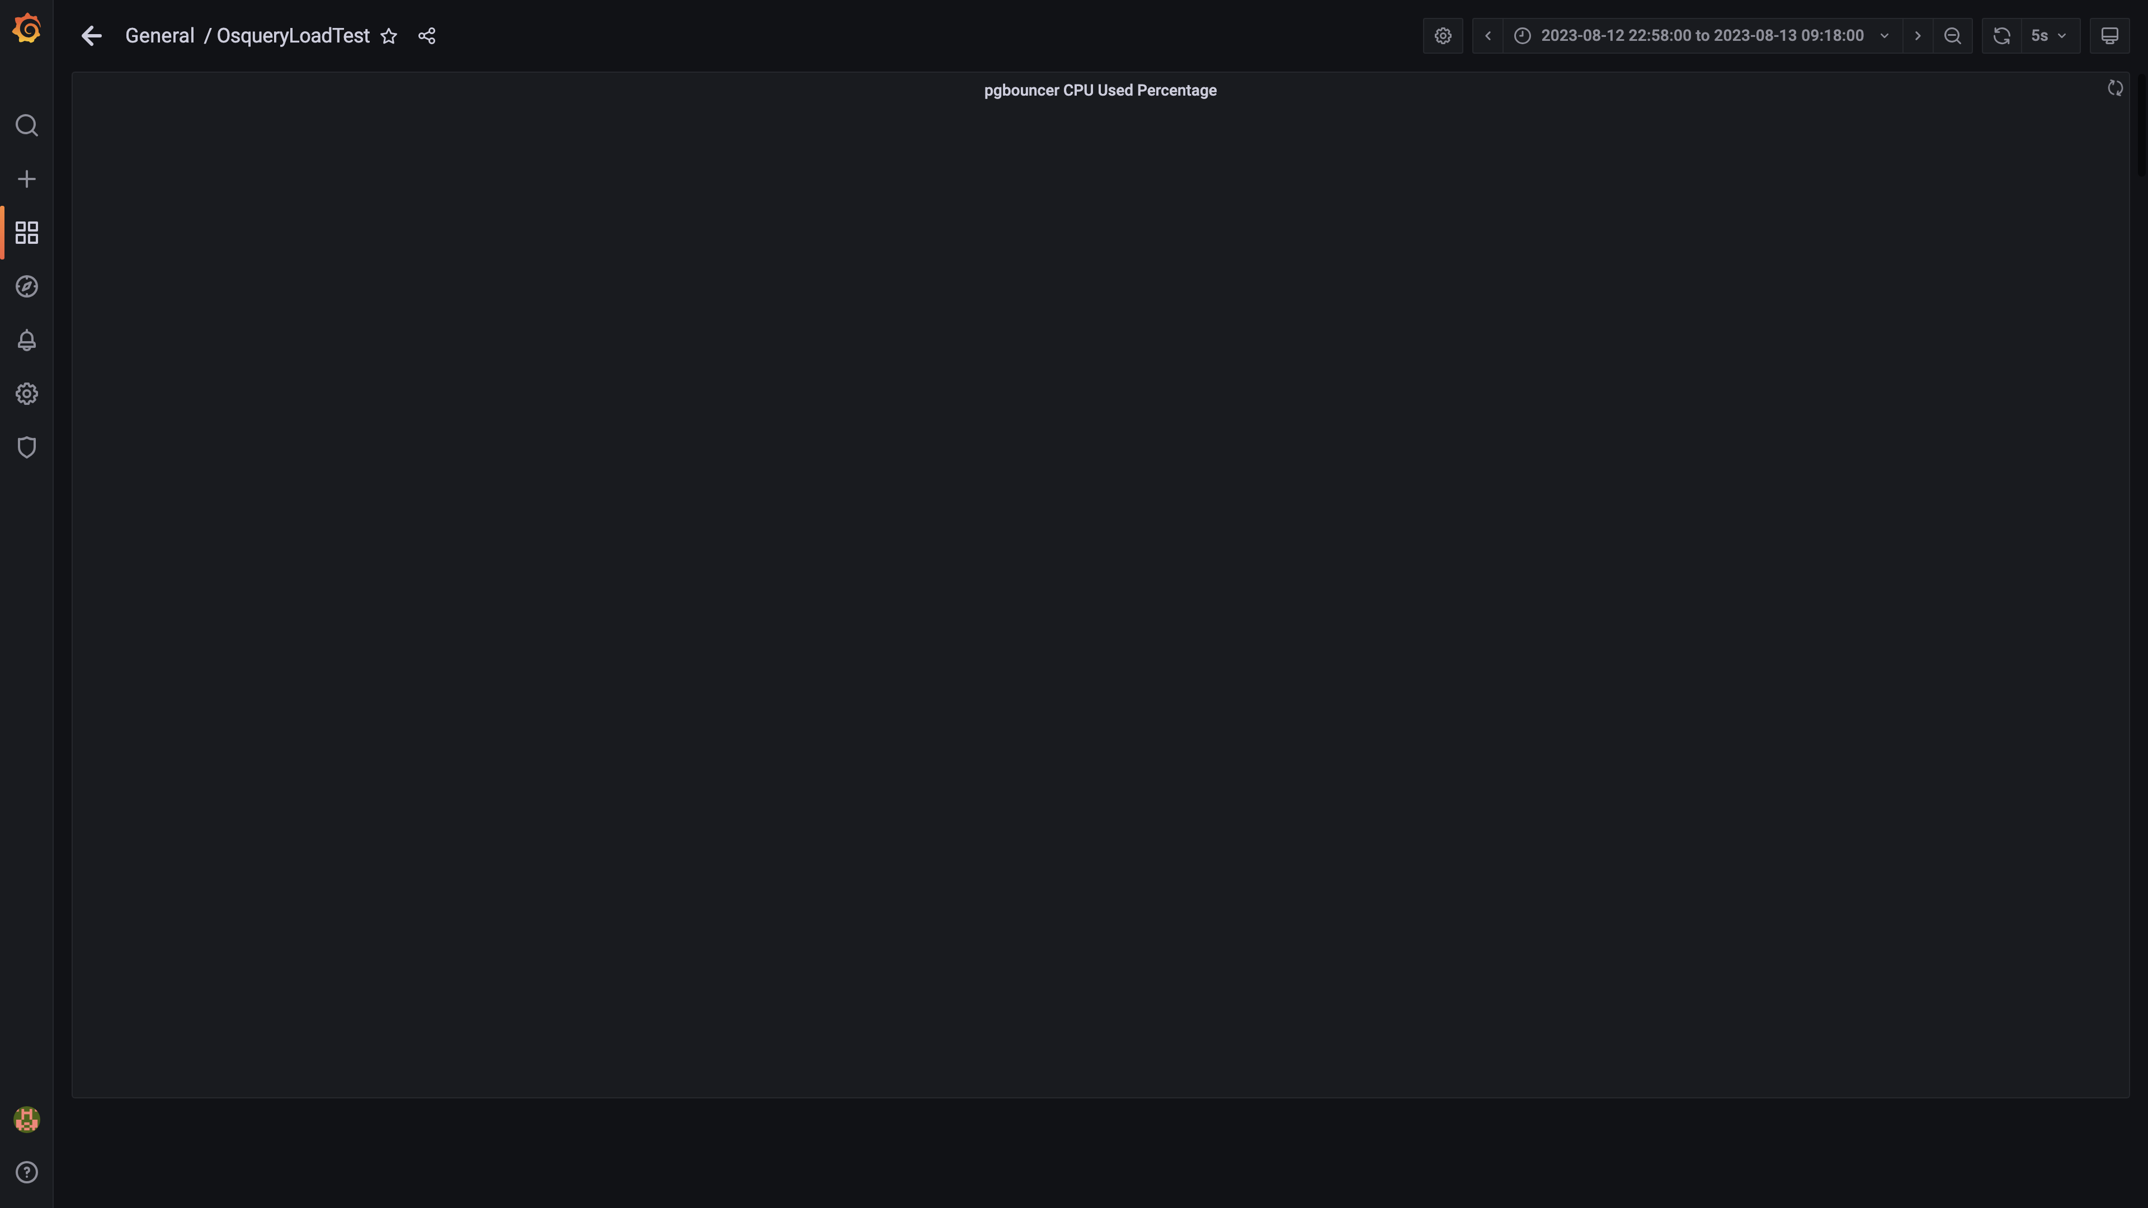

### Cpu consumed by eventsdbingestion

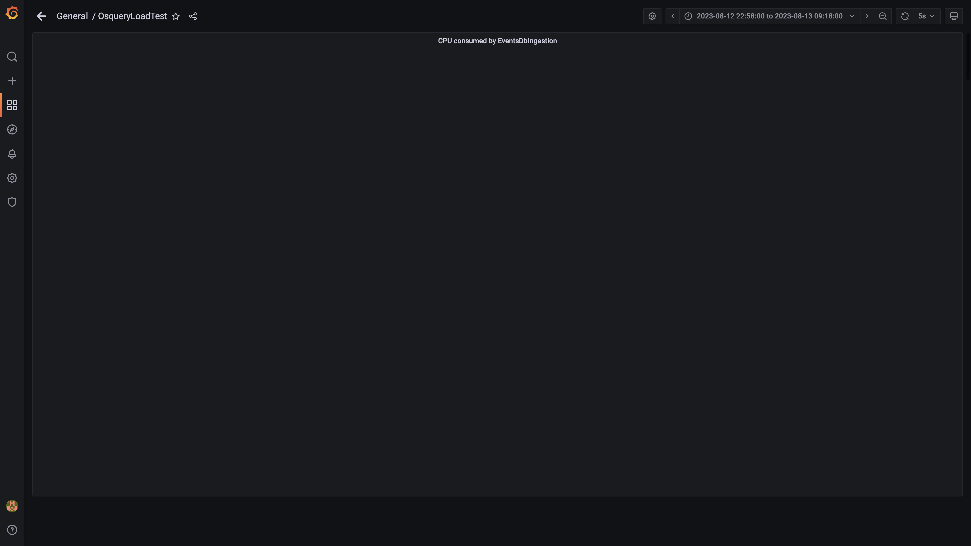

### Cpu used by data-archival

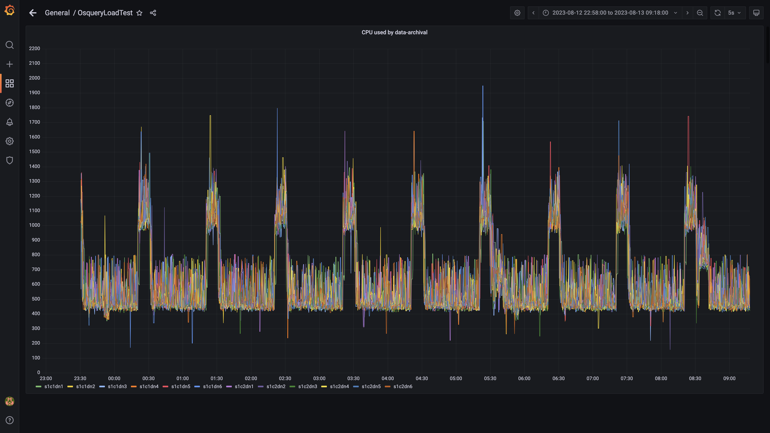

### Cpu consumed by osqueryingestion

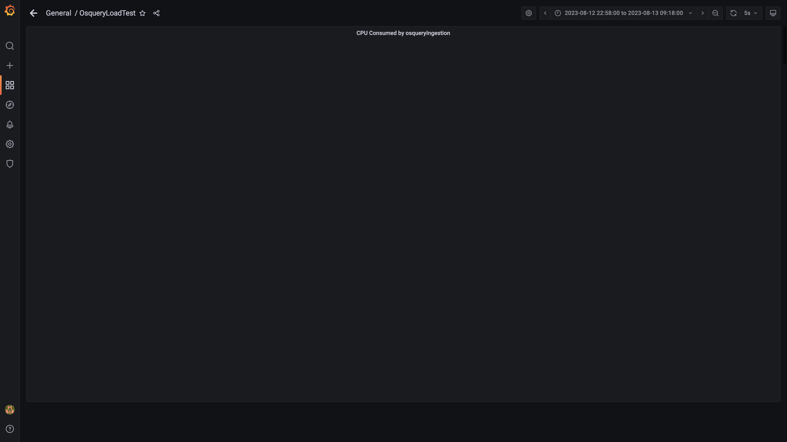

### Panel 48 not loaded in given time

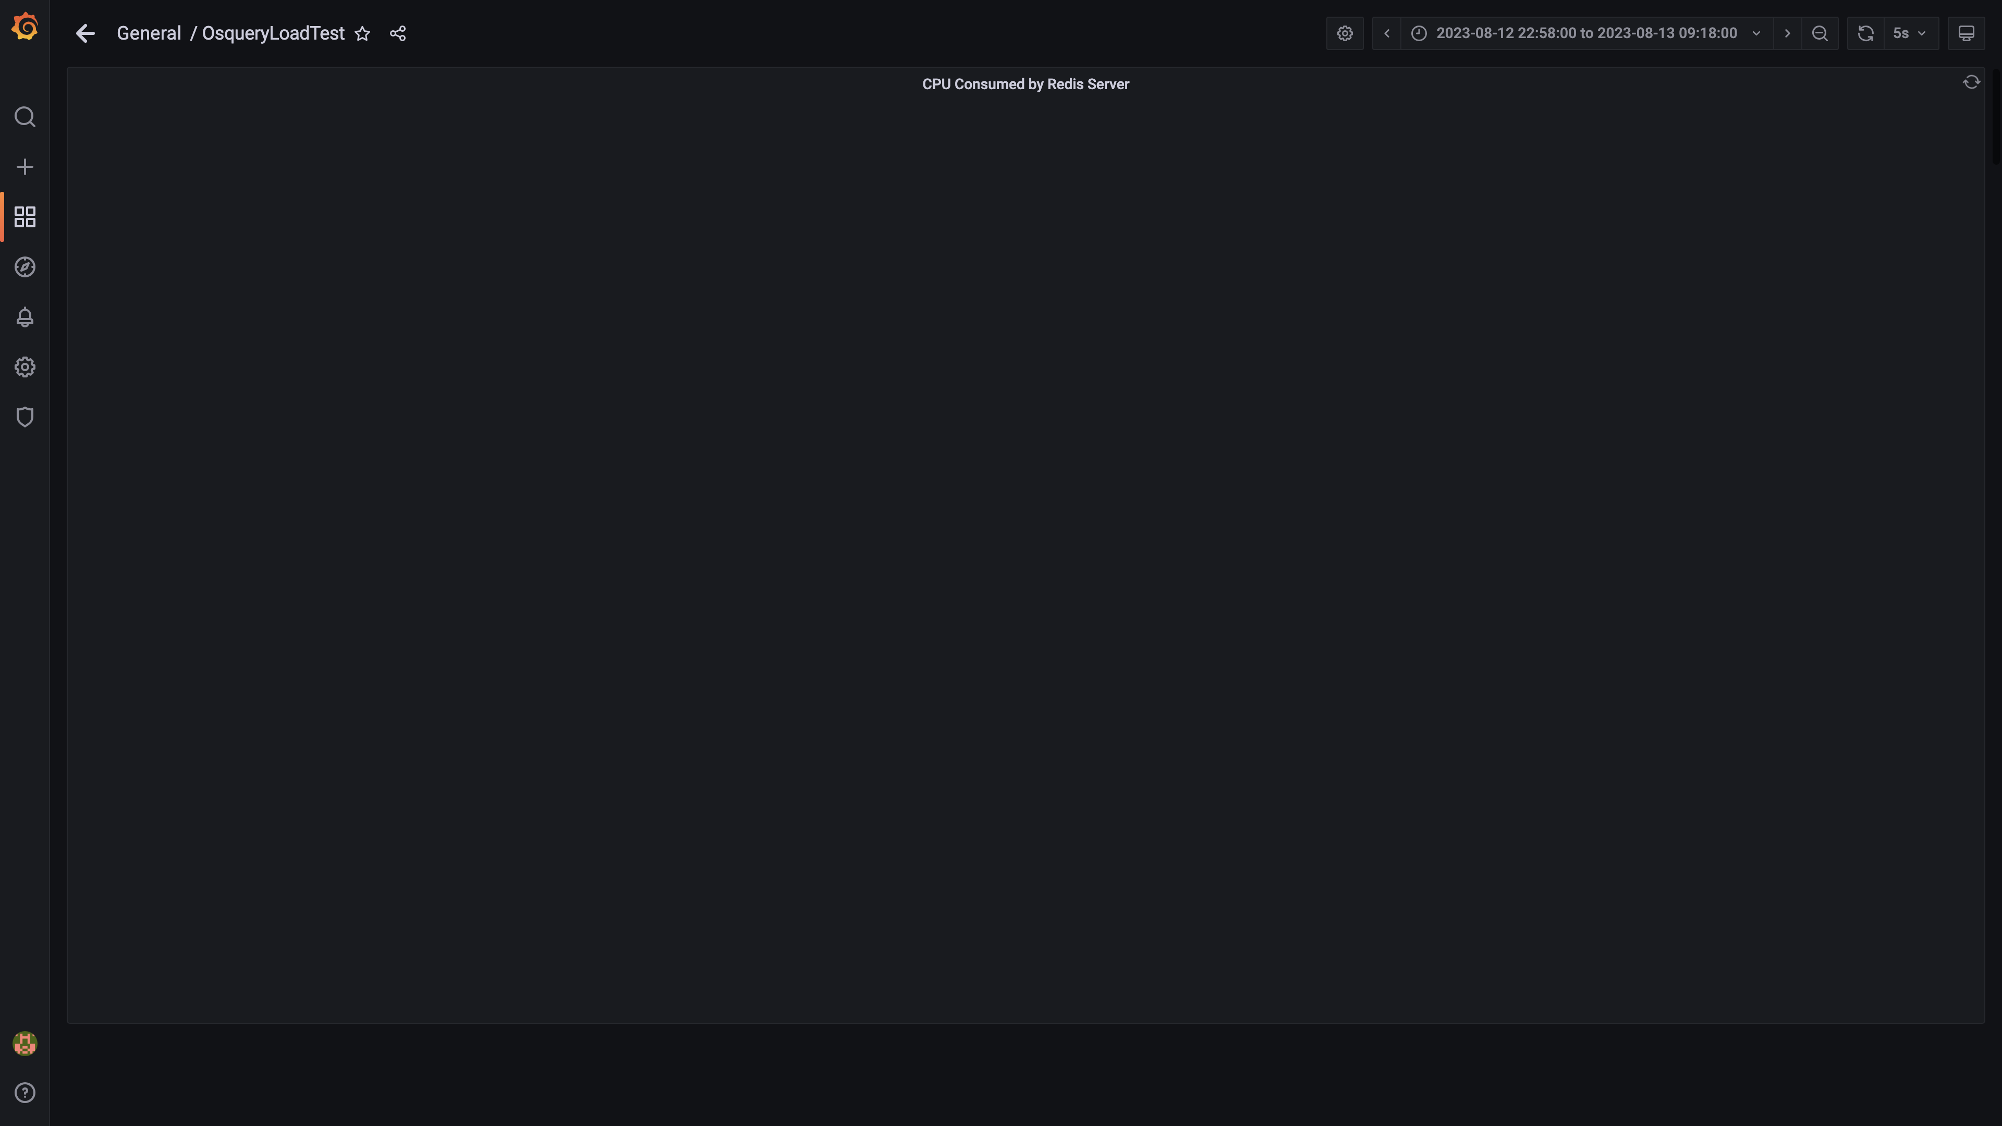

### Cpu consumed by orc-compaction

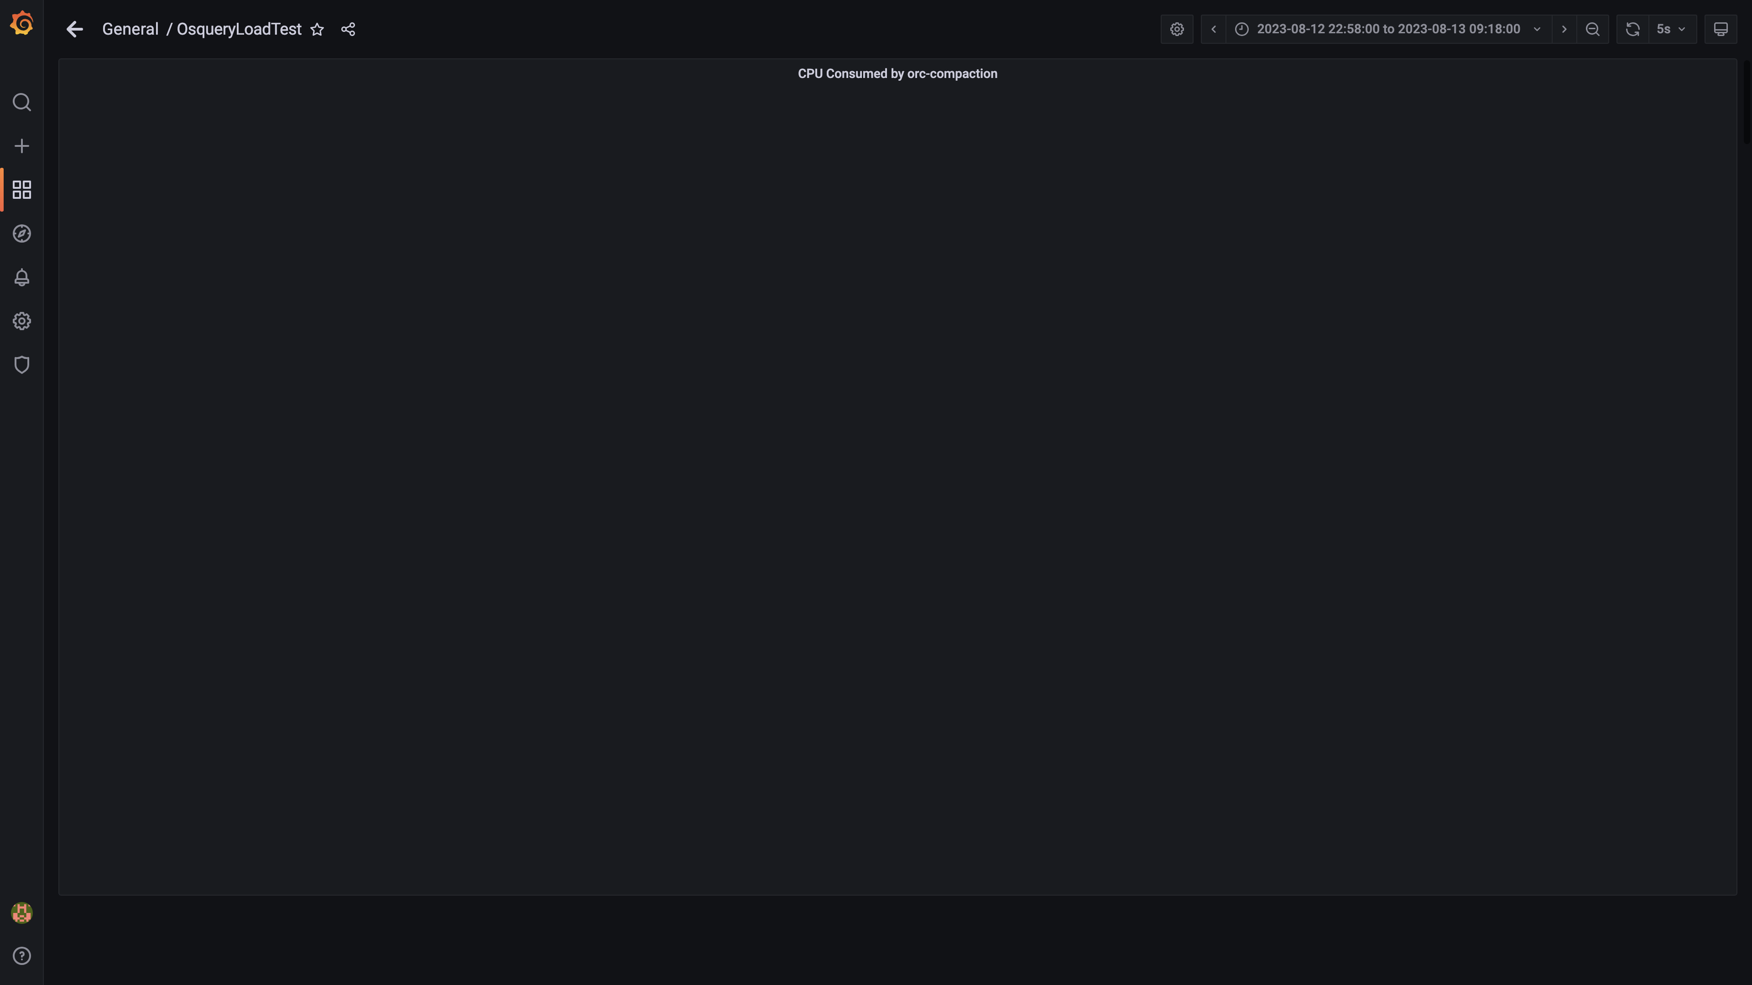

### Panel 44 not loaded in given time

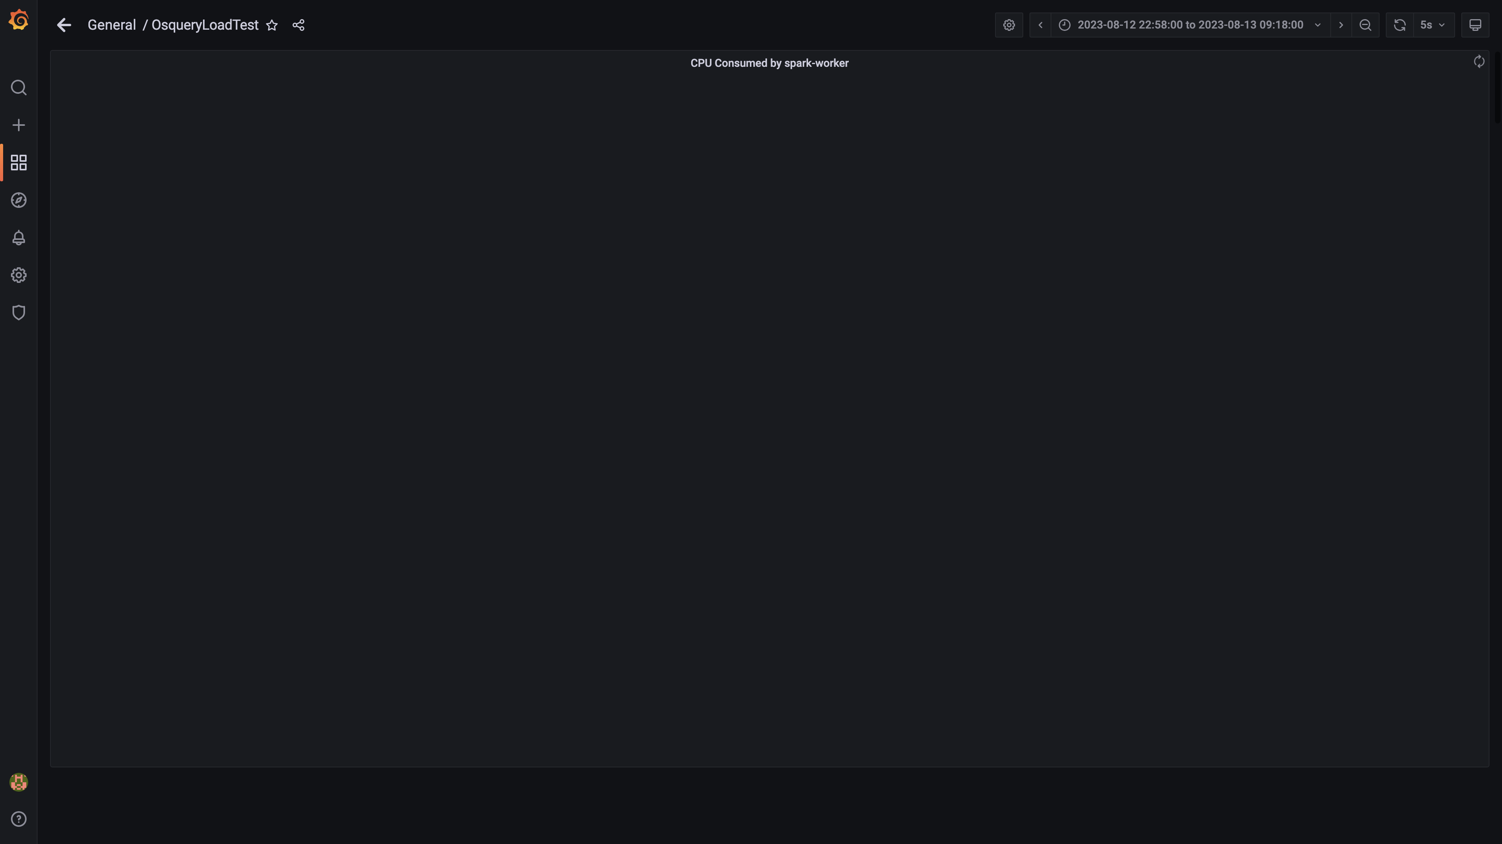

### Cpu consumed by logger

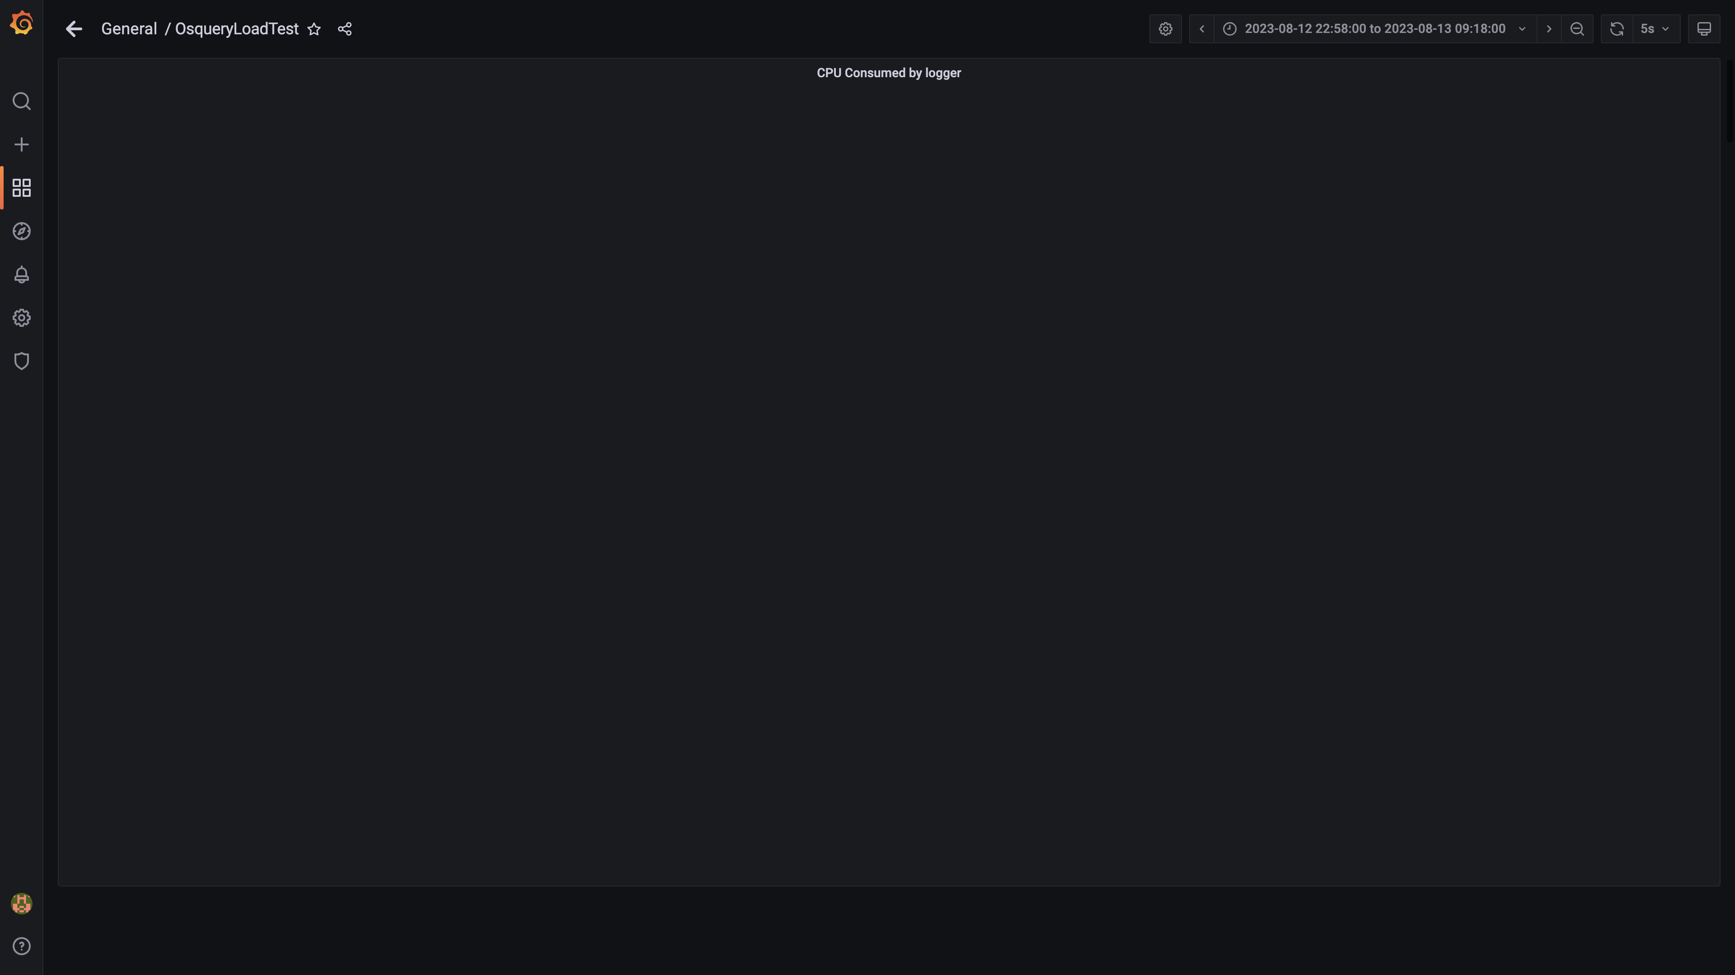

### Compliance summary consumer cpu consumption

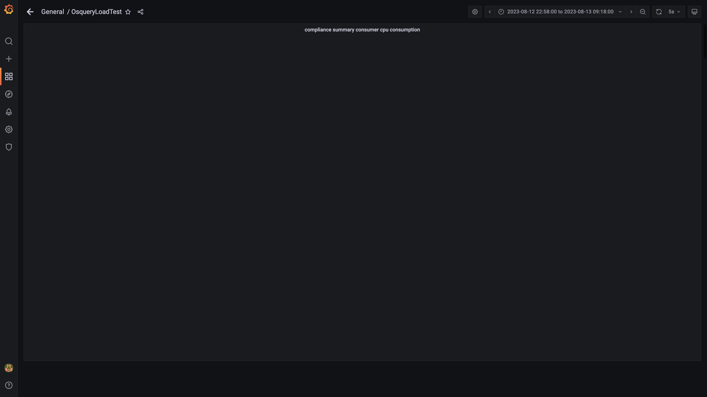

### Cpu consumed by trino

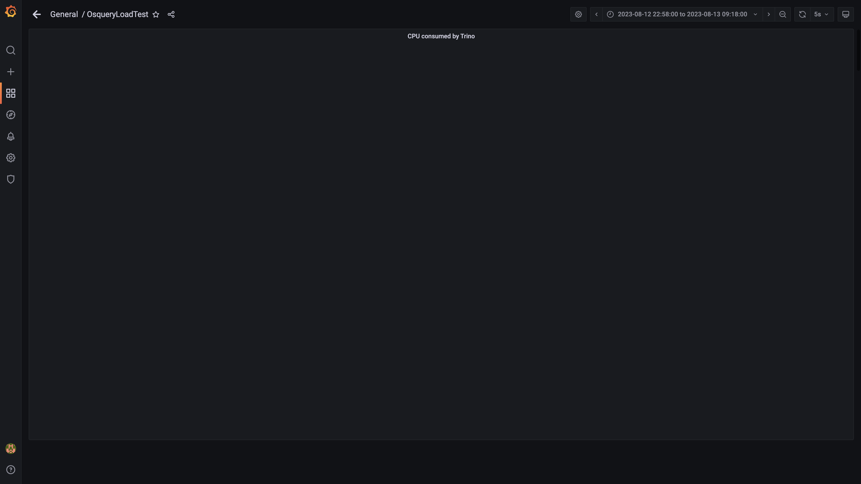

### Panel 106 not loaded in given time

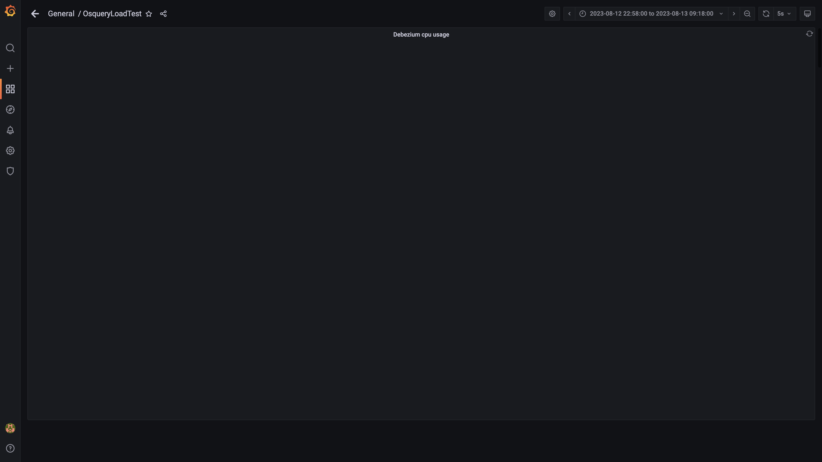

### Cpu consumed by tls

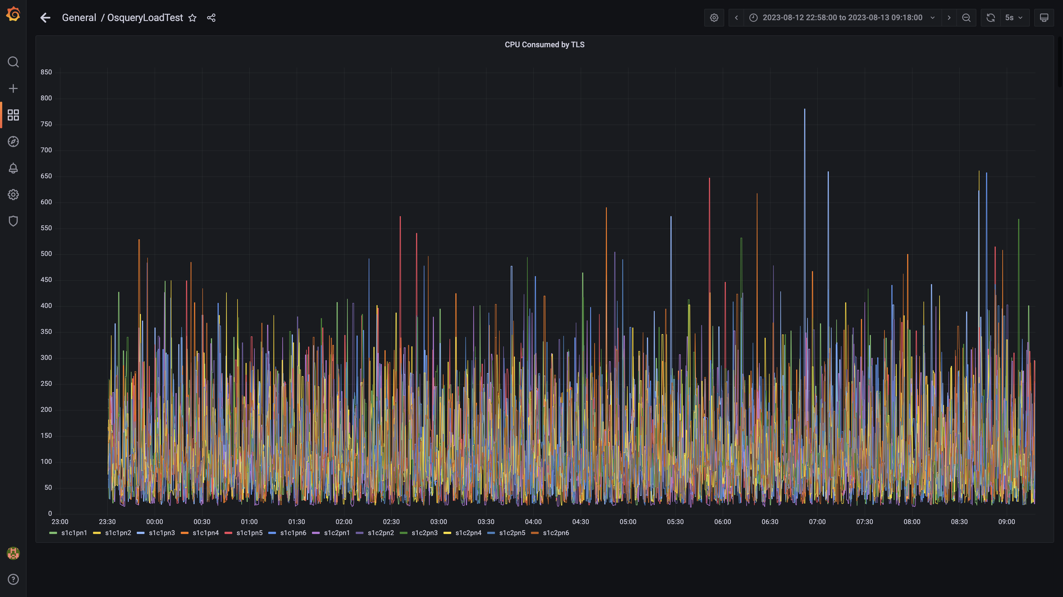

### Airflow cpu usage

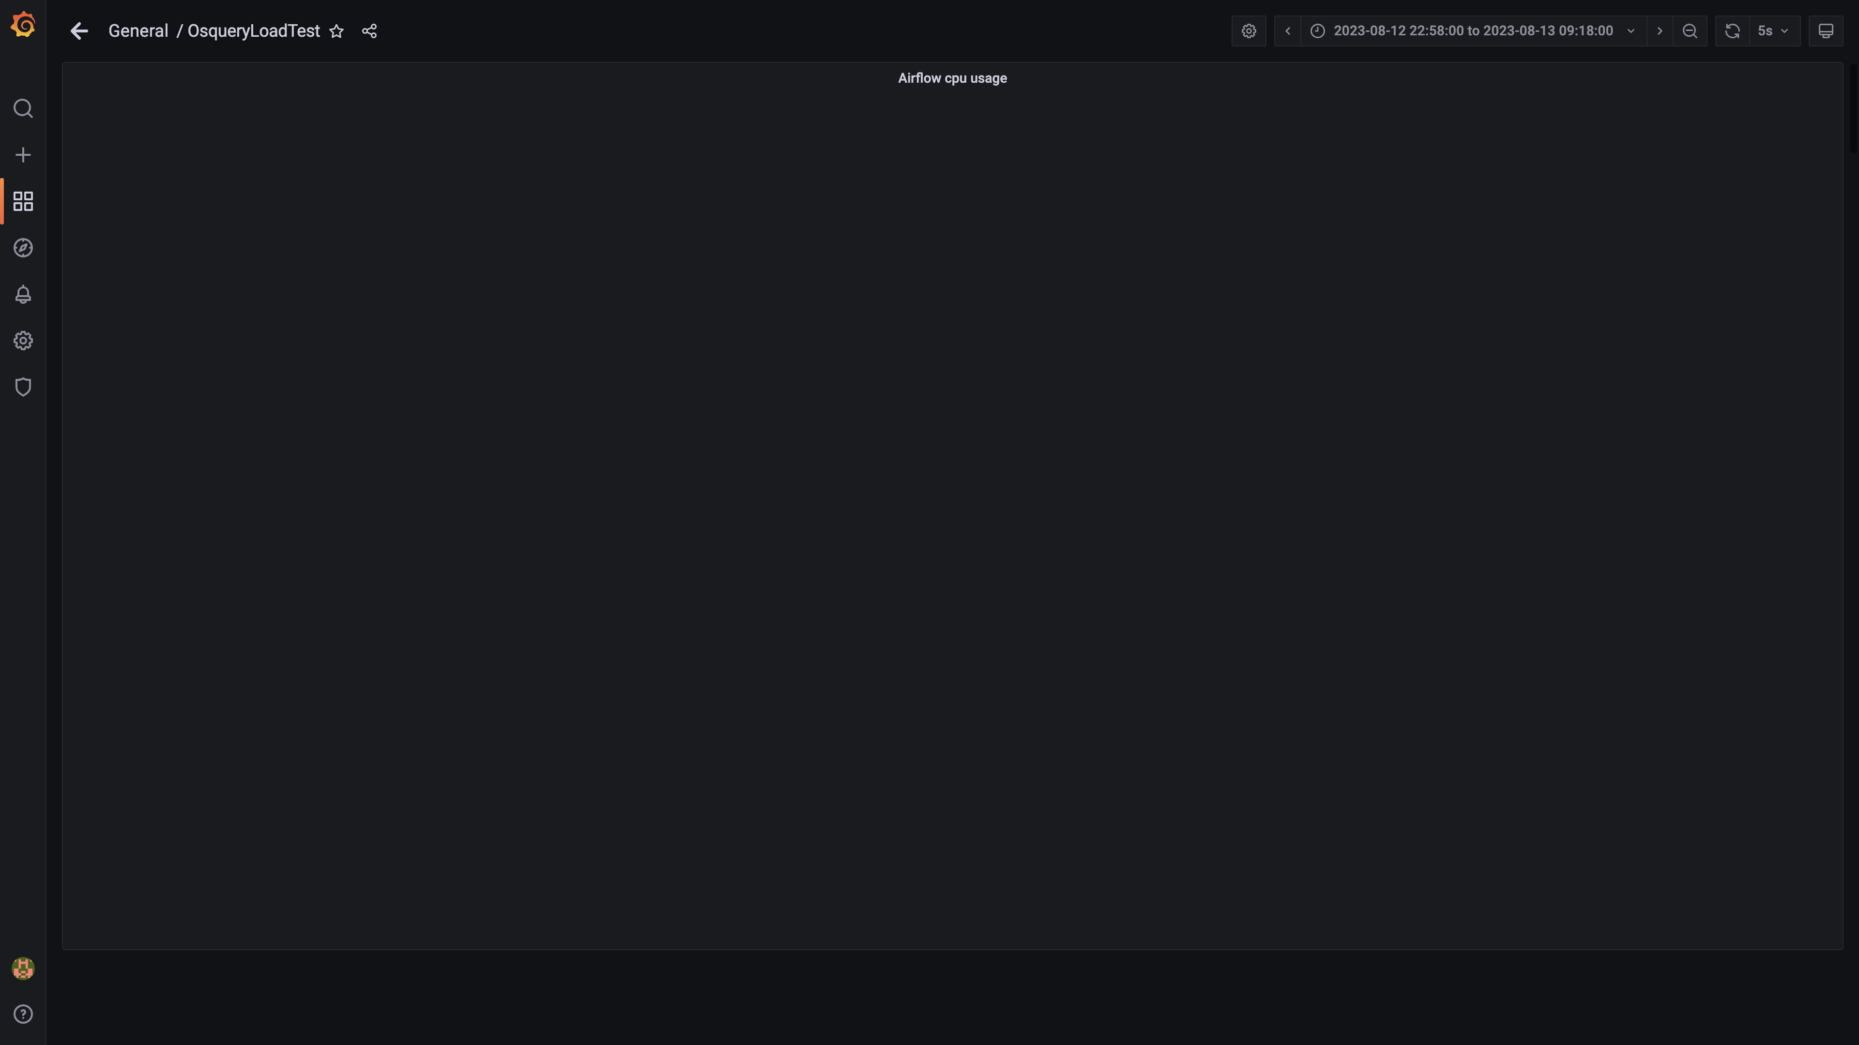

### Panel 146 not loaded in given time

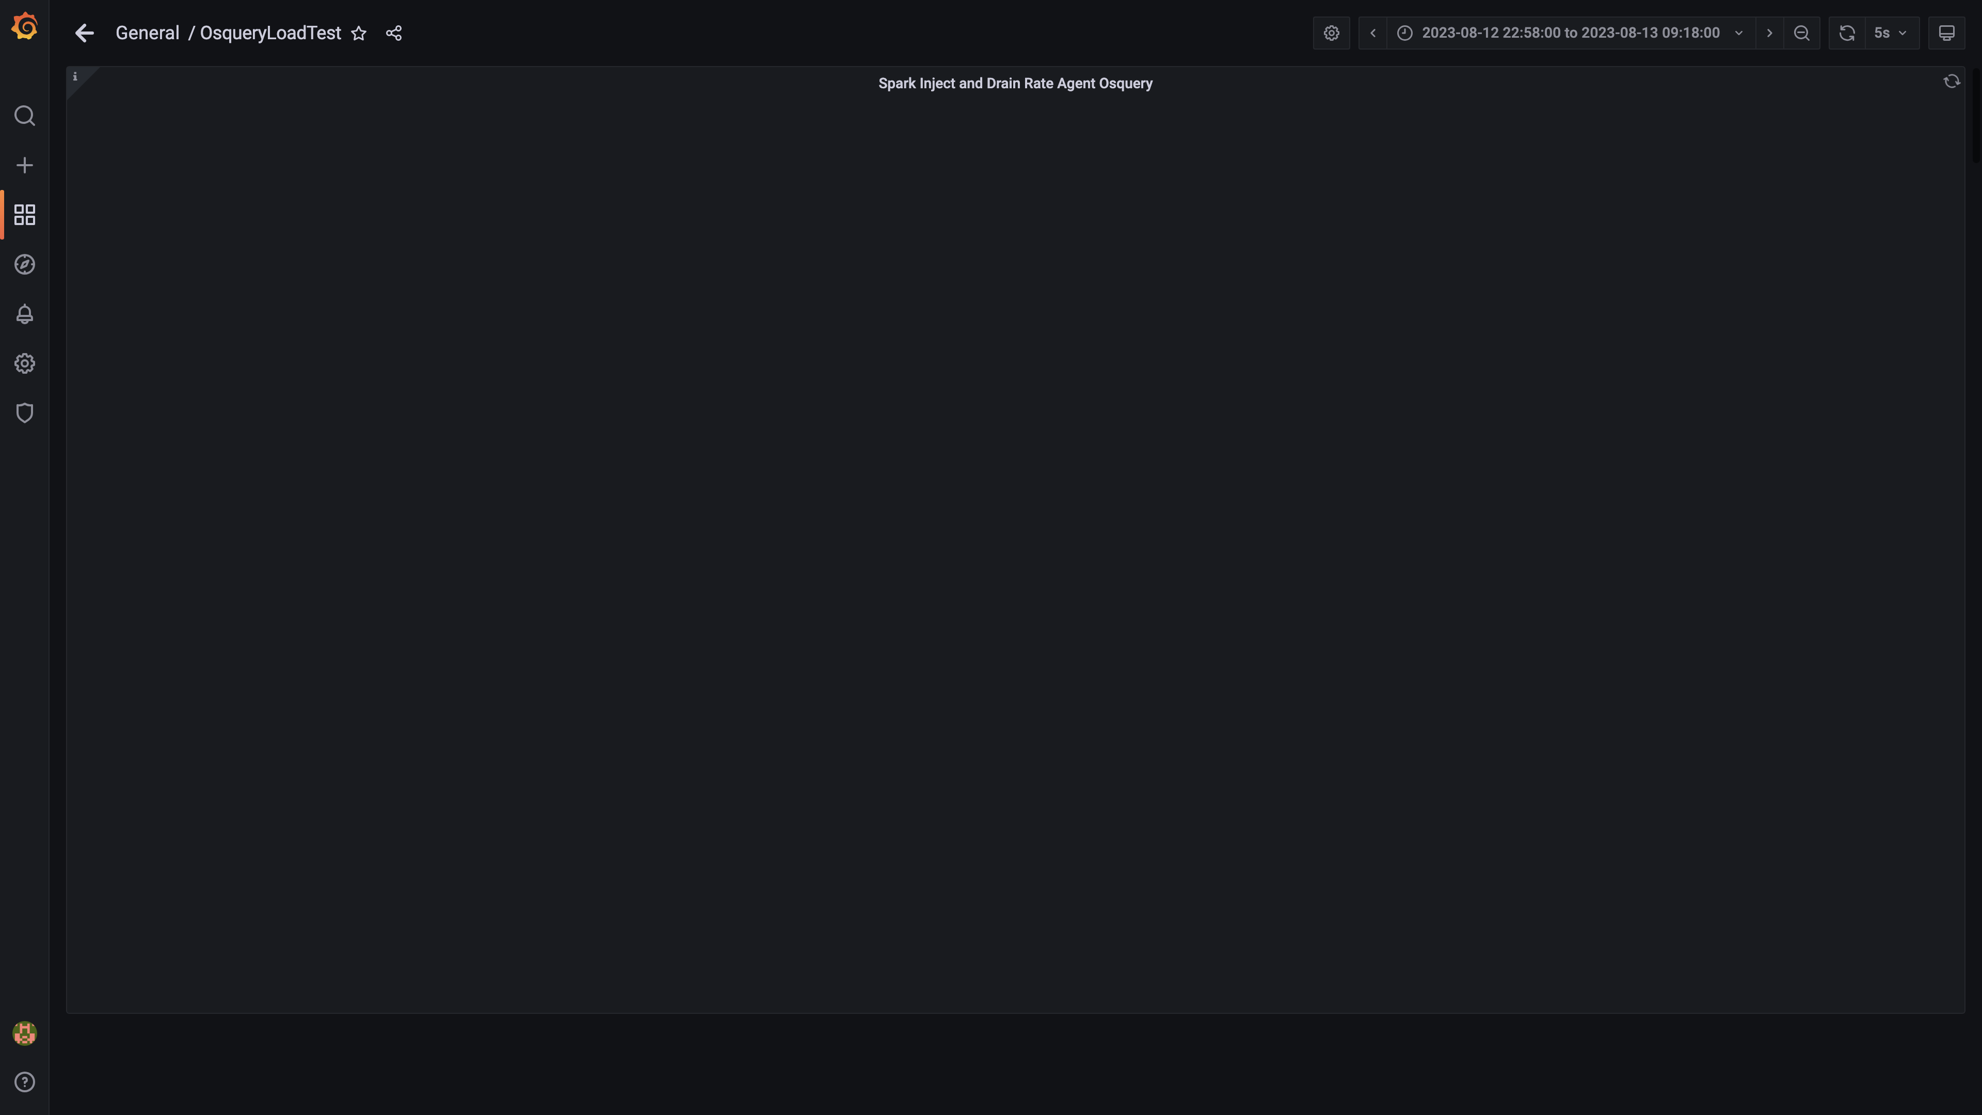

### Panel 147 not loaded in given time

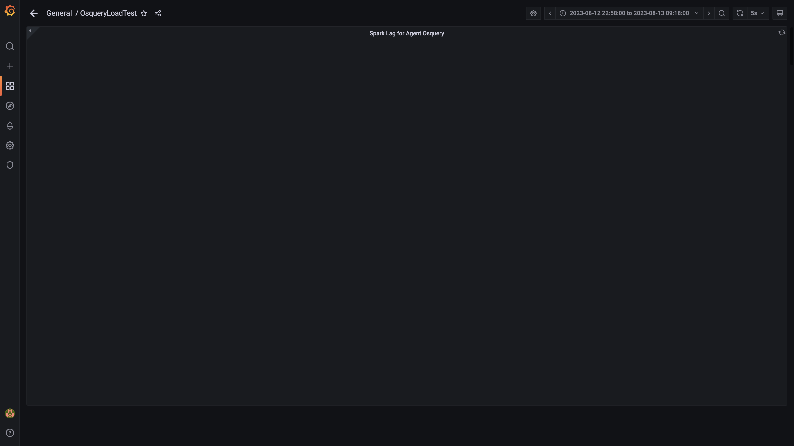

### Panel 148 not loaded in given time

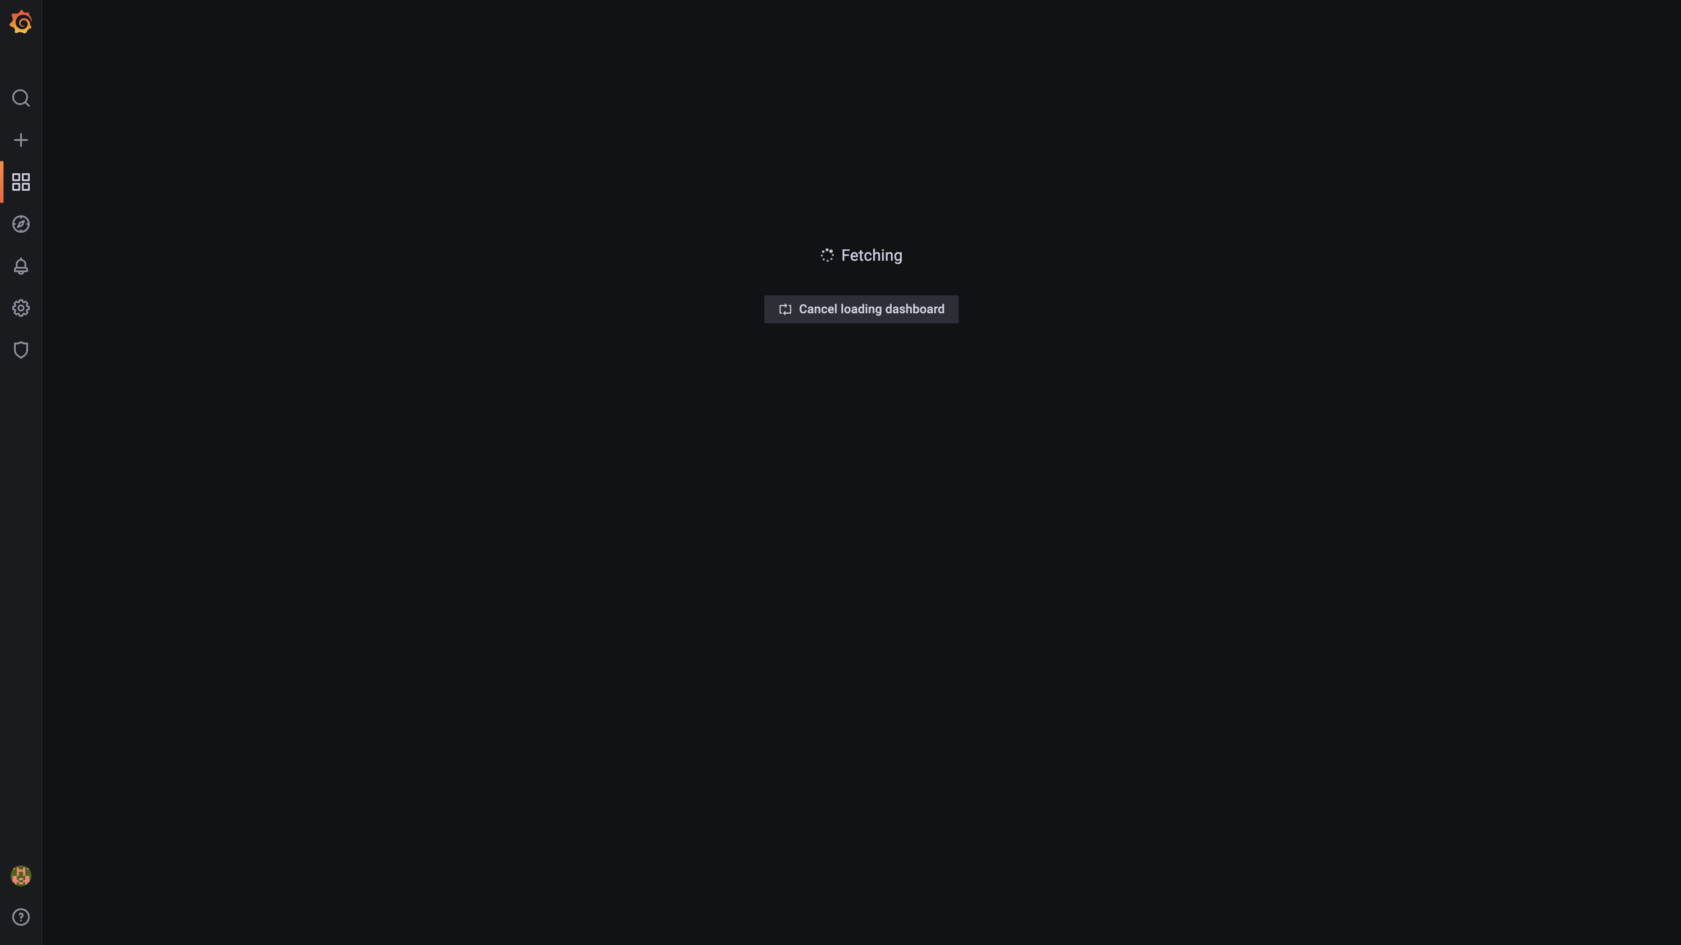

### Panel 100 not loaded in given time

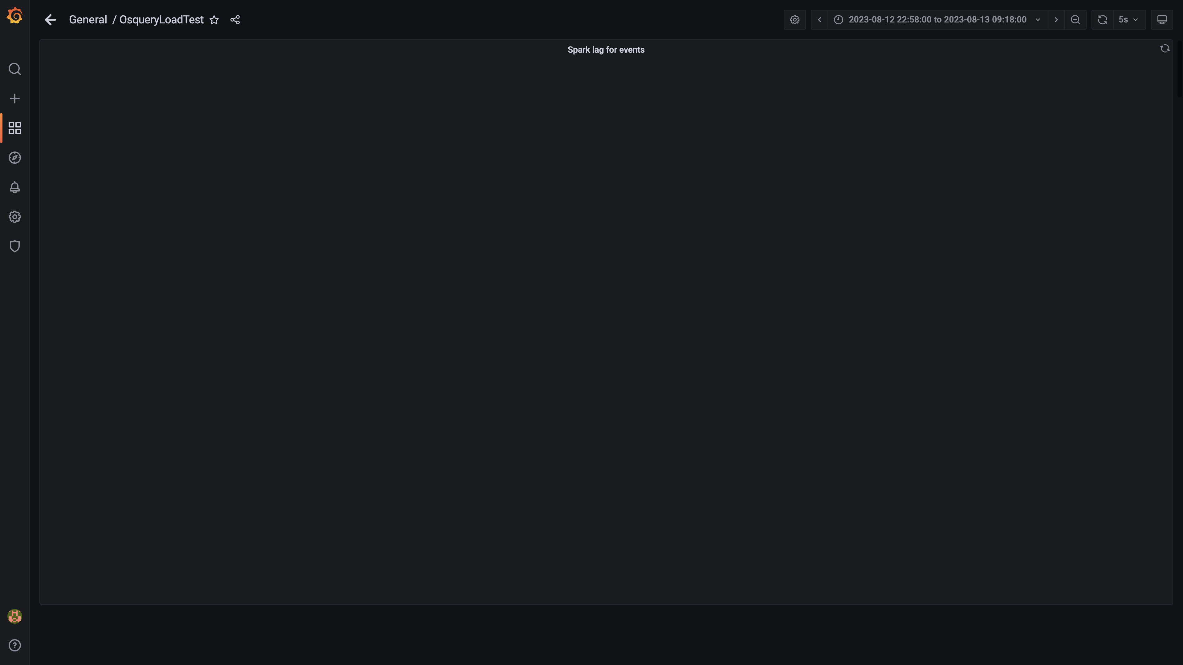

### Panel 149 not loaded in given time

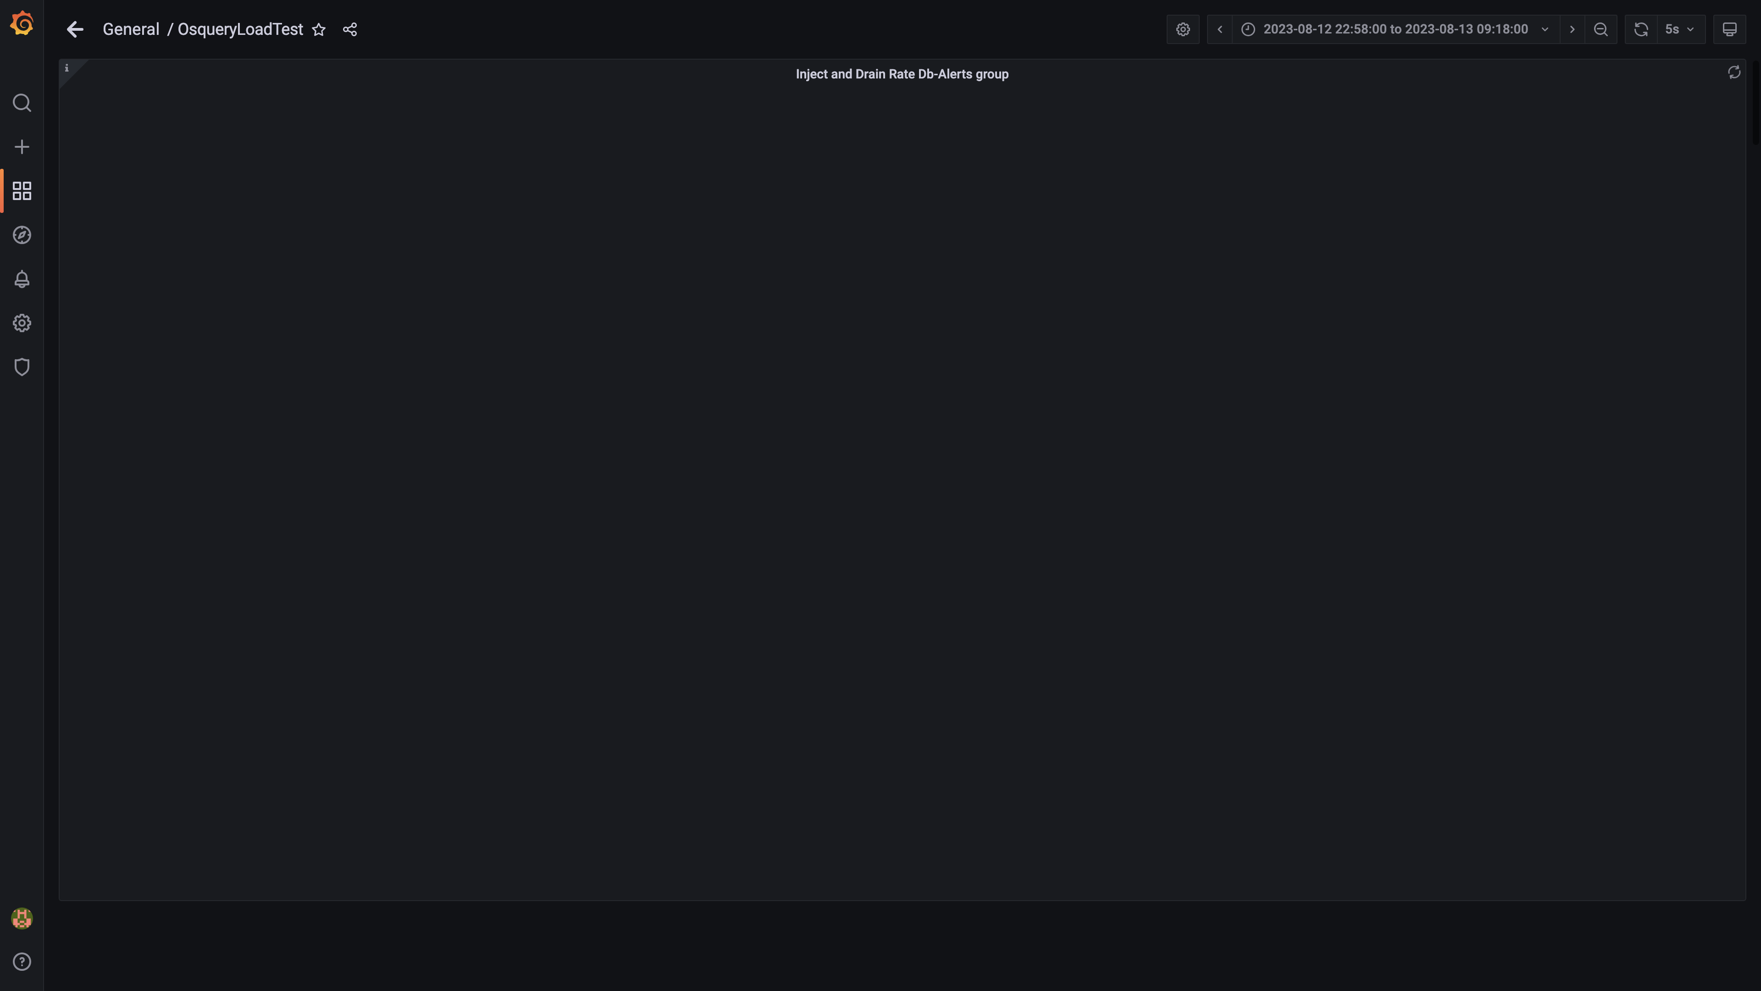

### Panel 150 not loaded in given time

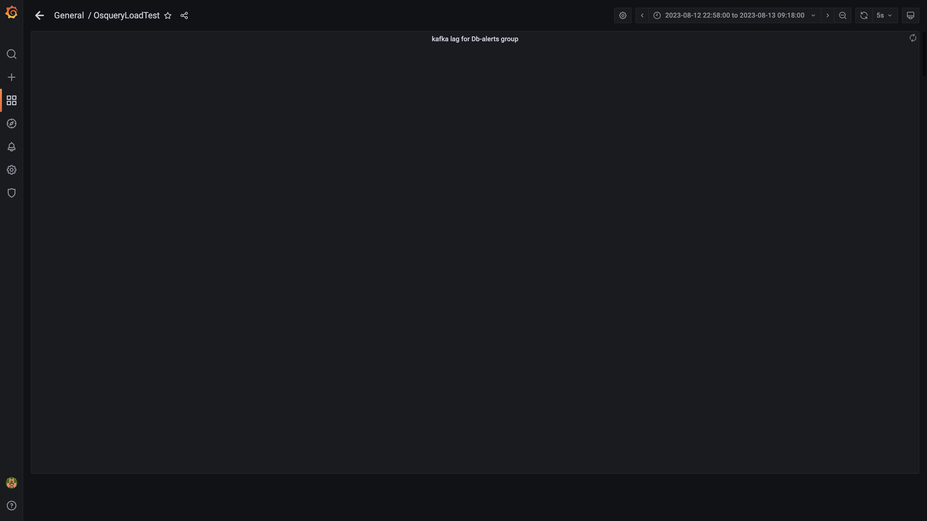

### Kafka inject and drain rates for debezium group

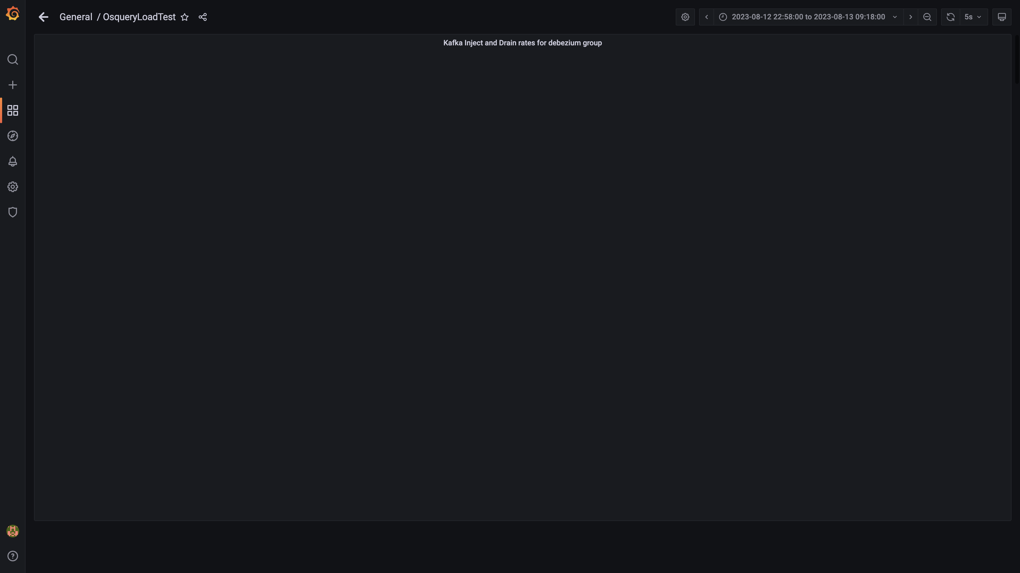

### Aggregate lag

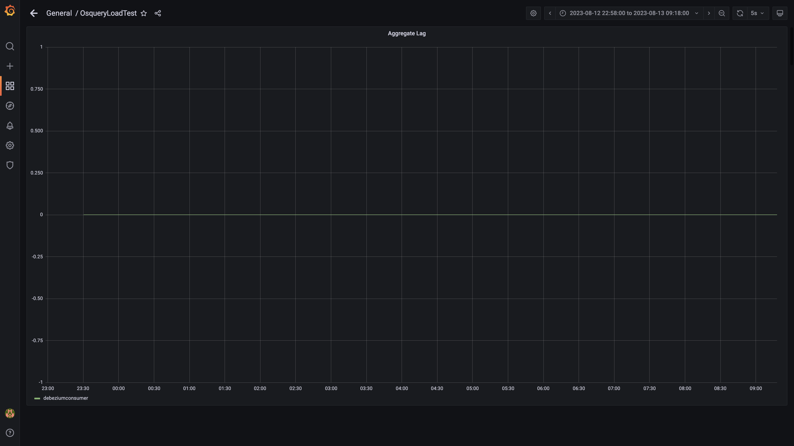

### Debezium replication lag

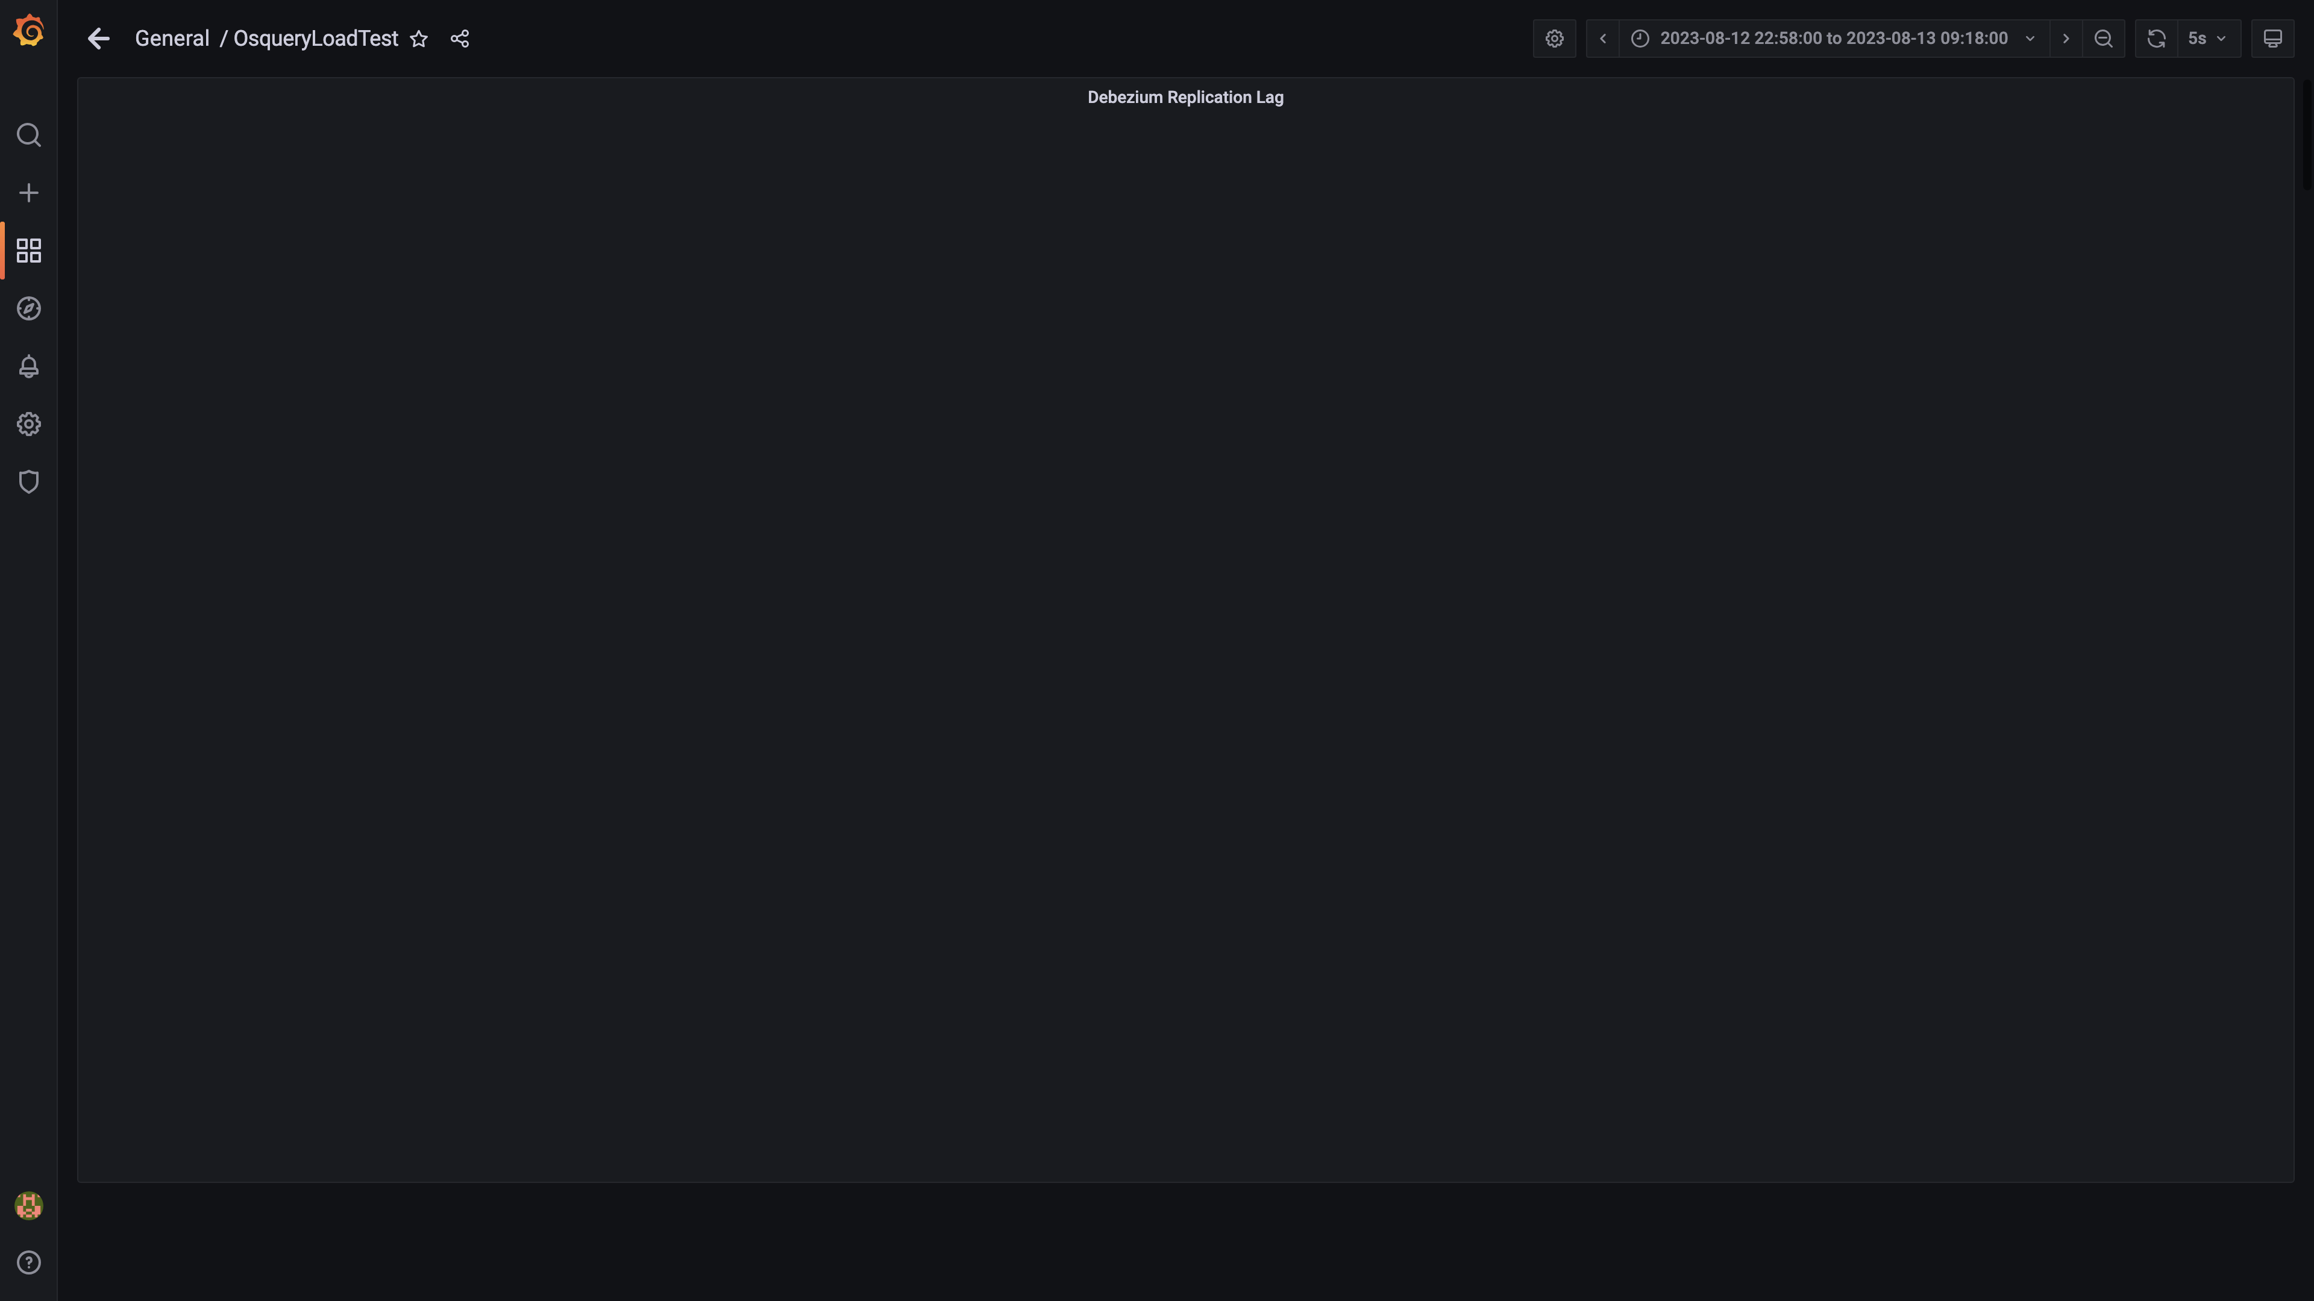

### Panel 132 not loaded in given time

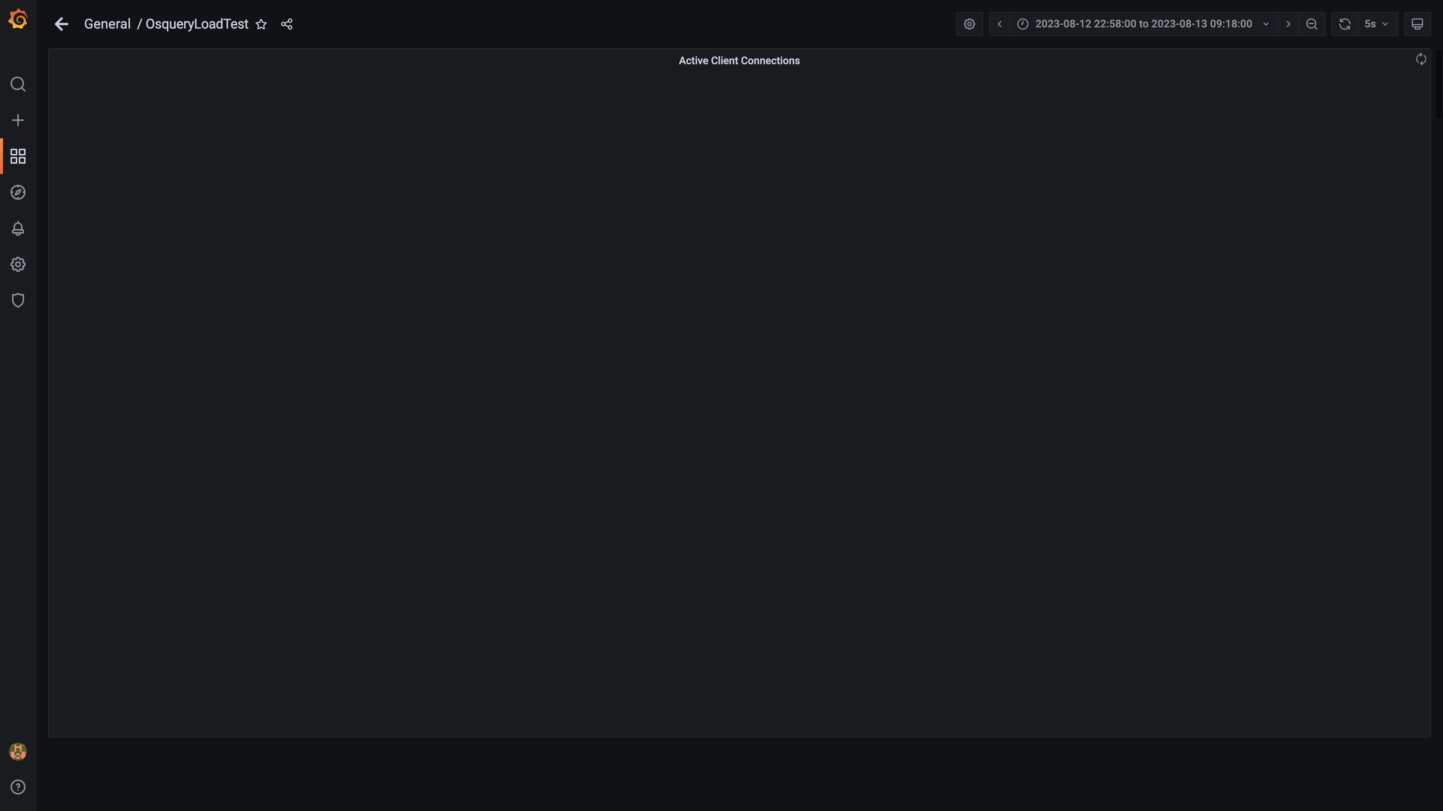

### Panel 130 not loaded in given time

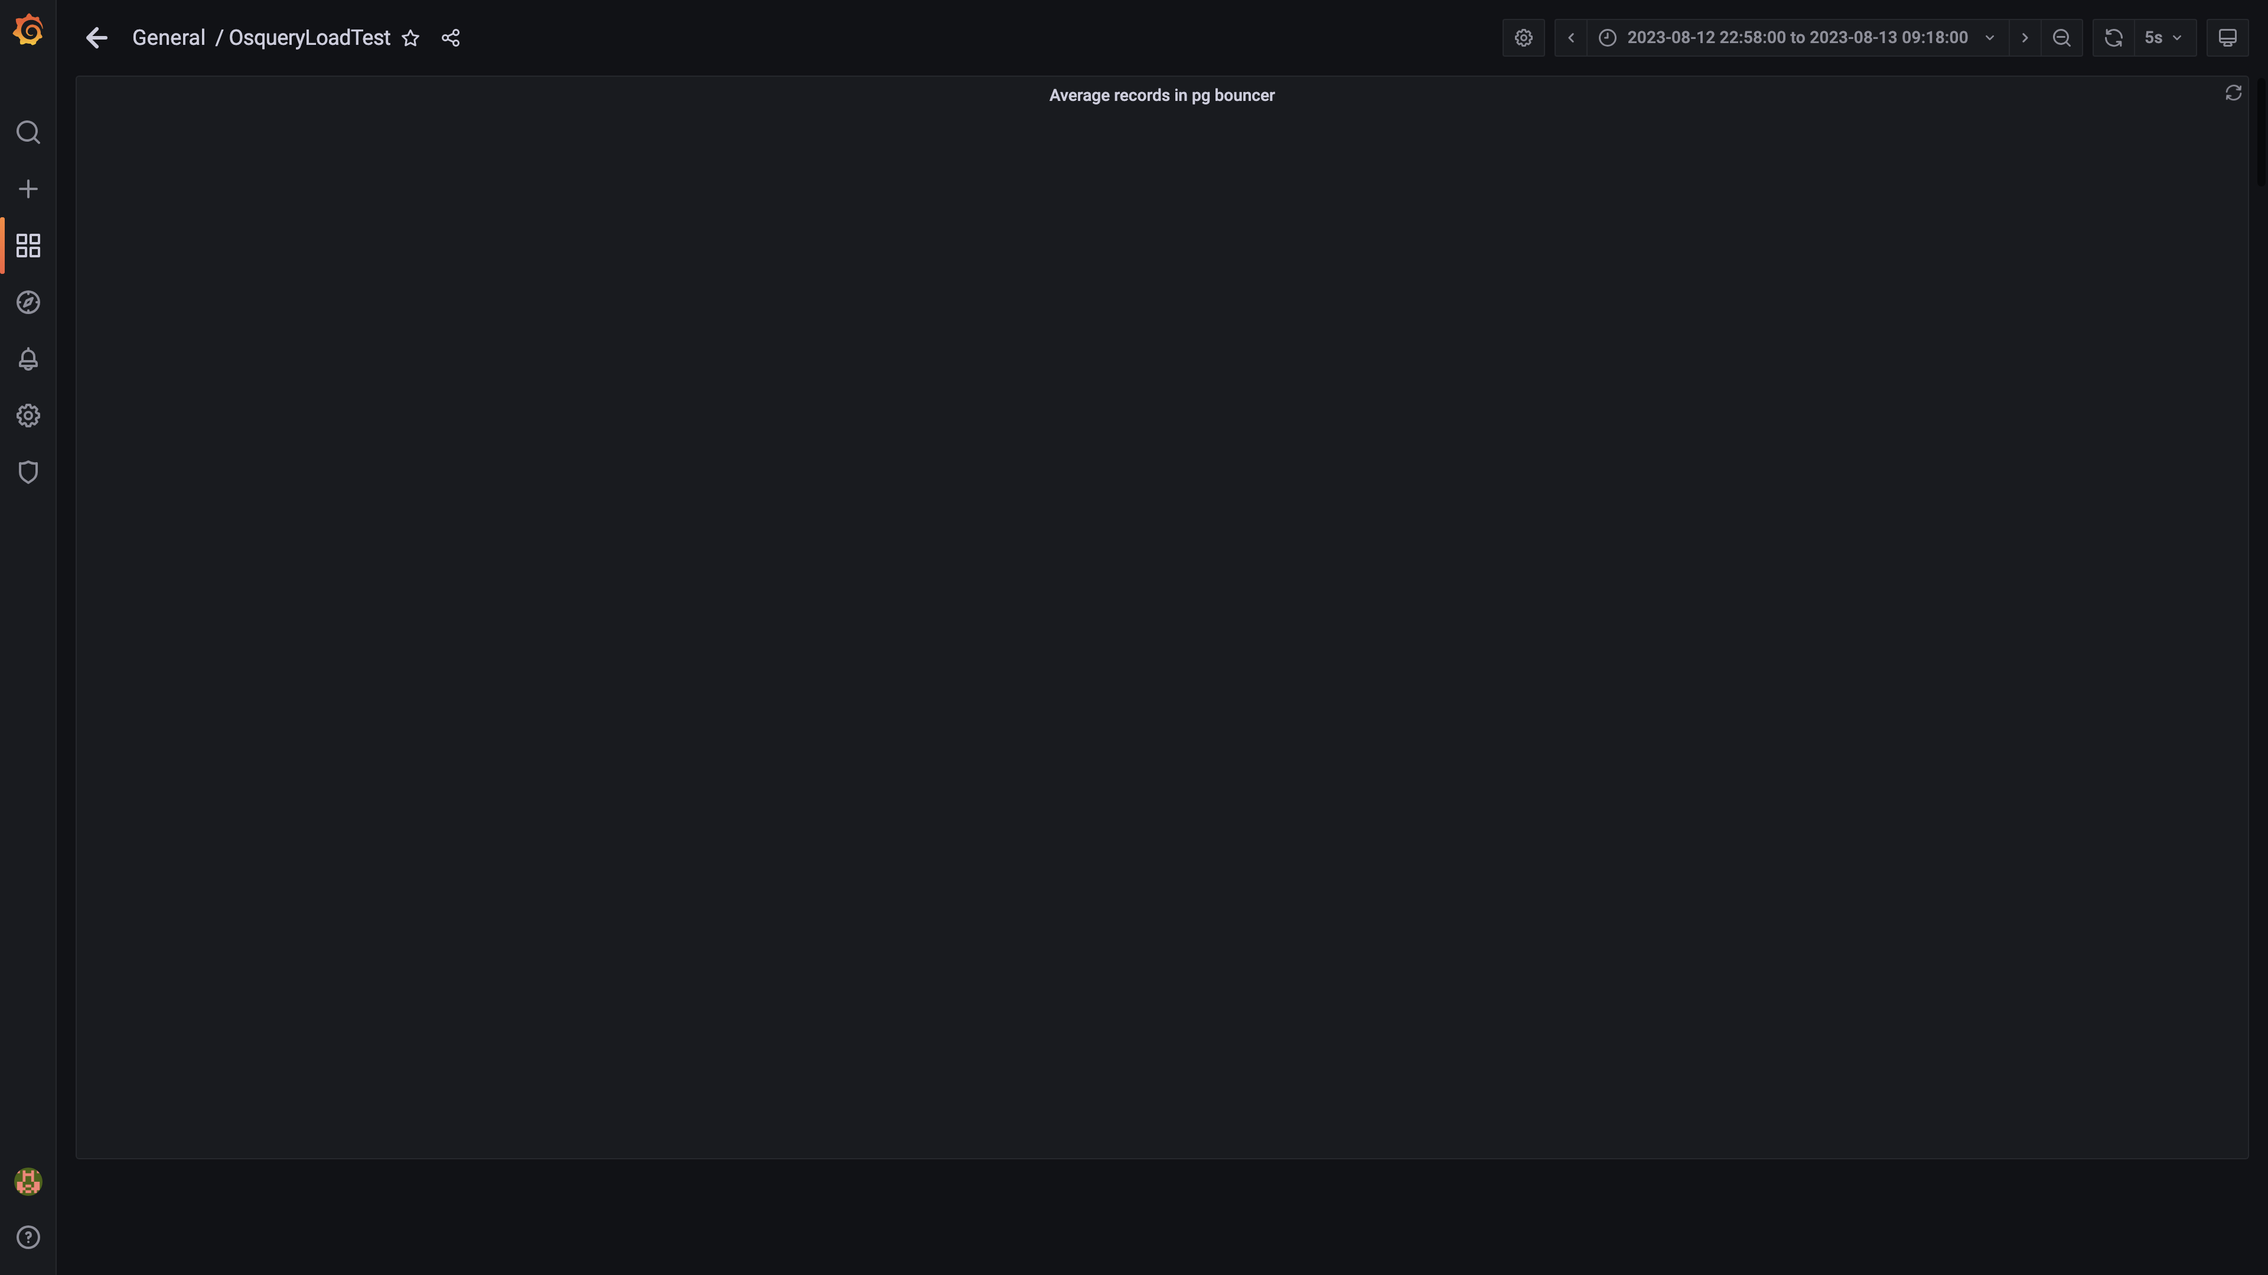

### Average time spent by pg bouncer

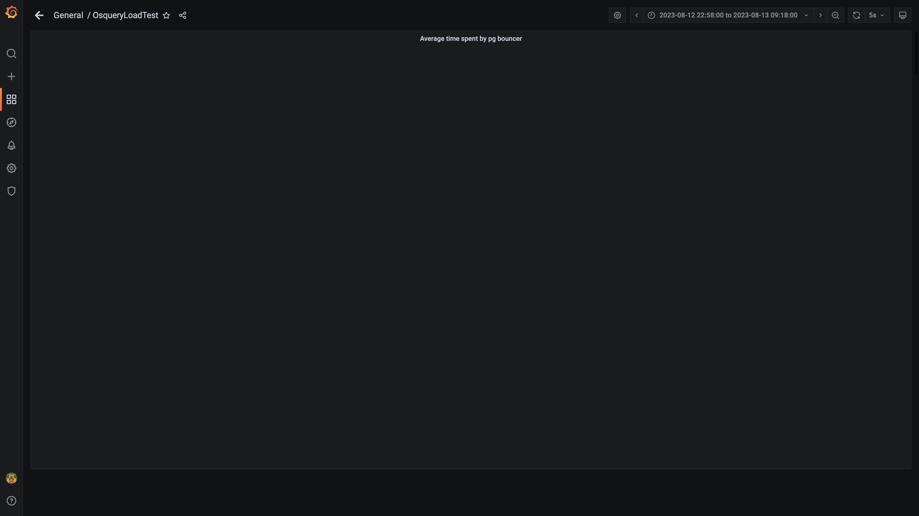

### Redis client connections for tls

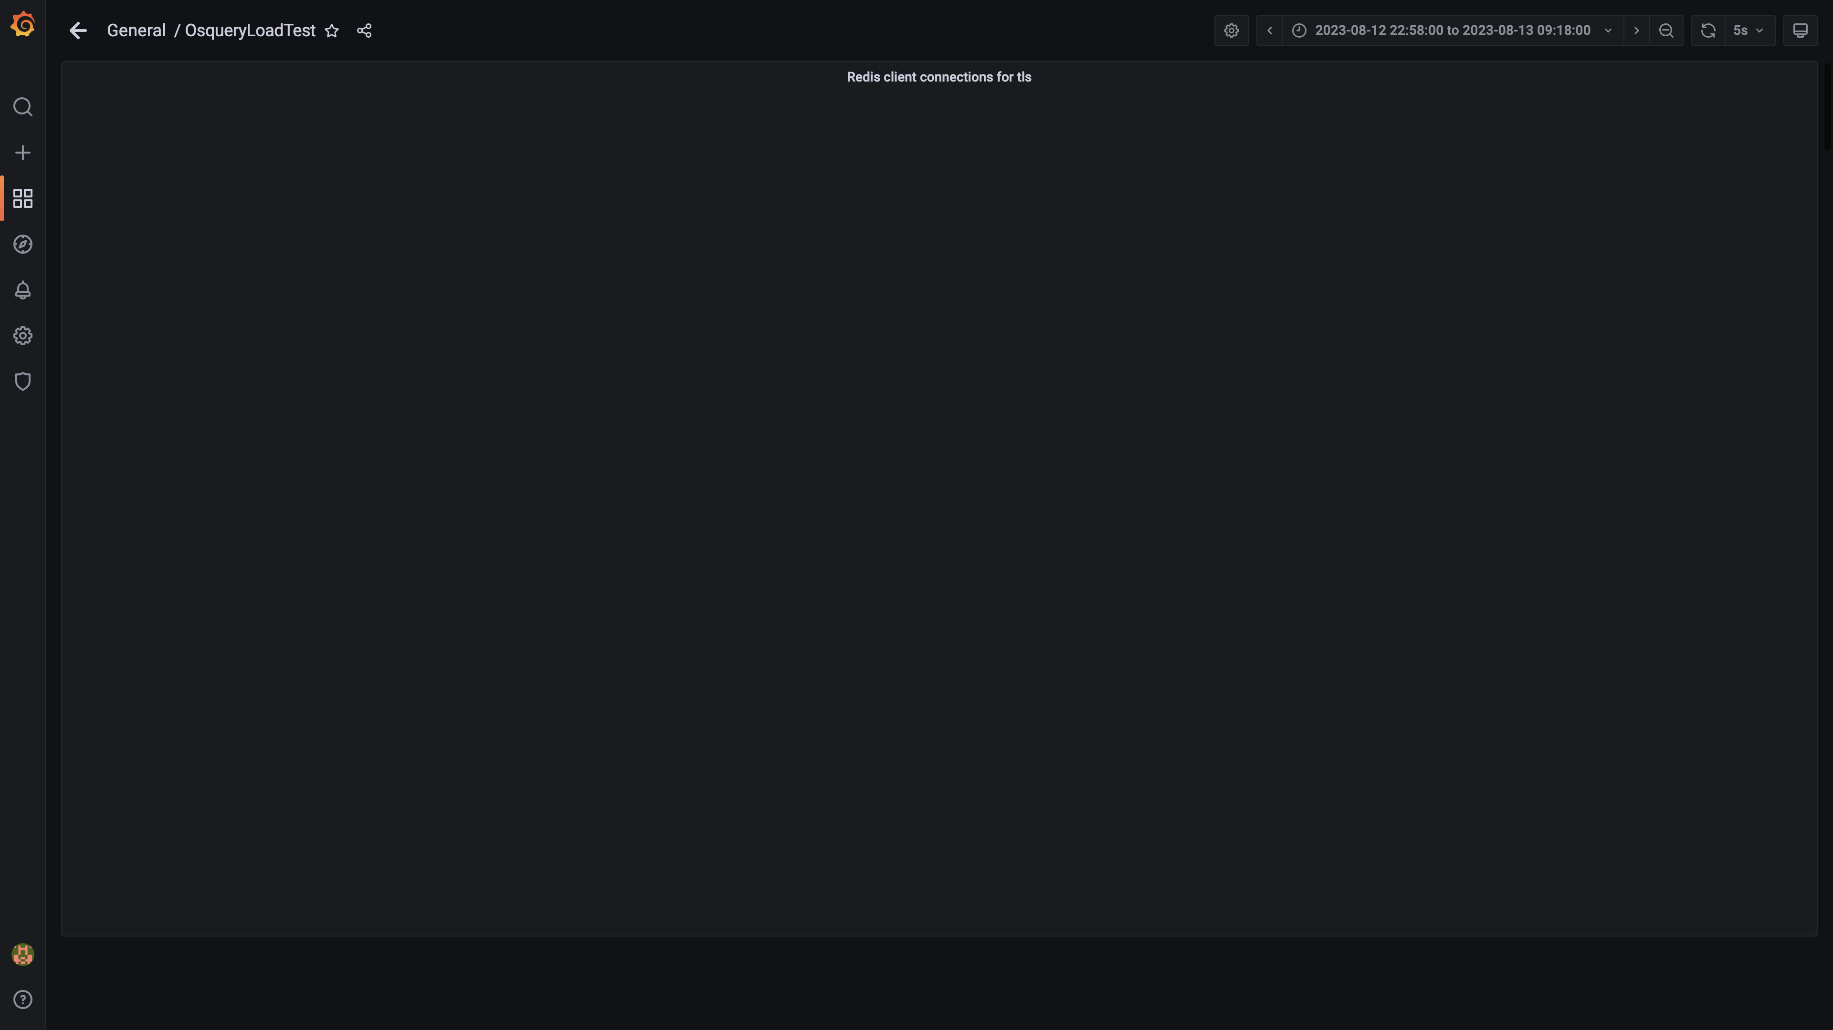

### Configdb pg wal folder size

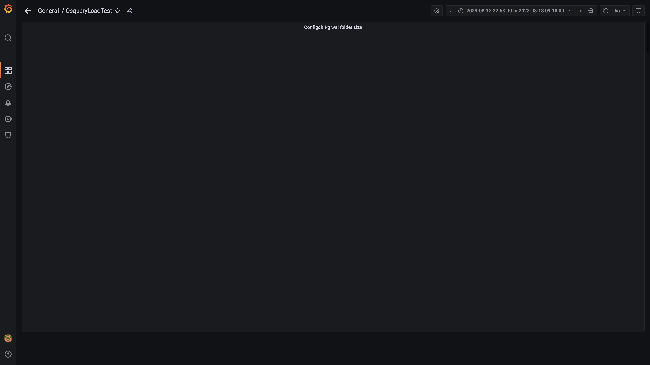

### Configdb number of wal files

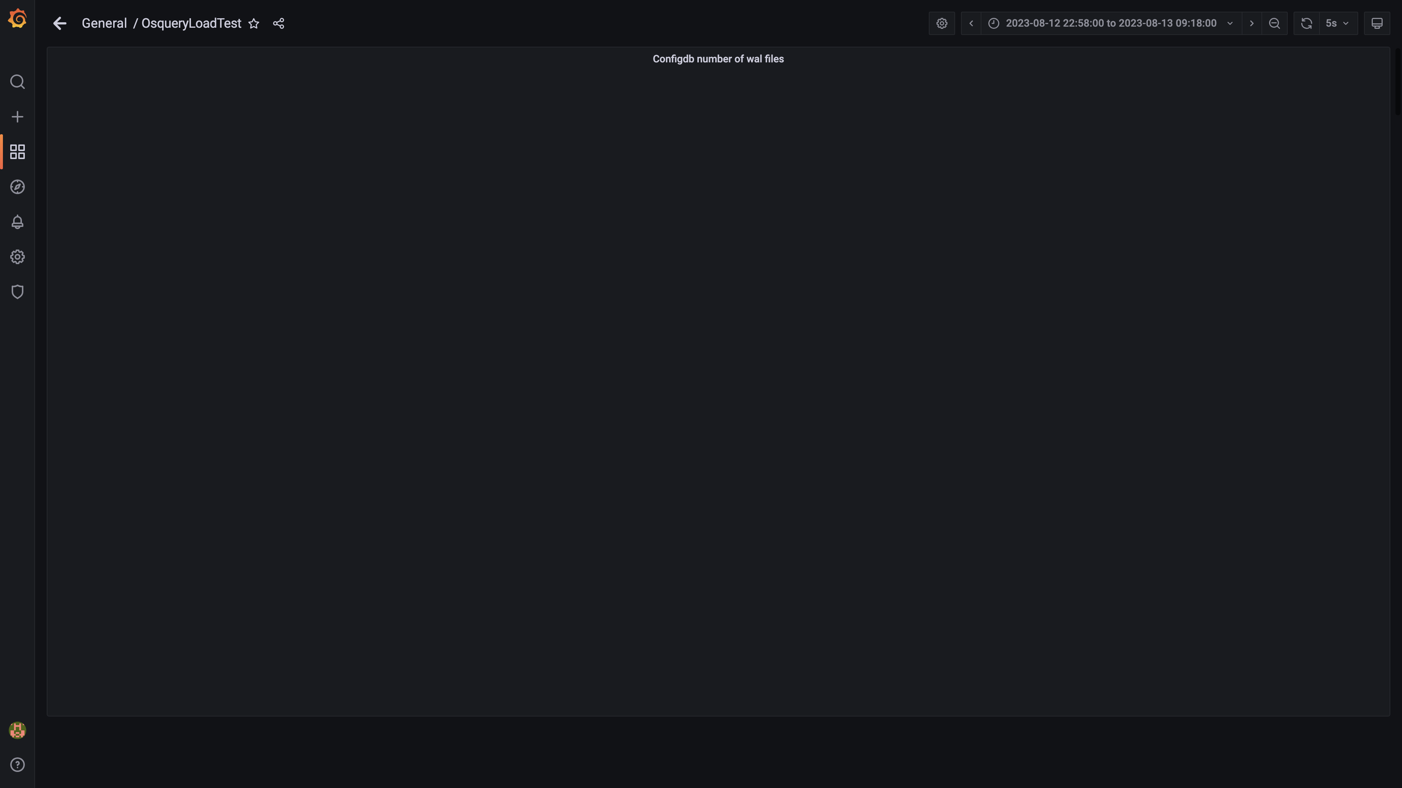

### Configdb folder size

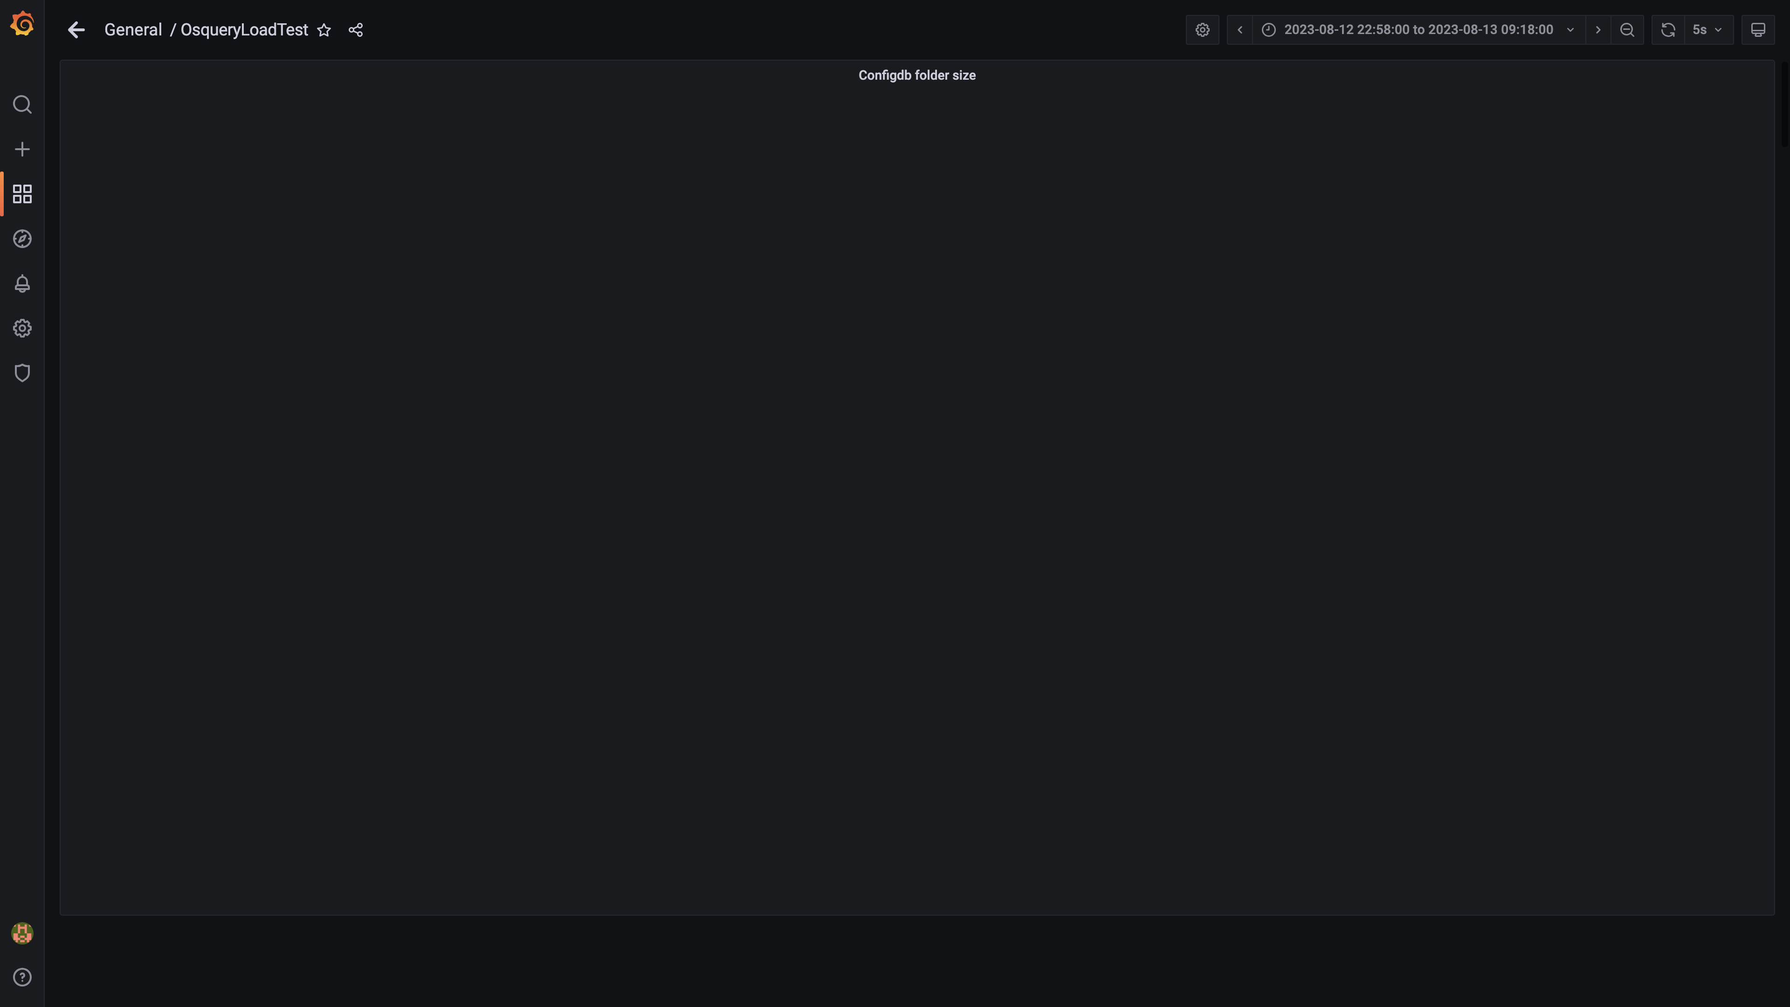

### Cpu and memory usages

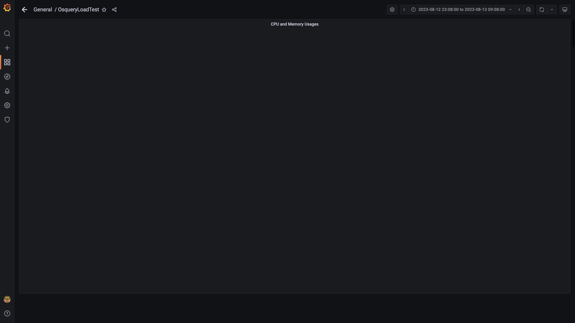

### Panel 80 not loaded in given time

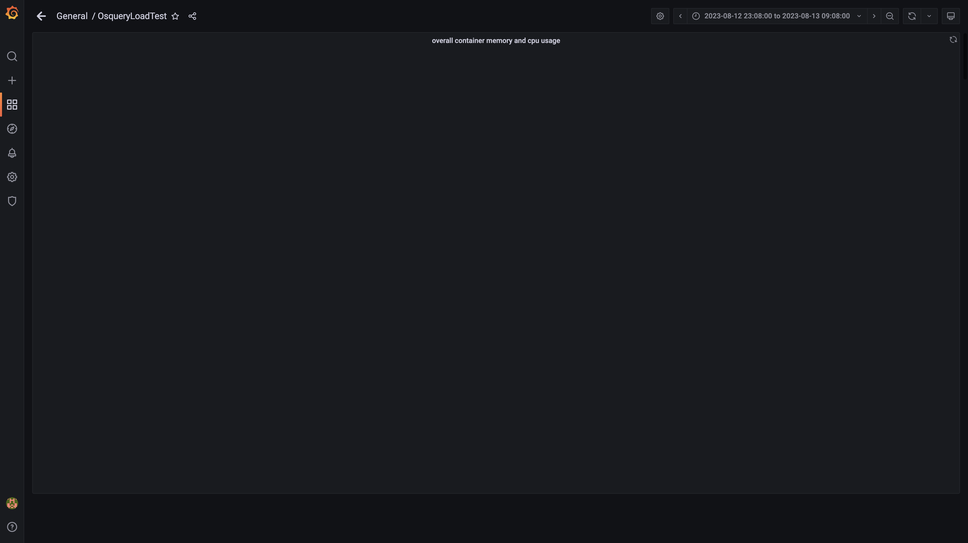

### Overall memory and cpu usages

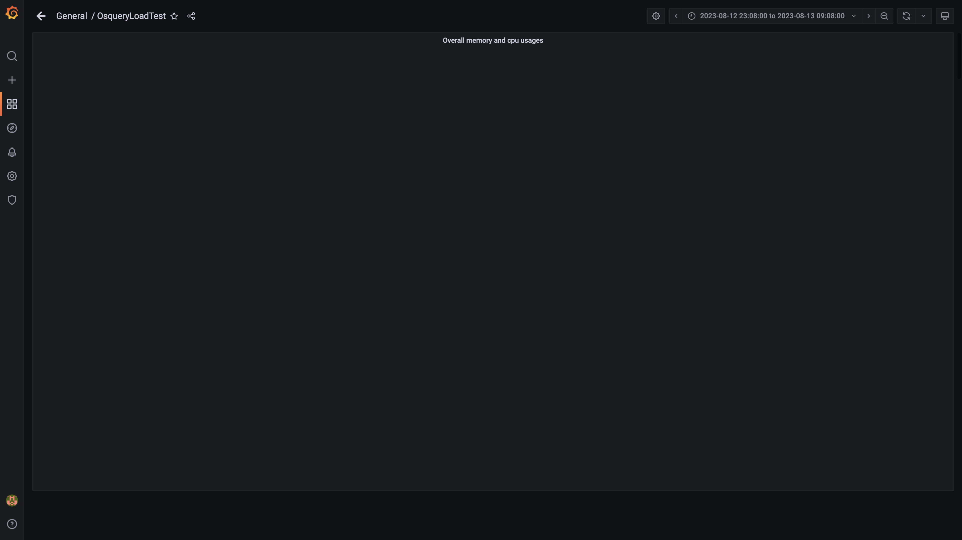

### Compaction status



## Average Resource Utilization

### Comparision of Average Memory utilization

|  |  |  |  |  |
| --- | --- | --- | --- | --- |
| Metric | 138888 | 139000 | Absolute(%) | Relative(%) |
| Memory used by s1c1dn1 | 76.46% (191.91 GB) | 76.46% (191.91 GB) | 0.00 GB (0.00%) | 0.00 % |
| Memory used by s1c1dn2 | 75.37% (189.18 GB) | 75.37% (189.18 GB) | 0.00 GB (0.00%) | 0.00 % |
| Memory used by s1c1dn3 | 76.47% (191.93 GB) | 76.47% (191.93 GB) | 0.00 GB (0.00%) | 0.00 % |
| Memory used by s1c1dn4 | 81.16% (152.58 GB) | 81.16% (152.58 GB) | 0.00 GB (0.00%) | 0.00 % |
| Memory used by s1c1dn5 | 80.76% (151.82 GB) | 80.76% (151.82 GB) | 0.00 GB (0.00%) | 0.00 % |
| Memory used by s1c1dn6 | 82.17% (154.49 GB) | 82.17% (154.49 GB) | 0.00 GB (0.00%) | 0.00 % |
| Memory used by s1c1pn1 | 29.94% (56.28 GB) | 29.94% (56.28 GB) | 0.00 GB (0.00%) | 0.00 % |
| Memory used by s1c1pn2 | 29.41% (55.29 GB) | 29.41% (55.29 GB) | 0.00 GB (0.00%) | 0.00 % |
| Memory used by s1c1pn3 | 28.40% (53.40 GB) | 28.40% (53.40 GB) | 0.00 GB (0.00%) | 0.00 % |
| Memory used by s1c1pn4 | 29.62% (55.69 GB) | 29.62% (55.69 GB) | 0.00 GB (0.00%) | 0.00 % |
| Memory used by s1c1pn5 | 28.40% (53.40 GB) | 28.40% (53.40 GB) | 0.00 GB (0.00%) | 0.00 % |
| Memory used by s1c1pn6 | 27.61% (51.91 GB) | 27.61% (51.91 GB) | 0.00 GB (0.00%) | 0.00 % |
| Memory used by s1c2dn1 | 62.70% (157.37 GB) | 62.70% (157.37 GB) | 0.00 GB (0.00%) | 0.00 % |
| Memory used by s1c2dn2 | 66.16% (166.06 GB) | 66.16% (166.06 GB) | 0.00 GB (0.00%) | 0.00 % |
| Memory used by s1c2dn3 | 61.63% (154.70 GB) | 61.63% (154.70 GB) | 0.00 GB (0.00%) | 0.00 % |
| Memory used by s1c2dn4 | 76.56% (143.94 GB) | 76.56% (143.94 GB) | 0.00 GB (0.00%) | 0.00 % |
| Memory used by s1c2dn5 | 73.86% (138.85 GB) | 73.86% (138.85 GB) | 0.00 GB (0.00%) | 0.00 % |
| Memory used by s1c2dn6 | 75.58% (142.10 GB) | 75.58% (142.10 GB) | 0.00 GB (0.00%) | 0.00 % |
| Memory used by s1c2pn1 | 26.52% (49.86 GB) | 26.52% (49.86 GB) | 0.00 GB (0.00%) | 0.00 % |
| Memory used by s1c2pn2 | 26.37% (49.57 GB) | 26.37% (49.57 GB) | 0.00 GB (0.00%) | 0.00 % |
| Memory used by s1c2pn3 | 26.11% (49.08 GB) | 26.11% (49.08 GB) | 0.00 GB (0.00%) | 0.00 % |
| Memory used by s1c2pn4 | 26.22% (49.29 GB) | 26.22% (49.29 GB) | 0.00 GB (0.00%) | 0.00 % |
| Memory used by s1c2pn5 | 27.57% (51.84 GB) | 27.57% (51.84 GB) | 0.00 GB (0.00%) | 0.00 % |
| Memory used by s1c2pn6 | 28.54% (53.65 GB) | 28.54% (53.65 GB) | 0.00 GB (0.00%) | 0.00 % |
| Memory used by s1cloudquery | 2.41% | 2.41% | 0.00% | 0.00 % |
| Memory used by s1configdb1 | 11.88% (22.34 GB) | 11.88% (22.34 GB) | 0.00 GB (0.00%) | 0.00 % |
| Memory used by s1configdb2 | 1.19% (2.24 GB) | 1.19% (2.24 GB) | 0.00 GB (0.00%) | 0.00 % |
| Memory used by s1elasticsearch | 24.21% | 24.21% | 0.00% | 0.00 % |
| Memory used by s1kibana | 4.18% | 4.18% | 0.00% | 0.00 % |
| Memory used by s1logstash1 | 16.39% | 16.39% | 0.00% | 0.00 % |
| Memory used by s1logstash2 | 15.71% | 15.71% | 0.00% | 0.00 % |
| Memory used by s1mlnode1 | 9.03% | 9.03% | 0.00% | 0.00 % |
| Memory used by s1mlnode2 | 4.26% | 4.26% | 0.00% | 0.00 % |
| Memory used by s1monitor | 19.99% (12.39 GB) | 19.99% (12.39 GB) | 0.00 GB (0.00%) | 0.00 % |
| Memory used by s1stsnode1 | 12.44% | 12.44% | 0.00% | 0.00 % |
| Memory used by s1stsnode2 | 9.01% | 9.01% | 0.00% | 0.00 % |
| Memory used by s1stsnode3 | 9.17% | 9.17% | 0.00% | 0.00 % |
| Memory used by Rule Engine s1c1pn1 | 3.52% (6.61 GB) | 3.52% (6.61 GB) | 0.00 GB (0.00%) | 0.00 % |
| Memory used by Rule Engine s1c1pn2 | 3.51% (6.60 GB) | 3.51% (6.60 GB) | 0.00 GB (0.00%) | 0.00 % |
| Memory used by Rule Engine s1c1pn3 | 3.56% (6.69 GB) | 3.56% (6.69 GB) | 0.00 GB (0.00%) | 0.00 % |
| Memory used by Rule Engine s1c1pn4 | 3.57% (6.71 GB) | 3.57% (6.71 GB) | 0.00 GB (0.00%) | 0.00 % |
| Memory used by Rule Engine s1c1pn5 | 3.53% (6.64 GB) | 3.53% (6.64 GB) | 0.00 GB (0.00%) | 0.00 % |
| Memory used by Rule Engine s1c1pn6 | 3.52% (6.61 GB) | 3.52% (6.61 GB) | 0.00 GB (0.00%) | 0.00 % |
| Memory used by Rule Engine s1c2pn1 | 3.58% (6.74 GB) | 3.58% (6.74 GB) | 0.00 GB (0.00%) | 0.00 % |
| Memory used by Rule Engine s1c2pn2 | 3.63% (6.82 GB) | 3.63% (6.82 GB) | 0.00 GB (0.00%) | 0.00 % |
| Memory used by Rule Engine s1c2pn3 | 3.52% (6.61 GB) | 3.52% (6.61 GB) | 0.00 GB (0.00%) | 0.00 % |
| Memory used by Rule Engine s1c2pn4 | 3.40% (6.38 GB) | 3.40% (6.38 GB) | 0.00 GB (0.00%) | 0.00 % |
| Memory used by Rule Engine s1c2pn5 | 3.49% (6.55 GB) | 3.49% (6.55 GB) | 0.00 GB (0.00%) | 0.00 % |
| Memory used by Rule Engine s1c2pn6 | 3.51% (6.60 GB) | 3.51% (6.60 GB) | 0.00 GB (0.00%) | 0.00 % |
| Memory used by Osquery Ingestion s1c1dn1 | 5.85% (14.68 GB) | 5.85% (14.68 GB) | 0.00 GB (0.00%) | 0.00 % |
| Memory used by Osquery Ingestion s1c1dn2 | 5.80% (14.56 GB) | 5.80% (14.56 GB) | 0.00 GB (0.00%) | 0.00 % |
| Memory used by Osquery Ingestion s1c1dn3 | 4.81% (12.06 GB) | 4.81% (12.06 GB) | 0.00 GB (0.00%) | 0.00 % |
| Memory used by Osquery Ingestion s1c1dn4 | 7.84% (14.75 GB) | 7.84% (14.75 GB) | 0.00 GB (0.00%) | 0.00 % |
| Memory used by Osquery Ingestion s1c1dn5 | 7.86% (14.77 GB) | 7.86% (14.77 GB) | 0.00 GB (0.00%) | 0.00 % |
| Memory used by Osquery Ingestion s1c1dn6 | 7.83% (14.71 GB) | 7.83% (14.71 GB) | 0.00 GB (0.00%) | 0.00 % |
| Memory used by Osquery Ingestion s1c2dn1 | 5.79% (14.53 GB) | 5.79% (14.53 GB) | 0.00 GB (0.00%) | 0.00 % |
| Memory used by Osquery Ingestion s1c2dn2 | 4.68% (11.76 GB) | 4.68% (11.76 GB) | 0.00 GB (0.00%) | 0.00 % |
| Memory used by Osquery Ingestion s1c2dn3 | 5.53% (13.88 GB) | 5.53% (13.88 GB) | 0.00 GB (0.00%) | 0.00 % |
| Memory used by Osquery Ingestion s1c2dn4 | 7.58% (14.26 GB) | 7.58% (14.26 GB) | 0.00 GB (0.00%) | 0.00 % |
| Memory used by Osquery Ingestion s1c2dn5 | 7.98% (15.00 GB) | 7.98% (15.00 GB) | 0.00 GB (0.00%) | 0.00 % |
| Memory used by Osquery Ingestion s1c2dn6 | 7.85% (14.76 GB) | 7.85% (14.76 GB) | 0.00 GB (0.00%) | 0.00 % |
| Memory used by Kafka s1c1pn1 | 2.90% (5.44 GB) | 2.90% (5.44 GB) | 0.00 GB (0.00%) | 0.00 % |
| Memory used by Kafka s1c1pn2 | 3.50% (6.58 GB) | 3.50% (6.58 GB) | 0.00 GB (0.00%) | 0.00 % |
| Memory used by Kafka s1c1pn3 | 3.50% (6.58 GB) | 3.50% (6.58 GB) | 0.00 GB (0.00%) | 0.00 % |
| Memory used by Kafka s1c1pn4 | 3.50% (6.58 GB) | 3.50% (6.58 GB) | 0.00 GB (0.00%) | 0.00 % |
| Memory used by Kafka s1c1pn5 | 3.50% (6.58 GB) | 3.50% (6.58 GB) | 0.00 GB (0.00%) | 0.00 % |
| Memory used by Kafka s1c1pn6 | 3.50% (6.58 GB) | 3.50% (6.58 GB) | 0.00 GB (0.00%) | 0.00 % |
| Memory used by Kafka s1c2pn1 | 2.89% (5.44 GB) | 2.89% (5.44 GB) | 0.00 GB (0.00%) | 0.00 % |
| Memory used by Kafka s1c2pn2 | 3.50% (6.58 GB) | 3.50% (6.58 GB) | 0.00 GB (0.00%) | 0.00 % |
| Memory used by Kafka s1c2pn3 | 3.50% (6.58 GB) | 3.50% (6.58 GB) | 0.00 GB (0.00%) | 0.00 % |
| Memory used by Kafka s1c2pn4 | 3.40% (6.39 GB) | 3.40% (6.39 GB) | 0.00 GB (0.00%) | 0.00 % |
| Memory used by Kafka s1c2pn5 | 3.50% (6.58 GB) | 3.50% (6.58 GB) | 0.00 GB (0.00%) | 0.00 % |
| Memory used by Kafka s1c2pn6 | 3.50% (6.58 GB) | 3.50% (6.58 GB) | 0.00 GB (0.00%) | 0.00 % |
| Memory used by Trino s1c1dn1 | 27.14% (68.11 GB) | 27.14% (68.11 GB) | 0.00 GB (0.00%) | 0.00 % |
| Memory used by Trino s1c1dn2 | 27.41% (68.80 GB) | 27.41% (68.80 GB) | 0.00 GB (0.00%) | 0.00 % |
| Memory used by Trino s1c1dn3 | 26.45% (66.38 GB) | 26.45% (66.38 GB) | 0.00 GB (0.00%) | 0.00 % |
| Memory used by Trino s1c1dn4 | 27.91% (52.46 GB) | 27.91% (52.46 GB) | 0.00 GB (0.00%) | 0.00 % |
| Memory used by Trino s1c1dn5 | 27.28% (51.28 GB) | 27.28% (51.28 GB) | 0.00 GB (0.00%) | 0.00 % |
| Memory used by Trino s1c1dn6 | 28.84% (54.21 GB) | 28.84% (54.21 GB) | 0.00 GB (0.00%) | 0.00 % |
| Memory used by Trino s1c2dn1 | 26.30% (66.01 GB) | 26.30% (66.01 GB) | 0.00 GB (0.00%) | 0.00 % |
| Memory used by Trino s1c2dn2 | 26.29% (65.98 GB) | 26.29% (65.98 GB) | 0.00 GB (0.00%) | 0.00 % |
| Memory used by Trino s1c2dn3 | 25.94% (65.10 GB) | 25.94% (65.10 GB) | 0.00 GB (0.00%) | 0.00 % |
| Memory used by Trino s1c2dn4 | 28.65% (53.87 GB) | 28.65% (53.87 GB) | 0.00 GB (0.00%) | 0.00 % |
| Memory used by Trino s1c2dn5 | 26.90% (50.57 GB) | 26.90% (50.57 GB) | 0.00 GB (0.00%) | 0.00 % |
| Memory used by Trino s1c2dn6 | 28.14% (52.90 GB) | 28.14% (52.90 GB) | 0.00 GB (0.00%) | 0.00 % |
| Memory used by Tls s1c1pn1 | 0.20% (0.38 GB) | 0.20% (0.38 GB) | 0.00 GB (0.00%) | 0.00 % |
| Memory used by Tls s1c1pn2 | 0.20% (0.38 GB) | 0.20% (0.38 GB) | 0.00 GB (0.00%) | 0.00 % |
| Memory used by Tls s1c1pn3 | 0.20% (0.38 GB) | 0.20% (0.38 GB) | 0.00 GB (0.00%) | 0.00 % |
| Memory used by Tls s1c1pn4 | 0.20% (0.38 GB) | 0.20% (0.38 GB) | 0.00 GB (0.00%) | 0.00 % |
| Memory used by Tls s1c1pn5 | 0.20% (0.38 GB) | 0.20% (0.38 GB) | 0.00 GB (0.00%) | 0.00 % |
| Memory used by Tls s1c1pn6 | 0.20% (0.38 GB) | 0.20% (0.38 GB) | 0.00 GB (0.00%) | 0.00 % |
| Memory used by Tls s1c2pn1 | 0.20% (0.38 GB) | 0.20% (0.38 GB) | 0.00 GB (0.00%) | 0.00 % |
| Memory used by Tls s1c2pn2 | 0.20% (0.38 GB) | 0.20% (0.38 GB) | 0.00 GB (0.00%) | 0.00 % |
| Memory used by Tls s1c2pn3 | 0.20% (0.38 GB) | 0.20% (0.38 GB) | 0.00 GB (0.00%) | 0.00 % |
| Memory used by Tls s1c2pn4 | 0.20% (0.38 GB) | 0.20% (0.38 GB) | 0.00 GB (0.00%) | 0.00 % |
| Memory used by Tls s1c2pn5 | 0.20% (0.38 GB) | 0.20% (0.38 GB) | 0.00 GB (0.00%) | 0.00 % |
| Memory used by Tls s1c2pn6 | 0.20% (0.38 GB) | 0.20% (0.38 GB) | 0.00 GB (0.00%) | 0.00 % |
| Memory used by EventsDbIngestion s1c1dn1 | 2.76% (6.92 GB) | 2.76% (6.92 GB) | 0.00 GB (0.00%) | 0.00 % |
| Memory used by EventsDbIngestion s1c1dn2 | 2.73% (6.86 GB) | 2.73% (6.86 GB) | 0.00 GB (0.00%) | 0.00 % |
| Memory used by EventsDbIngestion s1c1dn3 | 1.43% (3.58 GB) | 1.43% (3.58 GB) | 0.00 GB (0.00%) | 0.00 % |
| Memory used by EventsDbIngestion s1c1dn4 | 3.54% (6.66 GB) | 3.54% (6.66 GB) | 0.00 GB (0.00%) | 0.00 % |
| Memory used by EventsDbIngestion s1c1dn5 | 3.65% (6.86 GB) | 3.65% (6.86 GB) | 0.00 GB (0.00%) | 0.00 % |
| Memory used by EventsDbIngestion s1c1dn6 | 3.56% (6.69 GB) | 3.56% (6.69 GB) | 0.00 GB (0.00%) | 0.00 % |
| Memory used by EventsDbIngestion s1c2dn1 | 2.76% (6.92 GB) | 2.76% (6.92 GB) | 0.00 GB (0.00%) | 0.00 % |
| Memory used by EventsDbIngestion s1c2dn2 | 1.40% (3.50 GB) | 1.40% (3.50 GB) | 0.00 GB (0.00%) | 0.00 % |
| Memory used by EventsDbIngestion s1c2dn3 | 2.57% (6.44 GB) | 2.57% (6.44 GB) | 0.00 GB (0.00%) | 0.00 % |
| Memory used by EventsDbIngestion s1c2dn4 | 3.69% (6.94 GB) | 3.69% (6.94 GB) | 0.00 GB (0.00%) | 0.00 % |
| Memory used by EventsDbIngestion s1c2dn5 | 3.28% (6.16 GB) | 3.28% (6.16 GB) | 0.00 GB (0.00%) | 0.00 % |
| Memory used by EventsDbIngestion s1c2dn6 | 3.41% (6.41 GB) | 3.41% (6.41 GB) | 0.00 GB (0.00%) | 0.00 % |
| Memory used by Logger s1c2pn2 | 0.37% (0.69 GB) | 0.37% (0.69 GB) | 0.00 GB (0.00%) | 0.00 % |
| Memory used by Logger s1c2pn4 | 0.41% (0.78 GB) | 0.41% (0.78 GB) | 0.00 GB (0.00%) | 0.00 % |

### Comparision of Average CPU utilization

|  |  |  |  |  |
| --- | --- | --- | --- | --- |
| Metric | 138888 | 139000 | Absolute(%) | Relative(%) |
| CPU used by s1c1dn1 | 40.13% (12.84 cores) | 40.13% (12.84 cores) | 0.00 cores (0.00%) | 0.00 % |
| CPU used by s1c1dn2 | 39.48% (12.63 cores) | 39.48% (12.63 cores) | 0.00 cores (0.00%) | 0.00 % |
| CPU used by s1c1dn3 | 40.41% (12.93 cores) | 40.41% (12.93 cores) | 0.00 cores (0.00%) | 0.00 % |
| CPU used by s1c1dn4 | 35.64% (11.40 cores) | 35.64% (11.40 cores) | 0.00 cores (0.00%) | 0.00 % |
| CPU used by s1c1dn5 | 36.64% (11.73 cores) | 36.64% (11.73 cores) | 0.00 cores (0.00%) | 0.00 % |
| CPU used by s1c1dn6 | 37.30% (11.94 cores) | 37.30% (11.94 cores) | 0.00 cores (0.00%) | 0.00 % |
| CPU used by s1c1pn1 | 22.92% (7.33 cores) | 22.92% (7.33 cores) | 0.00 cores (0.00%) | 0.00 % |
| CPU used by s1c1pn2 | 17.01% (5.44 cores) | 17.01% (5.44 cores) | 0.00 cores (0.00%) | 0.00 % |
| CPU used by s1c1pn3 | 16.99% (5.44 cores) | 16.99% (5.44 cores) | 0.00 cores (0.00%) | 0.00 % |
| CPU used by s1c1pn4 | 14.93% (4.78 cores) | 14.93% (4.78 cores) | 0.00 cores (0.00%) | 0.00 % |
| CPU used by s1c1pn5 | 18.84% (6.03 cores) | 18.84% (6.03 cores) | 0.00 cores (0.00%) | 0.00 % |
| CPU used by s1c1pn6 | 13.83% (4.43 cores) | 13.83% (4.43 cores) | 0.00 cores (0.00%) | 0.00 % |
| CPU used by s1c2dn1 | 34.96% (11.19 cores) | 34.96% (11.19 cores) | 0.00 cores (0.00%) | 0.00 % |
| CPU used by s1c2dn2 | 39.33% (12.59 cores) | 39.33% (12.59 cores) | 0.00 cores (0.00%) | 0.00 % |
| CPU used by s1c2dn3 | 34.66% (11.09 cores) | 34.66% (11.09 cores) | 0.00 cores (0.00%) | 0.00 % |
| CPU used by s1c2dn4 | 34.34% (10.99 cores) | 34.34% (10.99 cores) | 0.00 cores (0.00%) | 0.00 % |
| CPU used by s1c2dn5 | 34.72% (11.11 cores) | 34.72% (11.11 cores) | 0.00 cores (0.00%) | 0.00 % |
| CPU used by s1c2dn6 | 35.94% (11.50 cores) | 35.94% (11.50 cores) | 0.00 cores (0.00%) | 0.00 % |
| CPU used by s1c2pn1 | 17.80% (5.69 cores) | 17.80% (5.69 cores) | 0.00 cores (0.00%) | 0.00 % |
| CPU used by s1c2pn2 | 13.92% (4.46 cores) | 13.92% (4.46 cores) | 0.00 cores (0.00%) | 0.00 % |
| CPU used by s1c2pn3 | 13.61% (4.36 cores) | 13.61% (4.36 cores) | 0.00 cores (0.00%) | 0.00 % |
| CPU used by s1c2pn4 | 13.65% (4.37 cores) | 13.65% (4.37 cores) | 0.00 cores (0.00%) | 0.00 % |
| CPU used by s1c2pn5 | 14.25% (4.56 cores) | 14.25% (4.56 cores) | 0.00 cores (0.00%) | 0.00 % |
| CPU used by s1c2pn6 | 14.89% (4.76 cores) | 14.89% (4.76 cores) | 0.00 cores (0.00%) | 0.00 % |
| CPU used by s1cloudquery | 6.39% | 6.39% | 0.00% | 0.00 % |
| CPU used by s1configdb1 | 9.27% (2.97 cores) | 9.27% (2.97 cores) | 0.00 cores (0.00%) | 0.00 % |
| CPU used by s1configdb2 | 2.63% (0.84 cores) | 2.63% (0.84 cores) | 0.00 cores (0.00%) | 0.00 % |
| CPU used by s1elasticsearch | 64.77% | 64.77% | 0.00% | 0.00 % |
| CPU used by s1kibana | 7.31% | 7.31% | 0.00% | 0.00 % |
| CPU used by s1logstash1 | 20.89% | 20.89% | 0.00% | 0.00 % |
| CPU used by s1logstash2 | 21.80% | 21.80% | 0.00% | 0.00 % |
| CPU used by s1mlnode1 | 4.32% | 4.32% | 0.00% | 0.00 % |
| CPU used by s1mlnode2 | 1.62% | 1.62% | 0.00% | 0.00 % |
| CPU used by s1monitor | 3.38% (0.54 cores) | 3.38% (0.54 cores) | 0.00 cores (0.00%) | 0.00 % |
| CPU used by s1stsnode1 | 3.23% | 3.23% | 0.00% | 0.00 % |
| CPU used by s1stsnode2 | 8.32% | 8.32% | 0.00% | 0.00 % |
| CPU used by s1stsnode3 | 8.58% | 8.58% | 0.00% | 0.00 % |
| CPU used by Rule Engine s1c1pn1 | 24.25% (0.24 cores) | 24.25% (0.24 cores) | 0.00 cores (0.00%) | 0.00 % |
| CPU used by Rule Engine s1c1pn2 | 9.75% (0.10 cores) | 9.75% (0.10 cores) | 0.00 cores (0.00%) | 0.00 % |
| CPU used by Rule Engine s1c1pn3 | 20.52% (0.21 cores) | 20.52% (0.21 cores) | 0.00 cores (0.00%) | 0.00 % |
| CPU used by Rule Engine s1c1pn4 | 8.67% (0.09 cores) | 8.67% (0.09 cores) | 0.00 cores (0.00%) | 0.00 % |
| CPU used by Rule Engine s1c1pn5 | 12.61% (0.13 cores) | 12.61% (0.13 cores) | 0.00 cores (0.00%) | 0.00 % |
| CPU used by Rule Engine s1c1pn6 | 11.23% (0.11 cores) | 11.23% (0.11 cores) | 0.00 cores (0.00%) | 0.00 % |
| CPU used by Rule Engine s1c2pn1 | 8.05% (0.08 cores) | 8.05% (0.08 cores) | 0.00 cores (0.00%) | 0.00 % |
| CPU used by Rule Engine s1c2pn2 | 11.93% (0.12 cores) | 11.93% (0.12 cores) | 0.00 cores (0.00%) | 0.00 % |
| CPU used by Rule Engine s1c2pn3 | 6.48% (0.06 cores) | 6.48% (0.06 cores) | 0.00 cores (0.00%) | 0.00 % |
| CPU used by Rule Engine s1c2pn4 | 6.81% (0.07 cores) | 6.81% (0.07 cores) | 0.00 cores (0.00%) | 0.00 % |
| CPU used by Rule Engine s1c2pn5 | 7.01% (0.07 cores) | 7.01% (0.07 cores) | 0.00 cores (0.00%) | 0.00 % |
| CPU used by Rule Engine s1c2pn6 | 4.63% (0.05 cores) | 4.63% (0.05 cores) | 0.00 cores (0.00%) | 0.00 % |
| CPU used by Osquery Ingestion s1c1dn1 | 17.26% (0.17 cores) | 17.26% (0.17 cores) | 0.00 cores (0.00%) | 0.00 % |
| CPU used by Osquery Ingestion s1c1dn2 | 14.38% (0.14 cores) | 14.38% (0.14 cores) | 0.00 cores (0.00%) | 0.00 % |
| CPU used by Osquery Ingestion s1c1dn3 | 14.47% (0.14 cores) | 14.47% (0.14 cores) | 0.00 cores (0.00%) | 0.00 % |
| CPU used by Osquery Ingestion s1c1dn4 | 12.67% (0.13 cores) | 12.67% (0.13 cores) | 0.00 cores (0.00%) | 0.00 % |
| CPU used by Osquery Ingestion s1c1dn5 | 14.36% (0.14 cores) | 14.36% (0.14 cores) | 0.00 cores (0.00%) | 0.00 % |
| CPU used by Osquery Ingestion s1c1dn6 | 18.26% (0.18 cores) | 18.26% (0.18 cores) | 0.00 cores (0.00%) | 0.00 % |
| CPU used by Osquery Ingestion s1c2dn1 | 14.77% (0.15 cores) | 14.77% (0.15 cores) | 0.00 cores (0.00%) | 0.00 % |
| CPU used by Osquery Ingestion s1c2dn2 | 10.52% (0.11 cores) | 10.52% (0.11 cores) | 0.00 cores (0.00%) | 0.00 % |
| CPU used by Osquery Ingestion s1c2dn3 | 15.39% (0.15 cores) | 15.39% (0.15 cores) | 0.00 cores (0.00%) | 0.00 % |
| CPU used by Osquery Ingestion s1c2dn4 | 12.50% (0.13 cores) | 12.50% (0.13 cores) | 0.00 cores (0.00%) | 0.00 % |
| CPU used by Osquery Ingestion s1c2dn5 | 14.64% (0.15 cores) | 14.64% (0.15 cores) | 0.00 cores (0.00%) | 0.00 % |
| CPU used by Osquery Ingestion s1c2dn6 | 17.99% (0.18 cores) | 17.99% (0.18 cores) | 0.00 cores (0.00%) | 0.00 % |
| CPU used by Kafka s1c1pn1 | 26.19% (0.26 cores) | 26.19% (0.26 cores) | 0.00 cores (0.00%) | 0.00 % |
| CPU used by Kafka s1c1pn2 | 14.61% (0.15 cores) | 14.61% (0.15 cores) | 0.00 cores (0.00%) | 0.00 % |
| CPU used by Kafka s1c1pn3 | 24.62% (0.25 cores) | 24.62% (0.25 cores) | 0.00 cores (0.00%) | 0.00 % |
| CPU used by Kafka s1c1pn4 | 27.20% (0.27 cores) | 27.20% (0.27 cores) | 0.00 cores (0.00%) | 0.00 % |
| CPU used by Kafka s1c1pn5 | 120.89% (1.21 cores) | 120.89% (1.21 cores) | 0.00 cores (0.00%) | 0.00 % |
| CPU used by Kafka s1c1pn6 | 25.21% (0.25 cores) | 25.21% (0.25 cores) | 0.00 cores (0.00%) | 0.00 % |
| CPU used by Kafka s1c2pn1 | 25.56% (0.26 cores) | 25.56% (0.26 cores) | 0.00 cores (0.00%) | 0.00 % |
| CPU used by Kafka s1c2pn2 | 14.46% (0.14 cores) | 14.46% (0.14 cores) | 0.00 cores (0.00%) | 0.00 % |
| CPU used by Kafka s1c2pn3 | 15.54% (0.16 cores) | 15.54% (0.16 cores) | 0.00 cores (0.00%) | 0.00 % |
| CPU used by Kafka s1c2pn4 | 14.27% (0.14 cores) | 14.27% (0.14 cores) | 0.00 cores (0.00%) | 0.00 % |
| CPU used by Kafka s1c2pn5 | 15.31% (0.15 cores) | 15.31% (0.15 cores) | 0.00 cores (0.00%) | 0.00 % |
| CPU used by Kafka s1c2pn6 | 26.61% (0.27 cores) | 26.61% (0.27 cores) | 0.00 cores (0.00%) | 0.00 % |
| CPU used by Trino s1c1dn1 | 118.71% (1.19 cores) | 118.71% (1.19 cores) | 0.00 cores (0.00%) | 0.00 % |
| CPU used by Trino s1c1dn2 | 42.80% (0.43 cores) | 42.80% (0.43 cores) | 0.00 cores (0.00%) | 0.00 % |
| CPU used by Trino s1c1dn3 | 47.20% (0.47 cores) | 47.20% (0.47 cores) | 0.00 cores (0.00%) | 0.00 % |
| CPU used by Trino s1c1dn4 | 49.36% (0.49 cores) | 49.36% (0.49 cores) | 0.00 cores (0.00%) | 0.00 % |
| CPU used by Trino s1c1dn5 | 48.80% (0.49 cores) | 48.80% (0.49 cores) | 0.00 cores (0.00%) | 0.00 % |
| CPU used by Trino s1c1dn6 | 49.50% (0.49 cores) | 49.50% (0.49 cores) | 0.00 cores (0.00%) | 0.00 % |
| CPU used by Trino s1c2dn1 | 48.18% (0.48 cores) | 48.18% (0.48 cores) | 0.00 cores (0.00%) | 0.00 % |
| CPU used by Trino s1c2dn2 | 51.11% (0.51 cores) | 51.11% (0.51 cores) | 0.00 cores (0.00%) | 0.00 % |
| CPU used by Trino s1c2dn3 | 43.45% (0.43 cores) | 43.45% (0.43 cores) | 0.00 cores (0.00%) | 0.00 % |
| CPU used by Trino s1c2dn4 | 48.00% (0.48 cores) | 48.00% (0.48 cores) | 0.00 cores (0.00%) | 0.00 % |
| CPU used by Trino s1c2dn5 | 44.96% (0.45 cores) | 44.96% (0.45 cores) | 0.00 cores (0.00%) | 0.00 % |
| CPU used by Trino s1c2dn6 | 43.66% (0.44 cores) | 43.66% (0.44 cores) | 0.00 cores (0.00%) | 0.00 % |
| CPU used by Tls s1c1pn1 | 14.51% (0.15 cores) | 14.51% (0.15 cores) | 0.00 cores (0.00%) | 0.00 % |
| CPU used by Tls s1c1pn2 | 14.30% (0.14 cores) | 14.30% (0.14 cores) | 0.00 cores (0.00%) | 0.00 % |
| CPU used by Tls s1c1pn3 | 15.08% (0.15 cores) | 15.08% (0.15 cores) | 0.00 cores (0.00%) | 0.00 % |
| CPU used by Tls s1c1pn4 | 14.76% (0.15 cores) | 14.76% (0.15 cores) | 0.00 cores (0.00%) | 0.00 % |
| CPU used by Tls s1c1pn5 | 14.21% (0.14 cores) | 14.21% (0.14 cores) | 0.00 cores (0.00%) | 0.00 % |
| CPU used by Tls s1c1pn6 | 14.26% (0.14 cores) | 14.26% (0.14 cores) | 0.00 cores (0.00%) | 0.00 % |
| CPU used by Tls s1c2pn1 | 14.95% (0.15 cores) | 14.95% (0.15 cores) | 0.00 cores (0.00%) | 0.00 % |
| CPU used by Tls s1c2pn2 | 14.83% (0.15 cores) | 14.83% (0.15 cores) | 0.00 cores (0.00%) | 0.00 % |
| CPU used by Tls s1c2pn3 | 14.73% (0.15 cores) | 14.73% (0.15 cores) | 0.00 cores (0.00%) | 0.00 % |
| CPU used by Tls s1c2pn4 | 15.20% (0.15 cores) | 15.20% (0.15 cores) | 0.00 cores (0.00%) | 0.00 % |
| CPU used by Tls s1c2pn5 | 14.76% (0.15 cores) | 14.76% (0.15 cores) | 0.00 cores (0.00%) | 0.00 % |
| CPU used by Tls s1c2pn6 | 15.21% (0.15 cores) | 15.21% (0.15 cores) | 0.00 cores (0.00%) | 0.00 % |
| CPU used by EventsDbIngestion s1c1dn1 | 7.07% (0.07 cores) | 7.07% (0.07 cores) | 0.00 cores (0.00%) | 0.00 % |
| CPU used by EventsDbIngestion s1c1dn2 | 5.70% (0.06 cores) | 5.70% (0.06 cores) | 0.00 cores (0.00%) | 0.00 % |
| CPU used by EventsDbIngestion s1c1dn3 | 6.05% (0.06 cores) | 6.05% (0.06 cores) | 0.00 cores (0.00%) | 0.00 % |
| CPU used by EventsDbIngestion s1c1dn4 | 5.41% (0.05 cores) | 5.41% (0.05 cores) | 0.00 cores (0.00%) | 0.00 % |
| CPU used by EventsDbIngestion s1c1dn5 | 5.92% (0.06 cores) | 5.92% (0.06 cores) | 0.00 cores (0.00%) | 0.00 % |
| CPU used by EventsDbIngestion s1c1dn6 | 5.56% (0.06 cores) | 5.56% (0.06 cores) | 0.00 cores (0.00%) | 0.00 % |
| CPU used by EventsDbIngestion s1c2dn1 | 7.89% (0.08 cores) | 7.89% (0.08 cores) | 0.00 cores (0.00%) | 0.00 % |
| CPU used by EventsDbIngestion s1c2dn2 | 4.01% (0.04 cores) | 4.01% (0.04 cores) | 0.00 cores (0.00%) | 0.00 % |
| CPU used by EventsDbIngestion s1c2dn3 | 5.26% (0.05 cores) | 5.26% (0.05 cores) | 0.00 cores (0.00%) | 0.00 % |
| CPU used by EventsDbIngestion s1c2dn4 | 5.02% (0.05 cores) | 5.02% (0.05 cores) | 0.00 cores (0.00%) | 0.00 % |
| CPU used by EventsDbIngestion s1c2dn5 | 7.60% (0.08 cores) | 7.60% (0.08 cores) | 0.00 cores (0.00%) | 0.00 % |
| CPU used by EventsDbIngestion s1c2dn6 | 5.62% (0.06 cores) | 5.62% (0.06 cores) | 0.00 cores (0.00%) | 0.00 % |
| CPU used by Logger s1c1pn1 | 4.31% (0.04 cores) | 4.31% (0.04 cores) | 0.00 cores (0.00%) | 0.00 % |
| CPU used by Logger s1c1pn2 | 5.79% (0.06 cores) | 5.79% (0.06 cores) | 0.00 cores (0.00%) | 0.00 % |
| CPU used by Logger s1c1pn3 | 5.26% (0.05 cores) | 5.26% (0.05 cores) | 0.00 cores (0.00%) | 0.00 % |
| CPU used by Logger s1c1pn4 | 9.40% (0.09 cores) | 9.40% (0.09 cores) | 0.00 cores (0.00%) | 0.00 % |
| CPU used by Logger s1c1pn5 | 7.25% (0.07 cores) | 7.25% (0.07 cores) | 0.00 cores (0.00%) | 0.00 % |
| CPU used by Logger s1c1pn6 | 10.17% (0.10 cores) | 10.17% (0.10 cores) | 0.00 cores (0.00%) | 0.00 % |
| CPU used by Logger s1c2pn1 | 7.15% (0.07 cores) | 7.15% (0.07 cores) | 0.00 cores (0.00%) | 0.00 % |
| CPU used by Logger s1c2pn2 | 9.49% (0.09 cores) | 9.49% (0.09 cores) | 0.00 cores (0.00%) | 0.00 % |
| CPU used by Logger s1c2pn3 | 8.92% (0.09 cores) | 8.92% (0.09 cores) | 0.00 cores (0.00%) | 0.00 % |
| CPU used by Logger s1c2pn4 | 9.29% (0.09 cores) | 9.29% (0.09 cores) | 0.00 cores (0.00%) | 0.00 % |
| CPU used by Logger s1c2pn5 | 10.36% (0.10 cores) | 10.36% (0.10 cores) | 0.00 cores (0.00%) | 0.00 % |
| CPU used by Logger s1c2pn6 | 11.27% (0.11 cores) | 11.27% (0.11 cores) | 0.00 cores (0.00%) | 0.00 % |

## Overall Usages

### Comparision of Overall Memory utilization

|  |  |  |  |
| --- | --- | --- | --- |
| Metric | 138888 | 139000 | Delta |
| Average Memory used by pnodes | 629.25 GB | 629.25 GB | 0.00% (0.00 GB) |
| Average Memory used by dnodes | 1934.92 GB | 1934.92 GB | 0.00% (0.00 GB) |
| Average Memory used by pgnodes | 24.57 GB | 24.57 GB | 0.00% (0.00 GB) |

### Comparision of Overall CPU utilization

|  |  |  |  |
| --- | --- | --- | --- |
| Metric | 138888 | 139000 | Delta |
| Average CPU used by pnodes | 61.64 cores | 61.64 cores | 0.00% (0.00 cores) |
| Average CPU used by dnodes | 141.93 cores | 141.93 cores | 0.00% (0.00 cores) |
| Average CPU used by pgnodes | 3.81 cores | 3.81 cores | 0.00% (0.00 cores) |